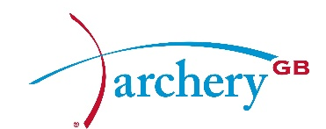

CONFERENCE CALL BOARD MINUTES
Monday 19 December
Present: | Neil Armitage | NA | CEO
 | Pippa Britton | PB | Co-opted Director
 | Lis Bellamy | LB | Independent Director
 | Mark Davies | MD | Chairman & Independent Director
 | Dave Harrison | DH | Elected Director
 | Muriel Kirkwood | MK | Elected Director
 | Chris Mortlock | CM | Independent Director
 | Erik Rowbotham | ER | Elected Director
 | Catherine Wilson | CW | Independent Director
In attendance: | Bob McGonigle | BM | Company Secretary
 | Peter Dickson | PD | For item AP1 only
 | Ceriann Davies | CD | For Item AP2 only
 | David Tillotson | DT | For item AP2 only

Apologies
Apologies were received from Lizzy Rees, Steve Tully and Bryan Woodcock.

AP1. Sport:80 (CRM) Contract
There was careful and considered discussion on this matter after which the Board approved the Sport:80 (CRM) contract subject to:
• Clause 3.3 being revisited
• The physical hosting location of the data being specified in contract
• The supplier’s security provisions being specified in contract

AP2. Talent Bid to Sport England
The Board received the submission and supporting documents for the Talent bid to Sport England. Directors made comments and raised questions by email prior to the meeting and responses were received in an additional paper in which the submission team noted alterations and actions to be done. On that basis, the Board approved the submission.

Archery GB is the trading name of the Grand National Archery Society, a company limited by guarantee no. 1342150 Registered in England.

