Junior Archery Series 2024
Stage 3 - hosted by West of Scotland Archery Association
A World Record Status event

Date & Timings: Saturday 1st June 2024 Registration & Inspection from 08:15 am. Assembly 09:00 am followed by practice.
Location: Riverside Sports Arena, University Avenue, Ayr, KA8 0SZ
Find Riverside Sports Arena What Three Words: warns.curving.linen
Rounds: A single WA 70/60/50/40m ranking rounds (see tables below) in the morning, followed by
head to head eliminations in the afternoon.
Judges Frank Schallmoser, Mike Alexander
Entry & Fees: Entry is via the Sport80 with a fee of £20 - Closing date is Monday 6th May 2024 or when the
event is full, and strictly no refunds after Friday 5th April .
This shoot is also part of a two-day event. The West of Scotland Open Outdoor Championship
which is being held on 2nd June 2024 a WA900. Entry cost Seniors £25 Juniors £20 entries also
on Sport80
Bosses: Tenzone layered foam bosses / danage / foam
Rules: WA Rules and Archery GB dress regulations will apply.
Music may be played during the event.
Awards: Top 3 places in each eligible age category (see JAS rules)
Divisions: Compound, Recurve & Barebow (see distance table below)
Classes: U21, U18, U15 (see year of birth table below)
Tents & Practice: Tents are permitted and can be put up from 4pm- 6pm on Friday (31st). Those wishing to
practice can do so from 4pm-6pm subject to field set up being completed.
A limited number of target faces will be provided on a first come first served basis.
Food: Hot and cold drinks along with a selection of hot food will be available throughout the
day. Please make sure that any litter is collected from the field before leaving.
Facilities: Ladies, gents, and disabled toilets are in the main building.
Smoking/Alcohol: Smoking/vaping is not allowed on the premises. No alcohol is allowed on the field.
Liability: West of Scotland Archery Association will not be liable for damage to cars or other property at the event.
Dogs: Dogs are not allowed unless assistance dogs.
Camping: There are unfortunately no camping facilities at Riverside Sports Arena the gates will be
locked 7pm with no access thereafter.
Photos & Videos: By entering the Junior Archery Series Stage 3 hosted by West of Scotland Archery
Association, you agree that photographs or video may be taken at the event. Photographers
are reminded that images must not be used on the internet without the permission of those
pictured. Archery GB / West of Scotland Archery Association may take general pictures of
the event which may be used to report on or promote future events. If you have any
concerns, please contact the TO.
24/02/2022

Junior Archery Series 2024

Stage 3 - hosted by West of Scotland Archery Association
A World Record Status event
GDPR & By entering the Junior Archery Series Stage 3 hosted by West of Scotland Archery Association,
Documentation: you agree that information may be collected and shared with tournament organisers, scoring systems, Archery GB, and other competitors. Some information may also be published in documents or lists relating to the event to a schedule decided by the organisers. These include the entrant’s name, gender, bow style, age category, round, disability information, email addresses, and/or contact numbers provided, club, county, region, and any assigned codes for this information.
A target list will be available a few days before the event and will be updated as necessary.
Organiser: Craig Paterson Mobile: 07968 627118 email: TO.westofscotlandarchery@gmail.com

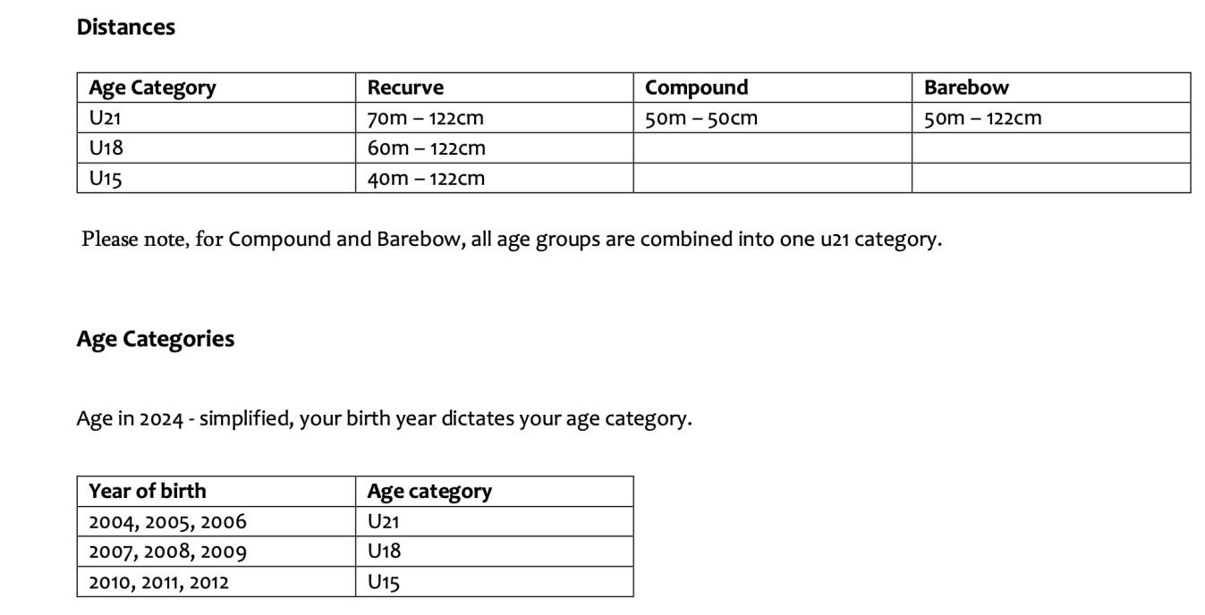

Archery GB Competitions – Conduct and Safeguarding
Archery GB strive to have a welcoming and friendly atmosphere at all levels of competition, and for everyone to leave having enjoyed their day’s competition. We welcome encouragement and cheering in support of competing athletes, in a good sporting manner.
Archery GB Values:
- We value people for who they are and their unique contribution to archery. o We choose to work and learn together. o We strive for excellence across the board. o We always act with integrity.
We are asking all individuals to please think how you are behaving at events when supporting people.
- Ask yourself what is an acceptable way to behave in a sporting environment.
- Please treat others as you would like to be treated yourself.
- When supporting people in matches please do so positively and constructively.
- Please demonstrate good sporting behaviour when supporting all athletes.

Poor Sporting Manner
Examples of poor sporting manner; the purposeful wrong calling of arrows or shouting loudly when an opponent is at full draw.
If you feel anyone is behaving in an inappropriate manner, inform either the Head Judge or the Tournament
Organiser. (They will make themselves known at assembly) or alternatively email competitions@archerygb.org
Both the Head Judge and the Tournament Organiser have the right to ask people to change their behaviour or leave the venue.

Competition Welfare Officer
The Competition Welfare Officer will deal with concerns around safeguarding (abuse, neglect, grooming, and antidoping) on the day. Their contact phone number and email address are available in the Welfare Notice on the relevant competition Ianseo page.

Archery GB Safeguarding Team
If you feel you cannot talk to the Competition Welfare Officer, or your concern has not been dealt with appropriately, contact Archery GB’s safeguarding team confidentially safeguarding@archerygb.org
Anne Rook, National Lead Safeguarding Officer 01952 602792
Karen Hodgkiss, Safeguarding and Governance Officer 01952 602793

If it is established that the Archery GB Code of Conduct and Values have been breached, Archery GB has the right to investigate and take disciplinary action as in line with the Archery GB Disciplinary Policy, Regulations and Procedures. Many thanks and safe shooting
The Archery GB Competitions Team

Archery GB Competitions – Conduct and Safeguarding April 2022

