BOLTON LAUNCH OF ARCHERY GB’S PROJECT RIMAYA SEES OVER 50 PARTICIPANTS TRY THE SPORT
- Two taster sessions launched archery initiative in the town
- 24 attendees have signed up to beginners’ classes

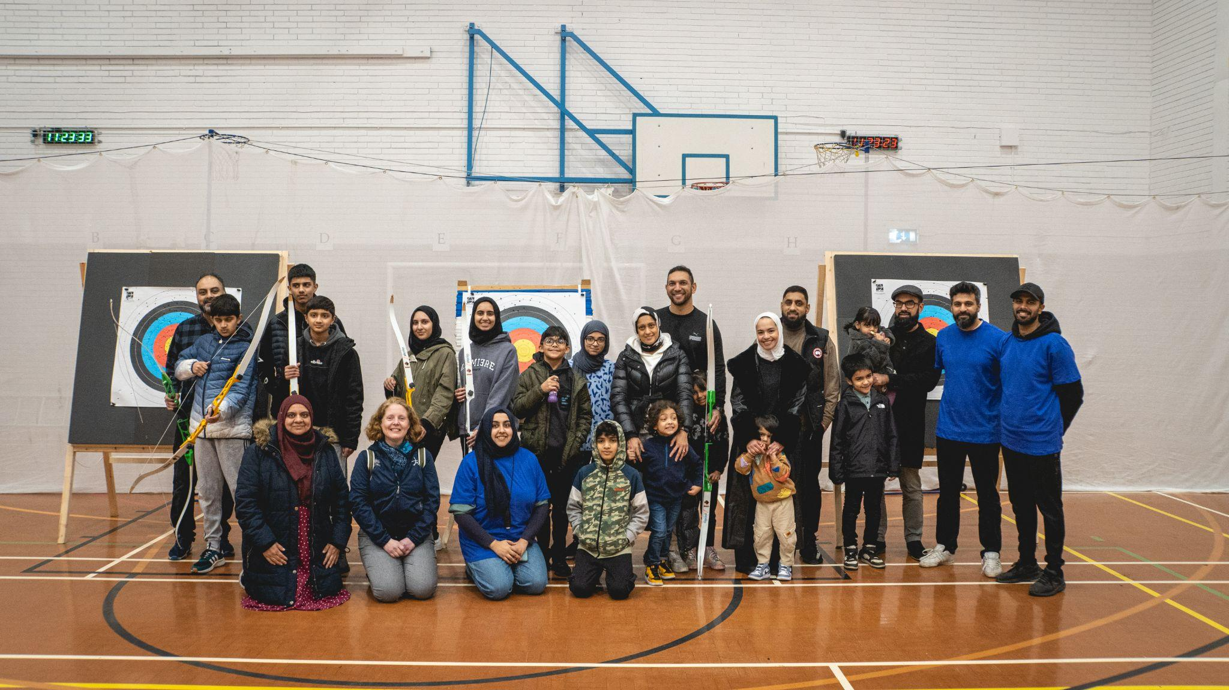

Archery GB’s Project Rimaya initiative has launched in Bolton with two taster sessions, held by Winter Hills Archery. Over 50 people attended the sessions in January (25th) and February (4th). More than 24 attendees have since signed up to a six-week beginners’ course.
Archery GB’s Project Rimaya, a SportsAid funded initiative, looks to increase archery participation amongst Muslim communities. Combining AGB strategic approach and Sport England’s ambitions of addressing the inequalities in sport, Project Rimaya looks to increase access to this inclusive sporting activity within ethnically diverse communities
Archery has a particular cultural significance within the Islamic community, as part of Muslim heritage for over a thousand years and one of a limited number of recreational activities cited specifically in the Qur’an as a fundamental ‘Sunnah’ sport and therefore an important activity for those of Muslim faith.
The two ‘Have a Go’ archery sessions took place on Wednesday 25th January and Saturday 4th February. Each session offered 27 spaces, all of which were filled.
On Project Rimaya and the initiative’s launch in Bolton, Farhana Sheth, Club Secretary and Coach at Winter Hill Archers, said, “The communication, support, and guidance of the Archery GB team has been amazing and I am so thankful for the opportunity to be a part of Project Rimaya”
“It has allowed me to develop my coaching and leadership skills which are sure to benefit the community. The club will no doubt be a way of not just introducing archery, but increasing cohesion and connection between people from all walks of life. Archery has no barriers!”
Gayle Pink, Head of Participation at Archery GB, comments, “Project Rimaya’s main aim is to provide practical support to establish new archery clubs in partnership with Islamic faith institutions and community groups.”
“It has become a particularly effective initiative, not only in addressing inequalities in sport but also in sharing the significant benefits of archery to ethnically diverse communities. Participants can wear what they wish, and the sport’s mental wellbeing benefits support mindfulness, focus and confidence building – of course, there’s also the social aspects to enjoy. Those wishing to take their experience further can even make the most of opportunities to train as a coach.”
Further information on Project Rimaya can be found here.
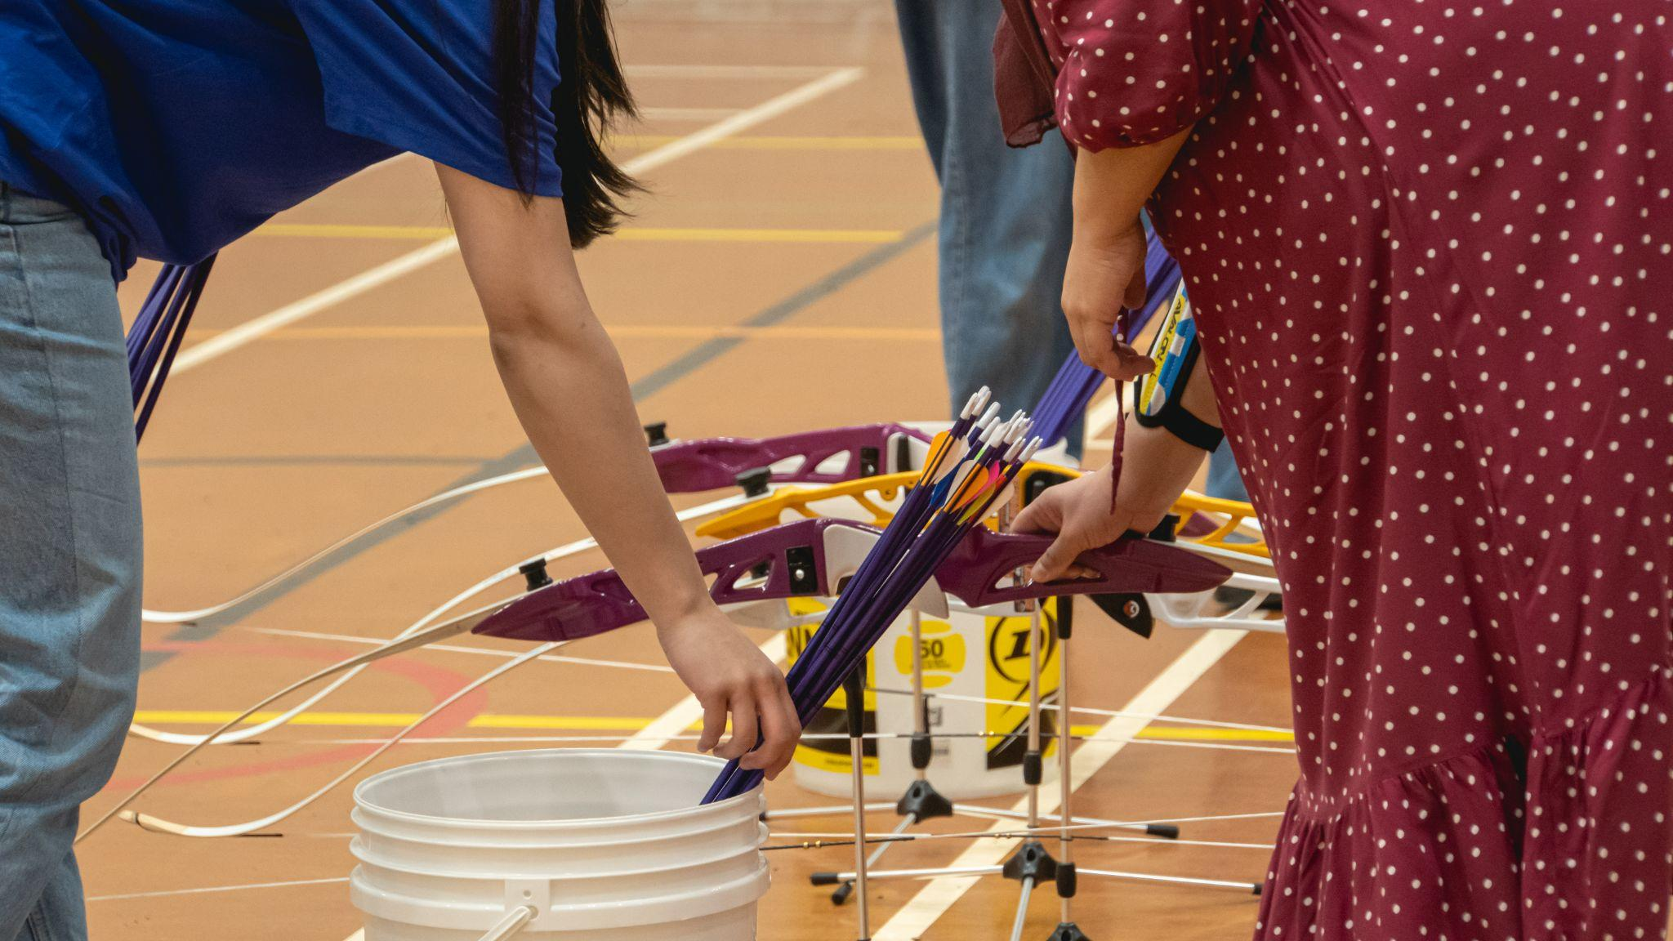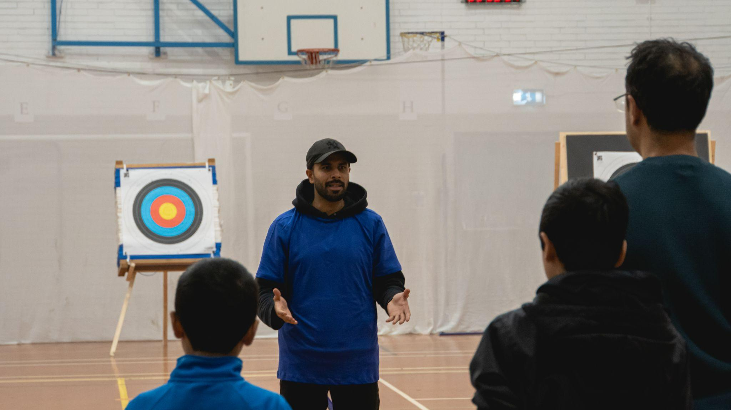
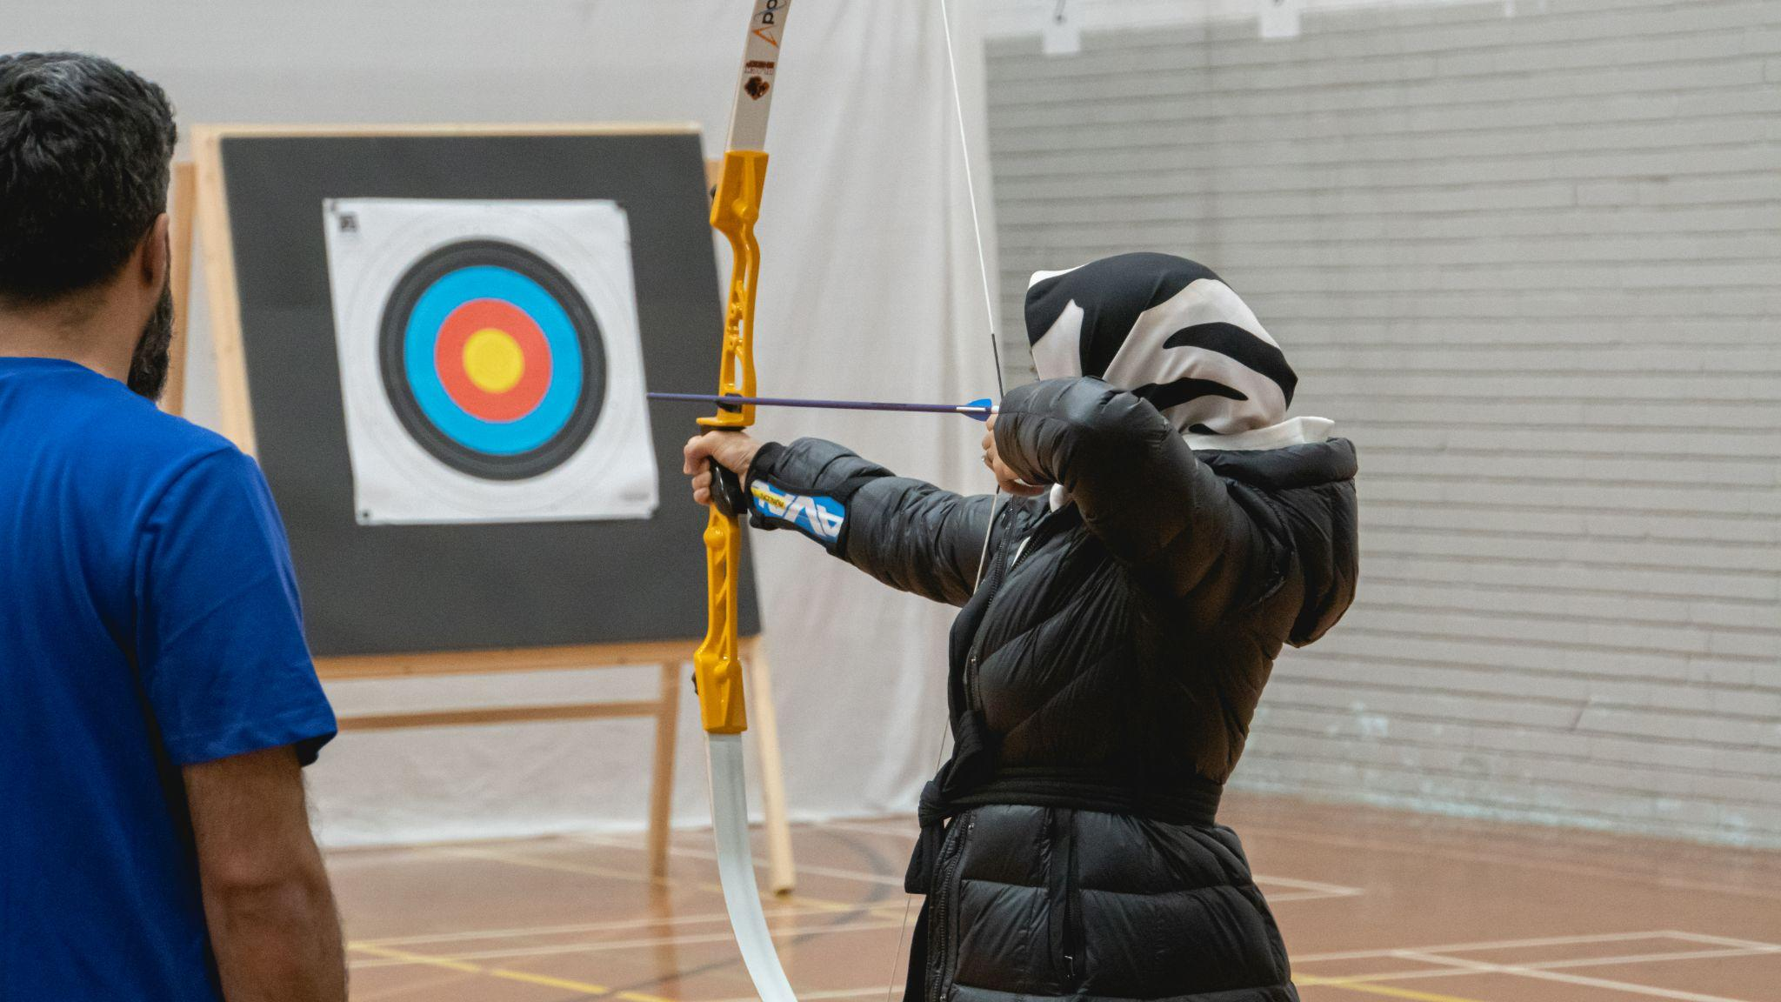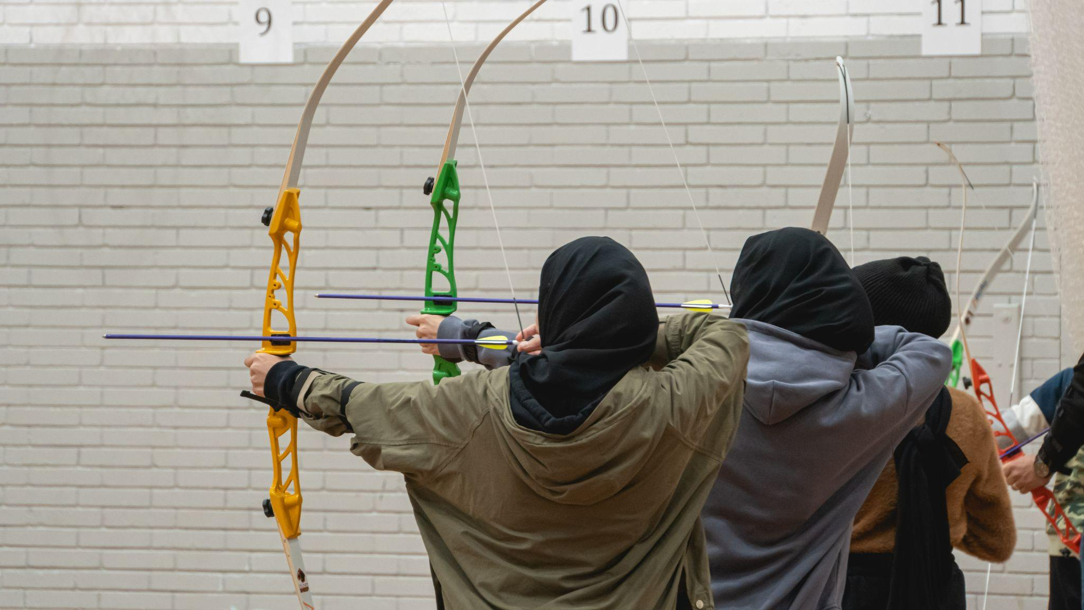

- ENDS -
Media Contacts: White Tiger PR - Archery@whitetigerpr.com
Leanne Barton / Leanne.barton@whitetigerpr.com / 07568 925069
Kimberley Powles / kimberley.powles@whitetigerpr.com / 07966 867827

About Archery GB
Archery GB is the British body for all forms of archery in the UK, an inclusive sport which lends itself to all spectrums of the population - regardless of age, disability or gender. With over 820 clubs and over 34,400 members, Archery GB is affiliated to World Archery, British Olympic Association & British Paralympic Association. More information www.archerygb.org. Beginners can visit www.startarchery.co.uk to find beginners’ courses and clubs near them and to learn more about the sport.

