GB ARCHERS CELEBRATING A WEEKEND OF WINS AND A NEW WORLD RECORD AT EUROPEAN GAMES
- Compound World Number One Ella Gibson smashes world record in Women's Compound
- Bryony Pitman, Penny Healey and Jaspreet Sagoo shoot to gold medal success in Recurve Women's Team final
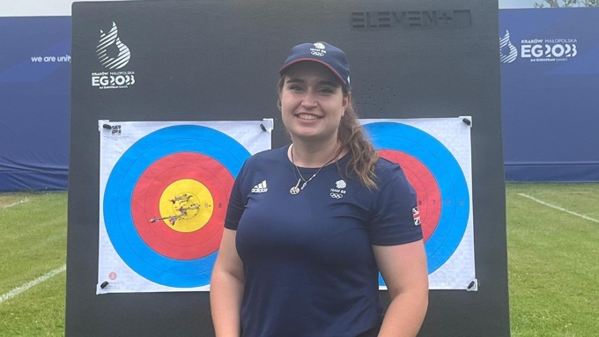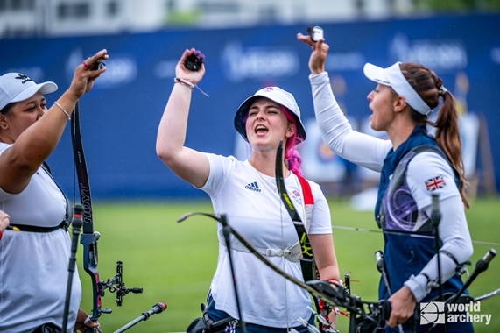
(Photos left to right: Ella Gibson after achieving her new world record and the female recurve team celebrate success (Credit: Team GB and World Archery).
26 June 2023: Archery GB is celebrating a weekend of international successes for several athletes at the European Games in Krakow, Poland.
The weekend started with celebrations as current women's compound world number one Gloucestershire’s Ella Gibson, shot the best qualifying round of her career smashing the eight -year old world record across the 50m distance, securing an impressive 715 finish.
Ella said about her new record: “It means so much to me. I’ve been near before and just missed out. This year’s been a really difficult year for me, I’ve had things go wrong and things breaking, so it’s been stressful. But it means so much to be able to finally do this, and not just do it but also to get a PB by three points.”
23-year-old Ella will next be seen shooting in the women's compound individual quarterfinals at 12 pm on Wednesday 28th June, where she will look to qualify for a place in the finals later that day.
Records were also broken by the recurve archers, with Penny Healey breaking her own senior UK record and U21 European record by one point. She then partnered with Monty Orton in the mixed team category where the pair smashed the U21 mixed team European record by 36 points!
Boosted by the team's confident start to the competitions, Penny took her place in the female recurve team alongside world number one, Bryony Pitman and Jaspreet Sagoo to compete for European glory. The ladies ranked 3rd following qualification and battled courageously through a quarterfinal against Denmark and a semi-final against a highly ranked Italian team. The semi-final was a true nail-biter as the match went all the way to a tie, with the GB women successfully out-shooting them to take their spot in the final against France, where the British women proved too strong for their French counterparts and won the gold medal convincingly 5-1.
Bryony said: "I think we put on a good performance. We worked really well as a team, and it paid off. To come out here and win this medal has been absolutely amazing."
Bryony and Penny will now go on to shoot for individual recurve glory at the games tomorrow (Tuesday 27th June) in the hope to qualify for the finals, which are scheduled to also take place on Wednesday 28th June.
For more information on Archery GB and its performance teams, please visit archerygb.org to follow the remainder of the European Games for visit european-games.org.
-Ends-
Notes to Editors:

The European Games takes place in Krakow, Poland between 21st June - 2nd July.

Athlete Profiles:
Ella Gibson: Current world number 1 Ella first tried archery in October 2014 when some coaches from Xperience Archery came to her secondary school. They put on a six-week taster session after school, which led to a beginners’ course with Deer Park Archers and she joined the club in June 2015. Ella has competed internationally since 2018.
In February, 2022, her first big win individually on the international stage came when she took the compound women European Indoor Champion title in Slovenia. In the same year she won the National Tour Final, individual gold at stages 1, 3 and 4 of the World Cup and silver in the World Cup Final. Ella won gold at the Birmingham 2022 World Games. As part of the women’s team, she won gold at the 2022 European Championships and silver at World Cup stages 3 and 4. She won bronze as part of the mixed team at the third stage of the World Cup.
Bryony Pitman: Bryony made her Olympic debut at the Tokyo 2020 Games, finishing ninth both individually and in the women’s team. Bryony was also part of the bronze-winning team at the 2019 World Archery Championships.
Bryony won individual gold at the World Cup in Antalya, along with Mixed Team Silver with Alex Wise and gold in the women’s team with Penny Healey and Jaspreet Sagoo. She also won individual silver at the Birmingham 2022 World Games and the World Archery Field Championships 2022 and silver as part of the women's recurve team at stage 4 of the World Cup. She is currently ranked world number 1.
Penny Healey: Penny is the youngest on the squad, at just 18 years old. She started archery when she was 9, after watching the Disney movie “Brave”. She won a gold medal at the first stage of this year's World Cup in Antalya, Turkey, meaning she has automatically qualified for the finals later this year in Mexico. She is currently ranked world number 2.
Monty Orton: Monty started archery in 2016 after spending a couple of years sitting in a tent at competitions watching his younger brother Paddy shoot barebow. He was persuaded to give it a go and when he eventually agreed, he found he really enjoyed it. Monty signed up to a beginners’ course at Meriden Archery Club.
He debuted for GBR in 2021 at the European Youth Cup, and, in 2022, won three golds at the European Youth Championships and the U21 gold across both stages of the European Youth Cups. He recently also scored the highest international recurve score by a recurve British man since 2012.

Media Contacts – White Tiger PR - Archery@whitetigerpr.com
Leanne Barton / Leanne.barton@whitetigerpr.com / 07568 925069
Rebekah Smith / rebekah.smith@whitetigerpr.com / 07840 104801

About Archery GB
Archery GB is the British body for all forms of archery in the UK, an inclusive sport which lends itself to all spectrums of the population - regardless of age, disability or gender. With over 820 clubs and over 34,400 members, Archery GB is affiliated to World Archery, British Olympic Association & British Paralympic Association. More information www.archerygb.org. Beginners can visit www.startarchery.co.uk to find beginners’ courses and clubs near them and to learn more about the sport.

