HIT THE TARGET DURING START ARCHERY WEEK
- Start Archery Week returns for 11th year
- Local clubs across the UK join forces to make archery sessions available to people of all ages
- Events take place between 6th - 14th May
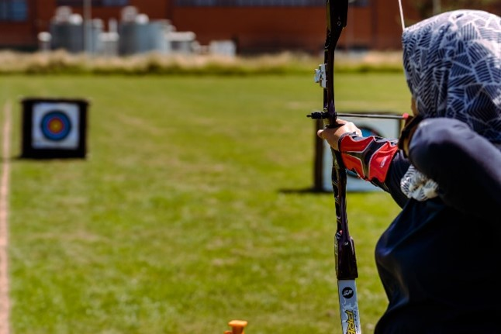
XX April 2023: Archery GB is encouraging adults and children of all ages* alike to come and try their hand at archery during Start Archery Week (6th - 14th May 2023). Now in its 11th year, Start Archery Week sees archery clubs and activity providers across the country open their doors to potential archers, welcoming people of all abilities to have a go at what is one of the most accessible sports around.
This fun and inclusive sport is perfect for anyone wanting to try something new, be it on their own or together with family and friends - even those who have never picked up a bow before will be able to enjoy the satisfaction of successfully hitting the target!
Aside from its amazing social appeal, archery has many health benefits for both body and mind, it can help develop physical strength and fitness as well as boost confidence and increase mindfulness.
Phoebe Paterson Pine, a gold medal Paralympian and current world number 1, said: “Archery is a truly adaptable sport; anyone can take it up at any age no matter their ability.
“I started archery back in 2012 after going on holiday and my club did its very best to make me feel welcomed and gave me the support I needed to be at the level I am today.
“If you are interested in starting archery, please don't hesitate to reach out to your local archery club.”

Those new to the sport needn’t worry about anything other than turning up and having fun as all equipment will be provided and, if you do find yourself wanting to continue there will be courses to sign up to, to help you start your archery journey.
To find your local event, simply visit the event finder map.
For more information about Start Archery Week and getting involved, please visit Start Archery Week or www.startarchery.co.uk
-Ends-
Notes to Editors
* Age limits and availability may differ between clubs
** Some clubs may charge a nominal fee for participation
Start Archery Week is an annual event organised by Archery GB with archery clubs and activity providers across the UK in order to encourage more people to have a go at archery.
About Archery GB
Archery GB is the national governing body for archery in Great Britain. Archery GB is responsible for all levels of archery within the UK from elite to grassroots. For more information please visit - www.archerygb.org
Start Archery
A dedicated resource for learning more about beginning archery, how to get involved in the sport and where to join a club, www.startarchery.co.uk – the site also offers a range of useful resources and information for schools, teachers and other interested parties.

