TWO GB ARCHERS TAKE THE LEAD IN WORLD RANKINGS
- Ella Gibson becomes World Number 1 Compound Women’s Archer following victory in USA
- Phoebe Paterson Pine takes top spot in Women’s Compound Open category
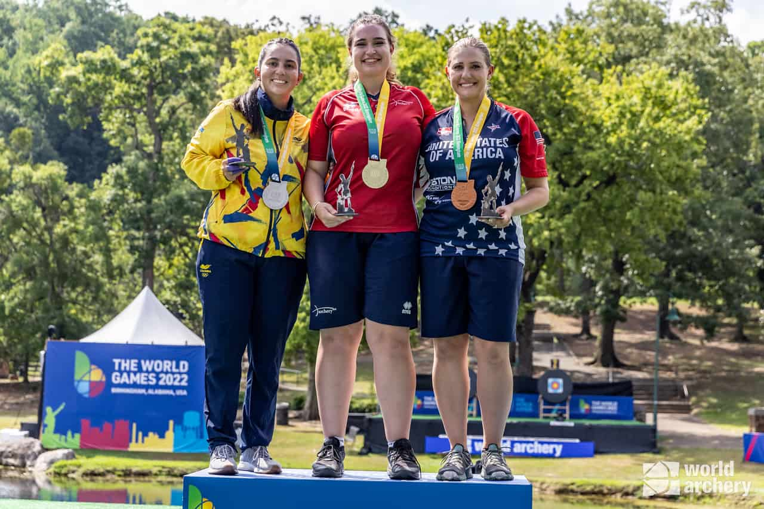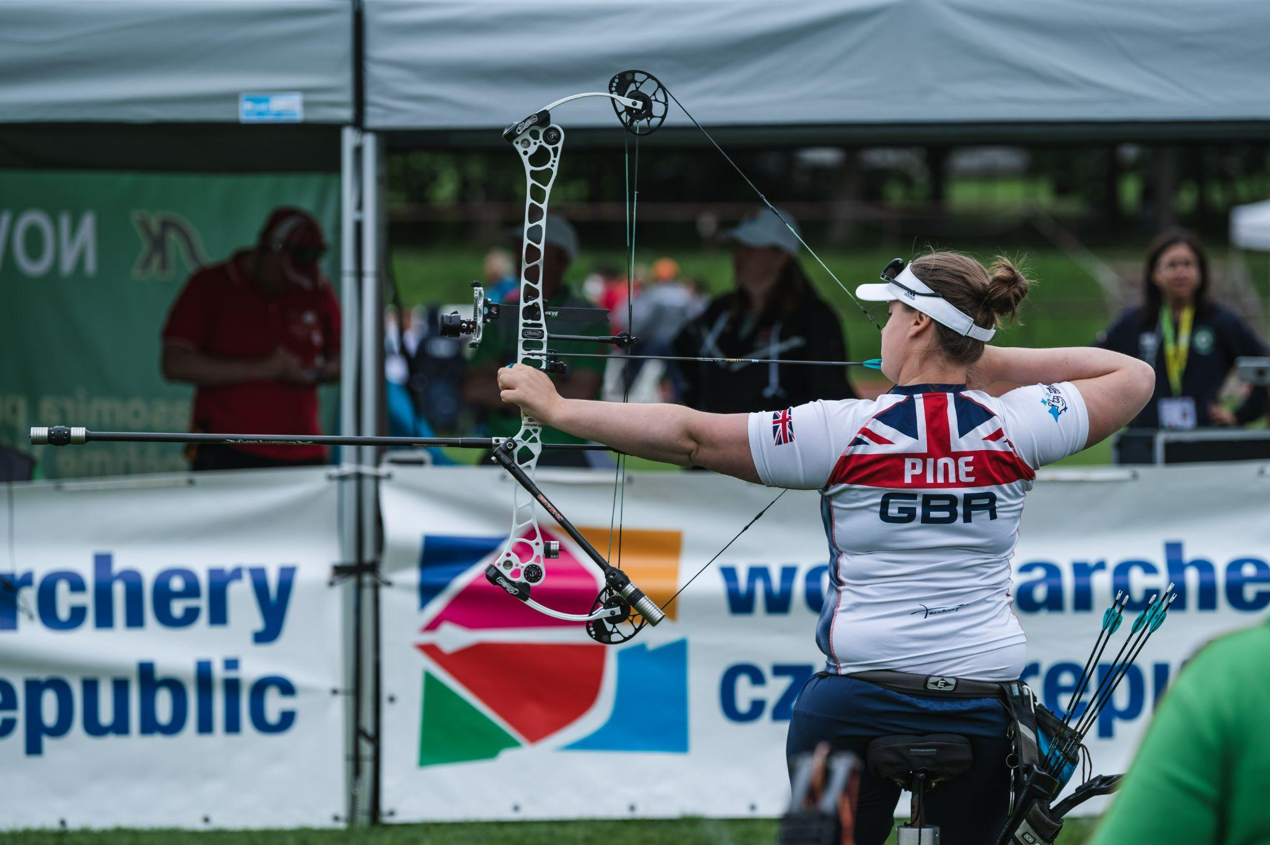
Photos left to right: Ella Gibson takes gold at the 2022 World Games (Photo credit: World Archery)
Phoebe Paterson Pine at the Para Archery European Cup in Nove Mesto (Photo credit: World Archery Europe)
XX July 2022: Two of Great Britain’s archers have taken the top spot in world rankings, in their respective categories. Phoebe Paterson Pine is now ranked as number 1 in the world in Women’s Compound Open archery, while Ella Gibson is now ranked as the world’s number one within Women’s Compound archery.
On the latest achievements for GB’s archers and the successful year to date, Neil Armitage, CEO of Archery GB, said, “It’s absolutely fantastic to see two of our archers take the top spots in world rankings at the same time. It’s been an exceptional year so far and it’s wonderful not only to see our archers securing medals at a wide range of international competitions, but also puting the inclusivity of archery into practice on the world stage.
“We are excited by the young talent in our developing squad and in August we will be holding the European Youth Archery Championships at Lilleshall, which is a great opportunity for us to showcase everything that is so inclusive, diverse and exciting about our sport.”
Ella Gibson takes the top spot following gold medal win at the 2022 World Games
22-year-old Gibson from Gloucestershire secured the top spot after winning gold at the 2022 World Games in Birmingham USA last week, beating Columbia’s Sara Lopez, the then world number one, in the Compound Women’s Individual final.
Prior to the competition, Gibson was ranked as number two in the world, just 3.5 points behind Lopez, who has spent a record 1,445 non-consecutive days in the top spot.
On this latest achievement, Gibson said, ““It feels super surreal right now. I planned on it and knew I would get there but didn’t think it would happen so soon or this year so that is definitely unexpected for me.”
“We walked off the stage and my coach Simon [Scott] hugged me and told me that I was world number one now because he had done all the maths before and figured out where I needed to finish to make it happen. I don’t quite feel that I can say I’m the best in the world or world number but one day I will. For now, I’ll just concentrate on one step at a time.”
Taking first position in world rankings and gold at the 2022 World Games are just the latest achievements in an exceptional year to date for Gibson.
June’s Paris 2022 Hyundai Archery World Cup Stage 3 competition saw Gibson secure multiple medals, including gold in the Individual Women’s Compound matches. She was part of the silver medal winning team, alongside Layla Annison and Liz Foster in the Compound Women’s Team event and also secured bronze in the Compound Mixed Team event with Adam Carpenter.
Last month’s European Championships in Munich also saw Gibson and her teammates, Izzy Carpenter and Jess Stretton (who won Paralympic gold in Rio in 2016), put the inclusivity of archery into practice, as they won gold in the Women’s Compound Team competition.
Phoebe Paterson Pine takes the lead in the Compound Women’s Open category
24-year-old Phoebe Paterson Pine, who won gold at the 2020 Tokyo Paralympics, has also secured the top spot in her category, Compound Women’s Open.
Earlier this month, Cheltenham’s Paterson Pine, secured Individual Compound Women Open gold in the ​first leg of the Para Archery European Cup in Nove Mesto, Czech Republic.
She also won gold in the Compound Women Open Team event with teammate Jessica Stretton (who won gold at the 2016 Paralympic Games in Rio) and bronze in Compound Open Mixed Team competition with fellow GB archer Jamie Harris.
On her wins in Nove Mesto and taking the top spot in world rankings, Paterson Pine said,”This is my first time ever winning three medals across the three events that are available, so it’s pretty surreal to me right now. I’m also proud to have been able to win individually, I've worked really hard on my individual game, and it’s finally beginning to show!”
“Being world number one is something I’ve always wanted to achieve. This year has been exceptionally successful with winning bronze at the world championships and then going on to do so well in the Czech Republic as well, both have made it possible for me to boost my world ranking points and I hope to keep the spot for a while yet!”
“The next world ranking event I have is the European championships. So right now I’m working hard to maintain my level of performance or improve it, and hopefully get some more points in the bag.”
-ends-
Notes to Editors
Ella Gibson: Ella first tried archery in October, 2014, when some coaches from Xperience archery came to her secondary school. They put on a six-week taster session after school and that led to a beginners’ course with Deer Park Archers and she joined the club in June, 2015. Ella has competed internationally since 2018, winning a silver at the European Outdoor Championships last summer, bronze at the Lancaster Classic and team medals on the World stage. In February, 2022, her first big win individually on the international stage came when she took gold and the compound women European Indoor Champion title in Slovenia. Ella’s family own and run Dolcetti Ice Cream, in Cirencester. They are moving to bigger premises, which will have a 25-metre indoor range so that Ella can continue to shoot, whatever the weather.

Phoebe Paterson Pine (Compound Women Open): Phoebe is a junior indoor and outdoor national champion and gold medal Paralympian. She won gold at her Games debut in Tokyo winning the Compound Women Open. She has spina bifida. She first tried archery on a family holiday enjoying it so much she joined her local club. Phoebe is a student at Worcester University, studying sports coaching science. She holds eight national records, four European records and three world records. Phoebe moved to Telford in 2019 from her family home in Cirencester, in the Cotswolds. Phoebe won bronze individually at the World Archery Para Championships in Dubai 2022.

Media Contacts - White Tiger PR - Archery@whitetigerpr.com
Leanne Barton / Leanne.barton@whitetigerpr.com / 07867332590
Kate Bates / Kate.Bates@whitetigerpr.com / 07876803947
Kimberley Powles / kimberley.powles@whitetigerpr.com / 07966 867827

Hi-res images are available from Dropbox with credit World Archery Europe HERE

About Archery GB
Archery GB is the British body for all forms of archery in the UK, an inclusive sport which lends itself to all spectrums of the population - regardless of age, disability or gender. With over 820 clubs and over 34,400 members, Archery GB is affiliated to World Archery, British Olympic Association & British Paralympic Association. More information www.archerygb.org. Beginners can visit www.startarchery.co.uk to find beginners’ courses and clubs near them and to learn more about the sport.

