GB ARCHERS CELEBRATING A WEEKEND OF WINS AND A NEW WORLD RECORD AT EUROPEAN GAMES
- Compound World Number One Ella Gibson wins World Cup stage in Paris to secure World Cup Final spot
- Para team shoot to gold medal success across the board at European Championships in Rotterdam
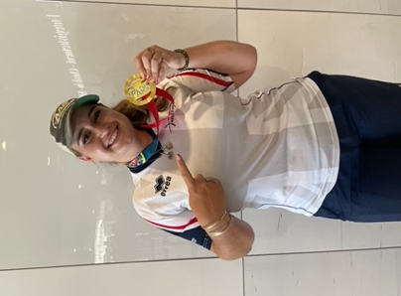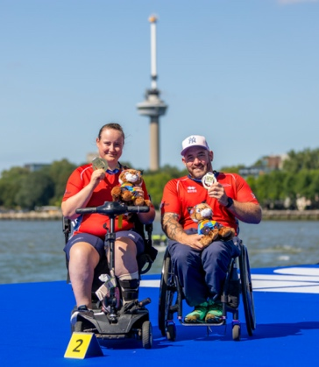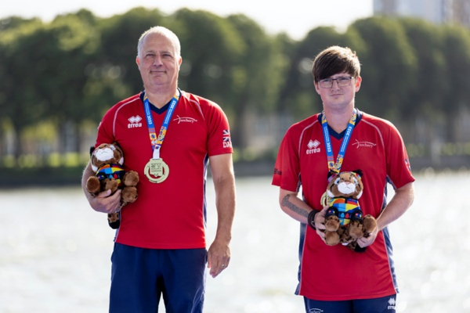
(Photos left to right: Ella Gibson, Phoebe Paterson Pine & Nathan Macqueen and Dave Phillips and Cameron Radigan after achieving their gold medal (Credit: Izzy Carpenter and European Para Championships).
21 August 2023: Archery GB is celebrating a weekend of international successes for several athletes at the final World Cup stage in Paris and the European Para Championships in Rotterdam.
Current women's compound world number one Gloucestershire’s Ella Gibson, gained her first gold medal of the World Cup season in Paris during an incredibly tight and close-fought gold medal match against Denmark’s Tanja Gellenthien. The match saw both athletes tied at 145-145 after five ends, taking them to a nail-biting sudden death shoot-off where Ella held her nerve to land her final arrow the closest to the centre.
After securing her gold medal, Ella said: "It feels amazing to finally get a gold this year."
When it's such high pressure like that [shoot off], you can be really nervous, adrenaline can get to you, and you can be scared.”
“But you just have to remind yourself that, actually, this is the aim, this is the thing that you want. This is the thing you train for every single day, to be on a world stage. You've just got to try and remember that, relax and enjoy it.”
“I felt like the universe had given me one little free pass and one extra opportunity to win gold."
In September, 23-year-old Ella will now take her place in the World Cup Finals alongside individual recurve athlete and world number one Penny Healey in Hermosillo, Mexico.
Success was also savoured at the European Para Championships in Rotterdam where athletes won a number of medals across both the compound and recurve categories.
Nathan Macqueen of Dumfries did the double securing gold medals in both the individual compound men's and compound mixed team competitions, the latter in partnership for the first time with world number three Phoebe Paterson Pine.
After winning his second gold at the European Para Championships, Nathan said:
“It’s a bit hard to believe to be honest as I had such a bad year last year with health issues and stuff so I only made one competition. To come out this year and medal at every event I’ve been to is a dream come true."
“I shot my shot the first three arrows then I got really excited and took my foot off the gas pedal a wee bit, but I managed to get it back again and pull away.”
On securing gold in partnership with Macqueen for the first time, Phoebe said:
“(I am) super happy and super proud of both of us. This is our first European gold together. We went out and we shot really well. (We were) fully calm and collected. We worked so well as a team and I’m super proud.”
Recurve glory was also gained in the men's doubles competition by the formidable pairing of Cwmbran's Dave Phillips and Galston's Cameron Radigan who saw off Turkey to take the title 6-2.
On winning gold, Dave said: “We are absolutely overwhelmed. We knew the conditions were tricky out there. We want to applaud our opponents because we know they are very good quality archers. We are very fortunate and very happy.”
“It was difficult today with the wind but I think we got the gaps in the wind where maybe our opponents were not quite so lucky.”
“Maybe it was a bit of experience, we get a lot of wind in Scotland, in Wales and in Great Britain, so we are masters at it.”
Of his teammate, Radigan said: “It’s a great feeling. I am just happy to be here and shoot with a great teammate.”
“The knowledge that he is giving me through archery is incredible. I learnt so much in such a short period of time. What he has shown me in three weeks has been great.”
Bronze medals were also won in the W1 Mixed Team and compound women's doubles categories.

In the W1 mixed team, Camberley's Victoria Kingstone and Ipswich's Martin Saych following an incredibly close-fought final finally beating Czechia 117-116.
Speaking after their win Martin said: “Normally I am a little bit more composed. It’s been a tough week, so it’s a very good way of finish the week."
“It was tight. I wasn’t paying attention to the score at all. I was focused on my shots and kept breathing.”
In the compound women's doubles, Hemel Hempstead's Jessica Stretton and Crawley’s Jodie Grinham completed their bronze-medal match with a convincing victory against Poland 133-124.
After winning the medal, Jessica said: “I feel pretty proud actually, pretty ecstatic. The conditions were not good at all for that match. The wind was an absolute nightmare. But we all shot probably the best we could, given the conditions. I think we all fought really hard for it."
“I think if I had to sum this final up in one word, it would be difficult. It’s always difficult with the wind and for the wind to be as changeable as it was today, it definitely was difficult to find the right shot to shoot."
For more information on Archery GB and its performance teams, please visit archerygb.org.
-Ends-
Notes to Editors:

Athlete Profiles:
Ella Gibson: Current world number 1 Ella first tried archery in October 2014 when some coaches from Xperience Archery came to her secondary school. They put on a six-week taster session after school, which led to a beginners’ course with Deer Park Archers and she joined the club in June 2015. Ella has competed internationally since 2018.
In February 2022, her first big win individually on the international stage came when she took the compound women's European Indoor Champion title in Slovenia. In the same year, she won the National Tour Final, individual gold at stages 1, 3 and 4 of the World Cup and silver in the World Cup Final. Ella won gold at the Birmingham 2022 World Games. As part of the women’s team, she won gold at the 2022 European Championships and silver at World Cup stages 3 and 4. She won bronze as part of the mixed team in the third stage of the World Cup.
Penny Healey: Penny is the youngest on the squad, at just 18 years old. She started archery when she was 9, after watching the Disney movie “Brave”. She won a gold medal at the first stage of this year's World Cup in Antalya, Turkey, meaning she automatically qualified for the finals later this year in Mexico. She is currently ranked world number 1.

Nathan Macqueen: Macqueen is an all-round sportsman who played rugby for Glasgow Warriors at under 18 level before he was involved in a serious motorbike accident when he was 17 years old. Before his accident, Macqueen was part of Scotland's archery team. After he was injured, he took up powerlifting and wheelchair basketball. But following a shoulder injury, he switched back to archery, making his international debut just months before Rio 2016, where he finished a highly respectable ninth.

The 29-year-old from Dumfries in Scotland has also won multiple medals at the European and World level. He was part of the gold-winning compound open mixed team at the Rome 2022 European Para Archery Championships along with Jessica Stretton. He also won bronze as part of the compound open men's team at the same event with Jamie Harris.

Jodie Grinham: Jodie first got involved in archery in 2008 when she saw her dad shooting at their local club and decided she would like to give the sport a go. After going through the Archery GB National Talent Development Programme, Jodie was selected to join the GB squad in 2014 and started competing internationally.

Jodie was selected to make her Paralympic debut at Rio 2016, and she made it in style, winning silver in the mixed team compound open alongside Beijing gold medallist John Stubbs.
In 2019, Jodie won team silver at the World Championships in Hertogenbosch, Netherlands.

Phoebe Paterson Pine: Phoebe is the current Paralympic champion, the 2022 European Para champion and world number 3. She won gold at her Games debut in Tokyo winning the Compound Women Open, and while she has been a member of the Archery GB para squad for some years, she has also now been named as a member of the Archery GB national compound squad. She has spina bifida and first tried archery on a family holiday, enjoying it so much that she joined her local club. Phoebe is a student at Worcester University, studying sports coaching science.

She holds multiple National, European and World records, breaking five UK, European and World records over five days in 2022! She was appointed an MBE for her services to archery in the New Year’s Honours List 2022.

David Phillips: Dave finished eighth individually and in the mixed team at Tokyo 2020, representing GBR in two-quarter finals. Dave is from Cwmbran, Wales. He has MS and is very active in the MS Society and is an ambassador for MS Cymru. Dave is also a Dual Ambassador for Ottobox and supports athletes with disabilities. He returned to archery after a 30-year break when he was looking for a way to stay active with MS. He was selected for the GB squad in 2014 and made his international debut at the Para World Ranking Tournament in Nove Mesto, Czech Republic where he secured a gold medal as part of the men’s team and a mixed team bronze. In the same year, Dave was selected to represent Great Britain at the European Para Championship in Notwill, Switzerland where he won team gold and mixed team bronze, as well as finishing fifth in the individual competition. Dave finished in second with teammate Cameron Radigan in the double-team event at the World Archery Para Championships. His Paralympic debut was in Rio where he finished fifth in the mixed team.

Cameron Radigan: Cameron is the youngest member of the squad. He is from Galston in East Ayrshire, Scotland. At the age of 2, he was diagnosed with a cancerous tumour in his left calf muscle. After being given a 10% survival rate and a maximum of 5 years in remission, Cameron defeated the odds. In 2018, his lower left leg was amputated due to the treatment taking a toll and to have freedom from being restricted to a wheelchair. Eleven days later, Cameron competed for Scotland at the Junior Outdoor Championships. Since then, Cameron has competed on the national circuit, competing for Scotland at national tournaments. He won the Disability Championships title back-to-back (2019 and 2021).
Cameron made his debut on the international circuit at the World Championships in Dubai. Radigan finished in second with teammate David Phillips in the double team event at the World Archery Para Championships. He won bronze at the Disability Championships 2022 and along with Dave Phillips won bronze in the men's team event at the Para Archery European Cup and silver at the European Para Archery Championships.

Martin Saych: Martin has been shooting for around four years. He is from Ipswich and works in Insurance as a Data Analyst. He was left paralysed as a teenager when he broke his neck in a trampolining accident. Prior to his injury, he had competed in trampolining at an international level. In archery, he has won various medals internationally in mixed team events and represented GB in the World Championships in Den Bosch in 2019. He has also played wheelchair rugby in the past.

Victoria Kingstone: Victoria grew up in Rainham, Kent but now lives in Camberley, Surrey. She has spina bifida. She is studying for a Masters degree in Sports and Exercise Psychology. Victoria was previously a Supporter Engagement Executive at Queen Elizabeth's Foundation for Disabled People. She is also a Global Athlete Mentor for The True Athlete Project. Victoria was part of the team that competed at the World Para Championships in 2019 in Den Bosch.

Jess Stretton: Stretton won gold at the Rio 2016 Paralympic Games in the Women’s Individual Compound W1 at just 16 years old - the youngest archer at the Games. The following year she was made an MBE for her services to archery. Since Rio, Stretton has changed category – she now competes in the Compound Open and claimed individual silver in the 2019 World Para Championships in the Netherlands, setting a new world record in the process. She also won bronze at the World Youth Championships the same year. Jessica won bronze with teammate Jamie Harris in the mixed team at the 2022 World Para Championships. Stretton is from Hemel Hempstead and is an avid reader.

Media Contacts – Spider PR - Archery@wearespider.com
Sara Dagen / Sara.Dagen@wearespider.com /
Rebekah Smith / rebekah.smith@wearespider.com / 07840 104801

About Archery GB
Archery GB is the British body for all forms of archery in the UK, an inclusive sport which lends itself to all spectrums of the population - regardless of age, disability or gender. With over 820 clubs and over 34,400 members, Archery GB is affiliated to World Archery, British Olympic Association & British Paralympic Association. More information www.archerygb.org. Beginners can visit www.startarchery.co.uk to find beginners’ courses and clubs near them and to learn more about the sport.

