INTERNATIONAL ARCHERY COMES TO THE HOME OF ROBIN HOOD
- European Para Archery Cup Finals and Archery GB National Tour Final to take place in Nottingham from September 15 to 17
- Phoebe Paterson Pine and Jessica Stretton among athletes named in Archery GB squad for European Para Archery Cup
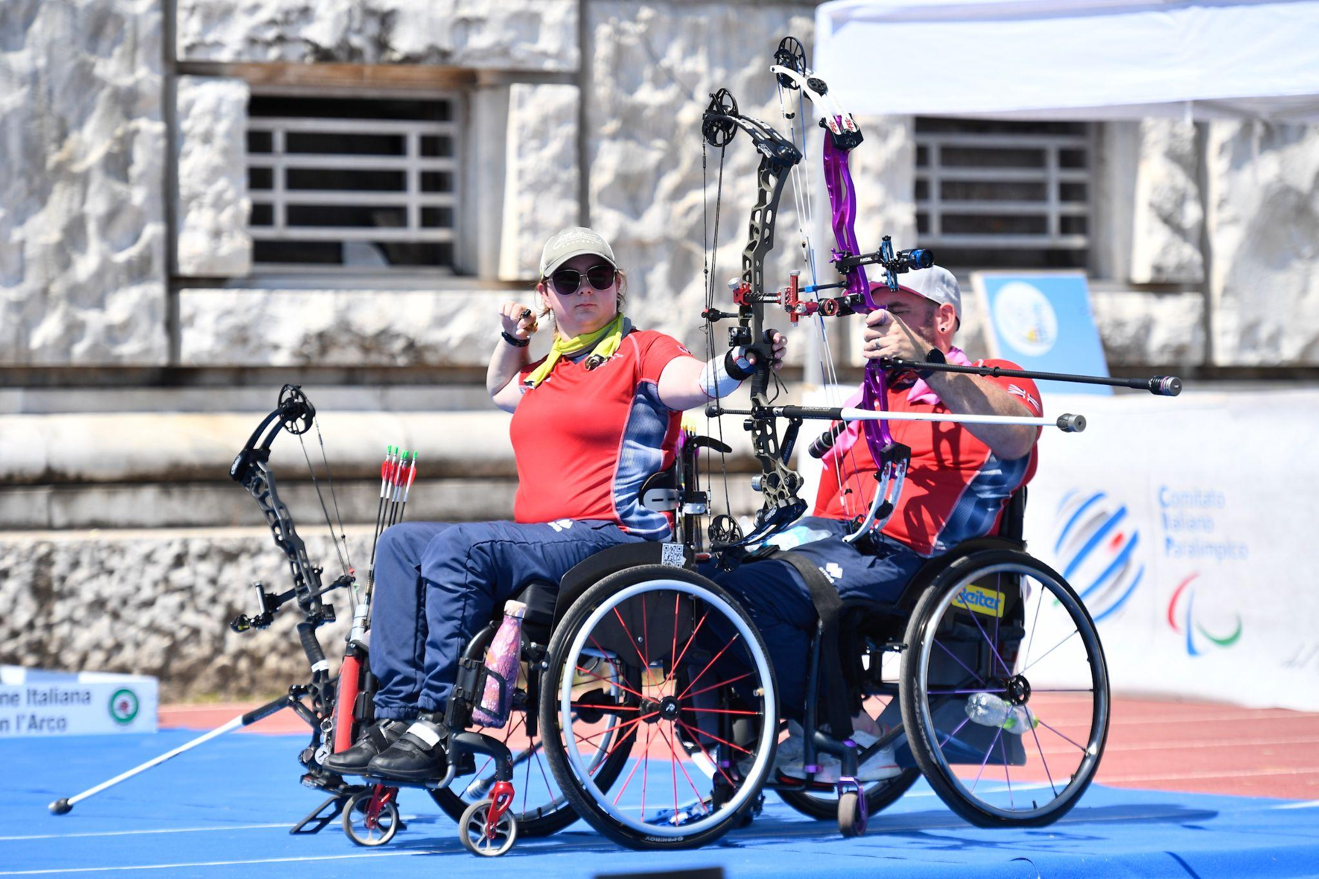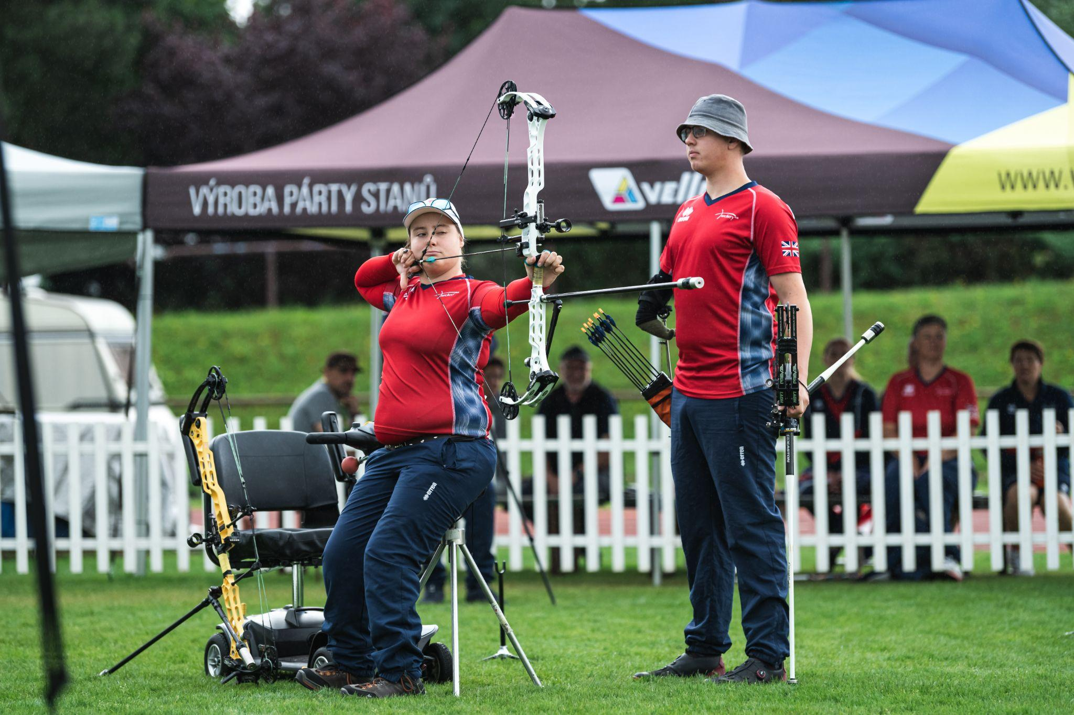
Images: Left, Jessica Stretton competes at the European Para-Archery Championships in Rome. Credit: World Archery Europe. Right, Phoebe Paterson Pine and Jamie Harris. Credit: World Archery Europe.
01 September 2022: Nottingham has a long association with archery, from the legend of Robin Hood right up to hosting the European Championships in 2016.
And now it is set to host two major archery competitions this month as the European Para Cup Finals and the Archery GB National Tour Final take place at Wollaton Park.
Great for spectators and to ‘have-a-go’ yourself
From September 15 to 17 there is a great opportunity to come and watch top world-class UK and European and Paralympian archers. Spectator entry is free and there is ticketed seating for those who want to get a grandstand view.
Archery GB will also be bringing their have-a-go range for visitors to try their hand at the sport. Tickets for both the National Tour Finals and the European Para Archery Cup Finals are available to purchase here.
World class talent named in GB squad
The finals will bring together some of the best para archers who attended both the European Para Archery Cup in Nove Mesto and the European Para Archery Championships in Rome.
There will be three disciplines competing: the W1 open, compound open and recurve open, with both men’s and women’s categories in each. They will be fighting for medals in the individual and mixed team sections.
For the compound women open, GB’s very own Phoebe Paterson Pine, the number one world-ranked Paralympic and European Champion will be in there, alongside teammate Jessica Stretton, the number three world ranking 2016 Paralympic Champion.
Bronze team world medallist Jamie Harris will be shooting for the compound open men.
On the recurve open side, Paralympian Hazel Taylor will shoot for the women.
Competing for the men is two-time Paralympian David Phillips.
In the W1 open category, 11th world ranked Victoria Kingstone will be attending, along with her male counterpart, 15th world ranked Martin Saych.
Tom Duggan, Director of Performance, is looking forward to the event: “The Para European Cup Finals present us with a great opportunity to perform internationally in this country which isn’t something that we get to do all that often.
“One of the key drivers behind us bidding for the event was to give as many of the WCP athletes the opportunity for more meaningful arrows and crucially to practice shooting finals style matches, which is the format that the Paralympics is shot in.
“We are really grateful for all the work that Jon Nott and Katy Cumming have put in to making this event viable, especially after such a busy time having so successfully hosted the European Youth Championships earlier this month.”
National Tour Finals
Wollaton Park will also host Archery GB’s National Tour finals.
This year’s collection of successful archers will be placed into their brackets to shoot head-to-head eliminations against one another to determine the finalists in each category.
On Friday, September 16, the recurve archers will be competing for their medals, and on Saturday, September 17, will be the turn of the compound and barebow archers.
Spectators should expect to see world-class shooting from these archers, as there will be some very talented and decorated athletes in attendance.
On the recurve side, there will be several Olympians who will be aiming for gold at the Finals, including Sarah Bettles and Bryony Pitman. Bryony is also currently ranked world number four, and she will be shooting at this year’s World Cup Final in Mexico.
They will be joined by the 2022 National Tour Finalist winner Penny Healey.
For the male Olympian attendees there will be James Woodgate, Tom Hall and the 2022 National Tour Finalist winner Patrick Huston. They will also be joined by world cup silver mixed team medallist Alex Wise.
For the compound men we have returning favourites, including the 2019 winner James Mason, and multiple tour finalist attendees Adam Ravenscroft, and Chris White.
They’ll be joined by the current National Tour Finalist winner for both 2020 and 2021, Adam Carpenter.
On the women’s side, Phoebe Paterson Pine will come straight from the Para Finals to
compete at the Finals, and last year’s National Tour Final winner Layla Annison will be
shooting. Also competing is the number one world-ranked woman, Ella Gibson, who will be going with Bryony Pitman to the World Cup Finals this year.
The 2022 European Champion Izzy Carpenter will be competing as well as the world-ranked number eight Sarah Prieels.
“It’s an absolute honour for Archery GB to be hosting this event,” says Jon Nott, Archery GB’s Events and Competition Manager. “The City of Nottingham has worked so hard to help make this event happen and we’re very grateful to them. It’s going to be a great weekend of archery.”
A Successful 2022 for GB’s Para Archers
Great Britain’s archers have enjoyed an exceptional 2022, winning eight medals at the European Para-Archery Championships in Rome, Italy.
Between them, the athletes secured two gold, three silver and three bronze across the individual and team events, which took place between July 30 and August 7.
This followed the fantastic seven medals won by the team in July at the ​first leg of the Para Archery European Cup in Nove Mesto, Czech Republic.
In Nove Mesto, the athletes secured two gold, two silver and three bronze medals across the individual and team events.
Book your tickets for the European Para Archery Cup Finals and National Tour Finals
More information about the events is available here, and tickets for both the National Tour Finals and the European Para Archery Cup Finals are available to purchase here.
-ends-
Notes to Editors

Hi-res images are available from Dropbox link with credit World Archery Europe HERE

Information on have-a-go sessions is available on request.

Jess Stretton (Compound Women Open): Stretton won gold at the Rio 2016 Paralympic Games in the Women’s Individual Compound W1 at just 16-years-old - the youngest archer at the Games. The following year she was made an MBE for her services to archery. Since Rio, Stretton has changed category – she now competes in the Compound Open and claimed individual silver in the 2019 World Para Championships in the Netherlands, setting a new world record in the process. She also won bronze at the World Youth Championships the same year. Jessica won bronze with teammate Jamie Harris in the mixed team at the 2022 World Para Championships. Stretton is from Hemel Hempstead and is an avid reader.

Phoebe Paterson Pine (Compound Women Open): Phoebe is a junior indoor and outdoor national champion and gold medal Paralympian. She won gold at her Games debut in Tokyo winning the Compound Women Open. She has spina bifida. She first tried archery on a family holiday, enjoying it so much she joined her local club. Phoebe is a student at Worcester University, studying sports coaching science. She holds eight national records, four European records and three world records. Phoebe moved to Telford in 2019 from her family home in Cirencester, in the Cotswolds. Phoebe won bronze individually at the World Archery Para Championships in Dubai 2022. Phoebe is currently ranked World Number One within the Compound Women Open category.

Martin Saych (W1M): Martin has been shooting for around four years. He is from Ipswich and works in Insurance as a Data Analyst. He was left paralysed as a teenager when he broke his neck in a trampolining accident. Prior to his injury he had competed in trampolining at an international level. In archery, he has won various medals internationally in Mixed team event and represented GB in the World Championships in Den Bosch in 2019. He has also played wheelchair rugby in the past.

Jamie Harris (Compound Men Open): Jamie is from Stratford Upon Avon. From birth his lower right arm was missing multiple bone's resulting in its length being reduced and only having two fingers on his hand. He uses this arm to draw the bow after first getting into archery in 2012 at an event called Limb Power, at Stoke Mandeville. After discovering his love for the sport, he joined a local club. It quickly became apparent shooting off his fingers would not be viable due to his disability. To continue shooting, Jamie switched to compound shooting this allowed him to develop a custom trigger release that attaches around his arm. The development of his triggers is ever ongoing as it's integral to shooting. Jamie made great improvements to both his shooting abilities and equipment reliability. This has enabled him to medal at every National disability championship since it started in 2017 and he has won it twice (2018-2021). Jamie won bronze with teammate Jessica Stretton in the mixed team at the 2022 World Para Championships.

Victoria Kingstone (W1W): Victoria grew up in Rainham, Kent but now lives in Camberley, Surrey. She has spina bifida. She is studying for a Masters degree in Sport and Exercise Psychology. Victoria was previously a Supporter Engagement Executive at Queen Elizabeth's Foundation for Disabled People. She is also a Global Athlete Mentor for The True Athlete Project. Victoria was part of the team that competed at the World Para Championships in 2019 in Den Bosch.

David Phillips (Recurve Men Open): Dave finished eighth individually and in the mixed team at Tokyo 2020, representing GBR in two quarter finals. Dave is from Cwmbran, Wales. He has MS and is very active in the MS Society and is an ambassador for MS Cymru. Dave is also a Dual Ambassador for Ottobox and supporting athletes with disabilities. He returned to archery after a 30-year break when he was looking for a way to stay active with MS. He was selected for the GB squad in 2014 and made his international debut at the Para World Ranking Tournament in Nove Mesto, Czech Republic where he secured a gold medal as part of the men’s team and a mixed team bronze. In the same year, Dave was selected to represent Great Britain at the European Para Championship in Notwill, Switzerland where he won team gold and mixed team bronze, as well as finishing fifth in the individual competition. Dave finished in second with teammate Cameron Radigan in the double team event at the World Archery Para Championships. His Paralympic debut was in Rio where he finished fifth in the mixed team.

Media Contacts: White Tiger PR - Archery@whitetigerpr.com
Leanne Barton / Leanne.barton@whitetigerpr.com / 07568 925069
Kimberley Powles / kimberley.powles@whitetigerpr.com / 07966 867827

About Archery GB
Archery GB is the British body for all forms of archery in the UK, an inclusive sport which lends itself to all spectrums of the population - regardless of age, disability or gender. With over 820 clubs and over 34,400 members, Archery GB is affiliated to World Archery, British Olympic Association & British Paralympic Association. More information www.archerygb.org. Beginners can visit www.startarchery.co.uk to find beginners’ courses and clubs near them and to learn more about the sport.

