ARCHERY GB ANNOUNCE STAR TEAM TO TAKE ON PARA WORLD & EUROPEAN CHAMPIONSHIPS
- Athletes can secure valuable qualification spots for the 2024 Paralympic Games
- The Recurve Men's Open category will feature a duo made up of the squad's youngest (21) and oldest members (57)
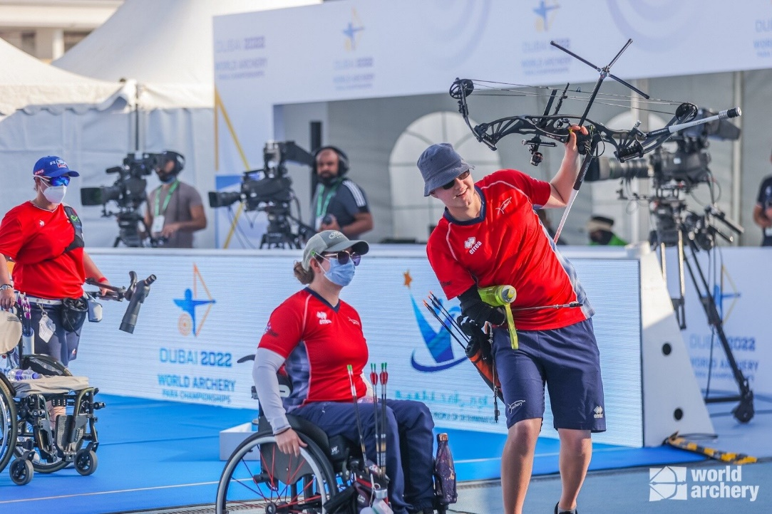

Images courtesy of World Archery and Archery GB.
Interviews available on request: archery@whitetigerpr.com
14 June 2023: Archery GB has announced an awe-inspiring team full of talent to take on the Para World Championships and European Championships in July and August of this year, respectively. Comprising of nine world-class athletes from all over Great Britain, who will have a vital shot at qualifying for the 2024 Paris Paralympic Games.
Featuring previous Paralympic gold and silver medallists, a world number one archer and a Recurve Men’s Open team comprising of both the youngest and oldest members of the squad, this team is truly showcasing Great Britain’s archery talent and the sport’s exceptional inclusivity.
Meet the Archers:
Compound Women
Jodie Grinham - Silver medallist at the Rio Paralympics.
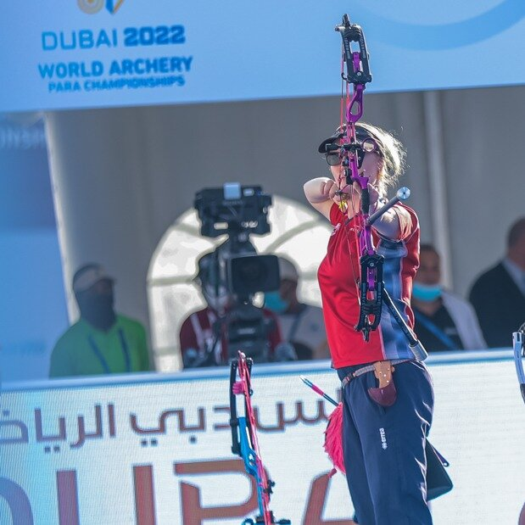
Jodie, 29 was born in Haverfordwest, Wales but grew up in Crawley. She was born with a condition called Brachysyndactyly, and after taking up archery in 2008 she has worked extensively with her dad to develop a way to shoot that allowed her to grip the bow. Her hard work has seen her achieve some amazing results including, winning silver at the Rio Paralympics Games in the Compound Mixed team event, where she was partnered with John Stubbs. With this impressive track record and determination, Jodie is a favourite for a place on the 2024 Paralympic squad. She won gold as part of the women’s doubles team at the European Para Cup in May, her first international competition since becoming a mum last year.
Phoebe Paterson- Pine (MBE) – World Number 1 and gold medal Paralympian.
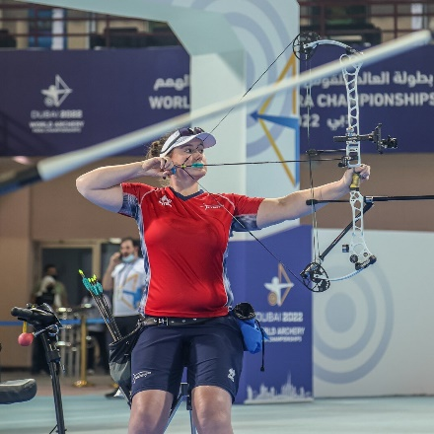
Currently ranked World Number 1 within the Compound Women Open category, 25-year-old Paterson-Pine won gold at her Paralympic Games debut in Tokyo and was awarded an MBE for her services to archery in 2022.
Phoebe who has spina bifida, first tried archery on a family holiday - enjoying it so much that she joined her local club. Having moved to Telford in 2019 from her family home in Cirencester, she is also a student at Worcester University, studying sports coaching science. She already holds multiple National, European and World records breaking five UK, European and World records over five days in 2022! Phoebe has achieved remarkable things, having already won gold with teammate Jamie Harris at the 2022 European Para Cup Final as part of the mixed team and bronze in the Compound Women individual event, she is sure to be one of the front runners at this year's events.
Jessica Stretton (MBE) - Gold medallist at the Rio Paralympic Games in 2016.
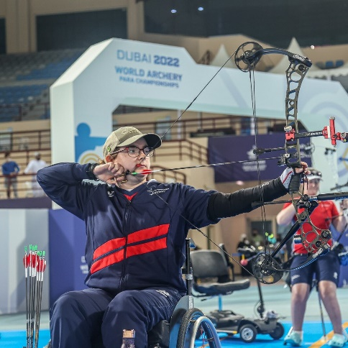
At just 16, Hemel Hempstead’s Stretton was the youngest archer competing at the 2016 Rio Paralympic Games and achieved a sensational gold medal in the Women’s Individual Compound W1. She has continued to secure exceptional success winning multiple medals and being awarded an MBE for her services to archery in 2017. Since Rio she has changed category and now competes in the Compound Open. Her achievements include claiming individual silver at the 2019 World Para Championships in the Netherlands and setting a new world record, winning bronze in the World Para Championships mixed team event alongside Jamie Harris and being part of the gold medal-winning mixed team at the European Para Archery Championships with Nathan Macqueen.
Compound Men
Jamie Harris - 3-time National Disability Champion and gold medallist at the European Para Cup Finals 2022.
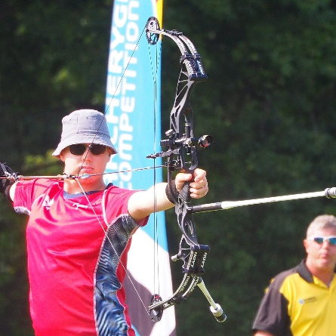
Jamie is one of the youngest on the World Class Programme Para Squad at 24 and first fell in love with archery at an event called 'Limb Power' in Stoke Mandeville 10 years ago. He went on to choose compound shooting which allowed him to develop a custom trigger release that attaches around his arm. Since beginning his archery career in 2013, Jamie has gone on to win a multitude of titles, such as: National Disability Championships, bronze at the World Para Championships, bronze at the Nove Mesto Para Archery European Cup and golds at the European Para Cup Finals.
Nathan Macqueen - Gold medallist at the European Para Archery Championships.

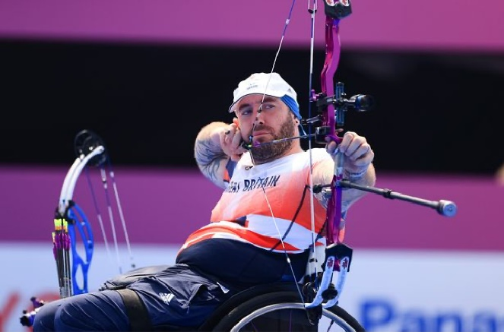

Nathan Macqueen is an experienced athlete, having previously competed nationally for Scotland’s archery team and playing rugby for Glasgow Warriors at Under 18 level. This athleticism has stayed with Nathan, even following a life-changing accident, which has since seen him become a devoted and invaluable member of the squad since 2016, just months before the Rio Paralympics. The 31-year-old from Dumfries, Scotland has won multiple medals at European and World Level, becoming part of the awe-inspiring team who led Great Britain to victory at the Rome 2022 European Para Archery Championships, as well as winning bronze as part of the men’s team with Jamie Harris. He took gold at the European Para Cup in May of this year.
Recurve Men
Dave Phillips - Silver in the Disability Championships and Bronze in the Men’s Recurve Open Event.
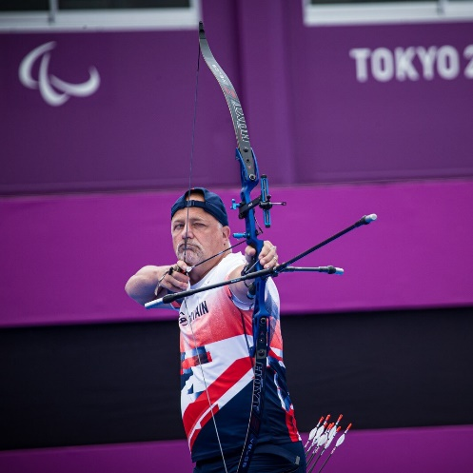
Dave first started archery back in 1978 and is currently the squad's oldest member, having previously taken a 30-year hiatus from his archery career, returning when he took up archery again following his MS diagnosis. He has represented his country on numerous occasions including the World Archery Para Championships, Para Archery European Cup Final, Para World Ranking Tournament and many more. As an ambassador for MS Cymru, he uses his platform to educate others and promote archery as an inclusive sport with huge benefits for disabled people. Dave, and his teammate Cameron, have set the bar this year and are aiming to reach new highs at the upcoming competitions.

Cameron Radigan - Bronze Medallist at the Disability Championships and Silver at the European Para Archery Championships.
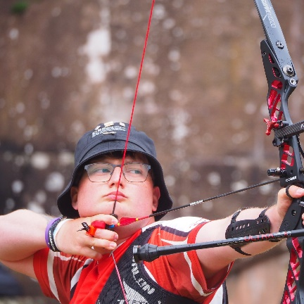
At just 21 years old, Cameron is the youngest member of the team, making his partnership with fellow archer Dave a special one, as the youngest and oldest competitors. Cameron made his debut at the Dubai World Championships in 2019 and has since gone from strength to strength in the Recurve category, picking up the Disability title back-to-back in 2019-2021. Radigan finished in second with teammate David Phillips in the double team event at the 2022 World Archery Para Championships. He won bronze at the Disability Championships 2022 and along with Dave Phillips also won bronze in the men's team event at the Para Archery European Cup and silver at the European Para Archery Championships.
W1 Women
Victoria Kingstone - Silver medallist at the European Para Championships in 2022 and Bronze in the Women W1 Open Competition.
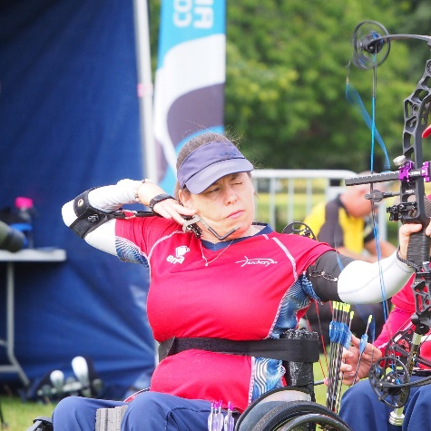
Victoria grew up in Rainham, Kent but now resides in Camberley, Surrey. Since dipping her toe into the sport of archery in 2017, she has earned medals at many events, notable ones including: Nove Mesto Para Archery European Cup, Rome 2022 European Championships and the European Para Cup Final. She is also a Global Athlete Mentor for the True Athlete Project and was previously a Supporter Engagement Executive at Queen Elizabeth’s Foundation for Disabled People.

W1 Men

Martin Saych - Gold Medallist in the Men’s W1 Open category at the European Para Archery Cup Finals.
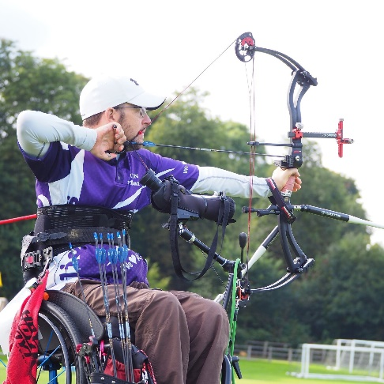

Martin is a 46-year-old data analyst from Ipswich, with an impressive history of sporting success, and many years of athletic experience. Since the beginning of his archery career in 2017, Martin has gone on to win a multitude of medals internationally in Mixed Team events and represented his country in Den Bosch in 2019. He won individual gold in the Men's W1 Open category at the European Para Archery Cup Finals as well as silver with teammate Victoria Kingstone in the W1 Mixed Team event. Last year he also successfully secured a bronze medal at the Disability Championships, as well as a silver medal in both the Para Archery European Cup and the European Para Archery Championships mixed events with teammate Victoria Kingstone.
- ENDS -
Media Contacts: White Tiger PR - Archery@whitetigerpr.com
Leanne Barton / Leanne.barton@whitetigerpr.com / 07568 925069
Rebekah Smith / rebekah.smith@whitetigerpr.com / 07840104801

About Archery GB
Archery GB is the British body for all forms of archery in the UK, an inclusive sport which lends itself to all spectrums of the population - regardless of age, disability or gender. With over 820 clubs and over 34,400 members, Archery GB is affiliated to World Archery, British Olympic Association & British Paralympic Association. More information www.archerygb.org. Beginners can visit www.startarchery.co.uk to find beginners’ courses and clubs near them and to learn more about the sport.

