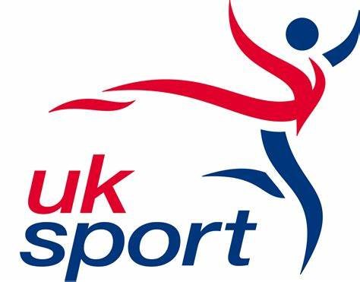
PARIS 2024: OFFICIAL OPENING OF £3.6M PERFORMANCE ARCHERY CENTRE
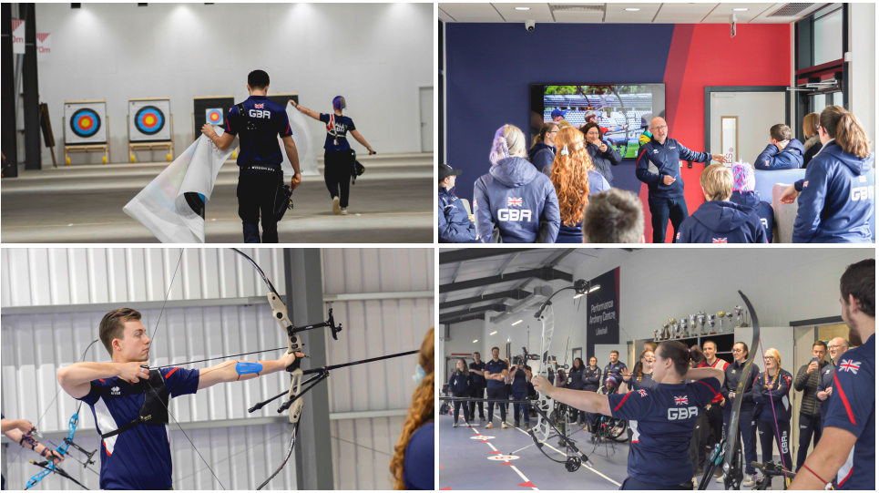
Photos: Credit Archery GB
EMBARGOED UNTIL 3PM ON MONDAY 22 APRIL 2024
A new Performance Archery Centre has officially opened at Lilleshall National Sports Centre, in Shropshire. The facility, funded by Sport England with support from UK Sport, will be used by Olympic and Paralympic archers as their daily elite training environment in the run up to the Paris 2024 Games. As the ‘Home of British Performance Archery’, Lilleshall also serves as a base for Talent Pathway athletes aiming to get onto UK Sport’s World Class archery programme and the National Compound Squad. Community activity including grassroots sport will take place at the centre as part of Sport England’s ‘Uniting the Movement’ strategy.
Representatives from the world of sport were invited along to the grand opening along with a local archery club which ran a taster session for school children to try archery and meet some of the athletes heading to Paris this year.
Archery GB have been based at Lilleshall for over 20 years. Previously Sport England funded the re-purposing of a sports hall and synthetic football surface as an archery facility. Over time the environment could not be further redeveloped to achieve the standards needed for a modern elite daily training environment. Adding a dedicated archery facility to Lilleshall’s onsite auxiliary facilities (elite athlete support services, catering, accommodation, conferencing and offices) means Lilleshall now provides a turn-key solution for all archery activities. The new facility features a 70m indoor and outdoor shooting range, enabling all-year-round shooting, changing rooms, coaching and training support areas, toilets as well as car and cycle parking. Facilities are on the same level and are fully inclusive and accessible.
The centre has a number of green initiatives including an array of south-facing solar panels on the roof along with additional battery storage to ensure the benefit is gained all year-round. Hot water is generated via air source heat pumps which are located externally to avoid the building requiring any kind of gas supply. The heat pumps ensure that the building increases its energy efficiency and reduces its carbon footprint.
Lisa Dodd-Mayne, Sport England Executive Director, Place, said: “This dedicated Archery Performance Centre will give elite archers the greatest opportunity to prepare and compete on the world stage.

“The centre provides talent development archers access to world class training facilities, whilst also making archery accessible to community groups and organisations and helping more people to enjoy the benefits of living active lives.

“We’re looking forward to seeing people from all backgrounds and communities coming together in this facility to enjoy archery activities. In aiming to inspire and attract a future generation of archers, it's been fantastic to see young children from local schools giving the sport a go this morning.”

Dr Kate Baker, UK Sport’s Performance Director, said: “We’re excited about the opening of the new centre, we think it can be a real game changer for our Olympic and Paralympic archers, both in the run-in to Paris and looking ahead to LA and Brisbane.

“The ability to have focused time on task in a world class daily training environment is a key part of any world class programme, which this new facility delivers with its combined indoor and outdoor ranges.

“The eco-friendly nature also aligns strongly with our sustainability strategy, our goal for sports to have a net positive impact on the environment by 2040 is boosted by it.”

The project was completed during the winter season to enable elite athletes the best possible preparations for this year’s Paris Olympic and Paralympic Games. The collaborative approach between Sport England, UK Sport, Serco and Archery GB to deliver this facility means Archery GB remains a long-term key partner at Lilleshall. The sport’s National Governing Body have relocated into new offices on the site to enable staff to have a permanent base close to the new performance centre.
The athletes moved into the new centre in early December with four of them chosen at random to shoot the first arrows. The first indoor arrows were shot by Olympian Tom Hall and Para archer Jamie Harris. The first outdoor arrows were shot by Paralympic champion Phoebe Paterson Pine and World Class Programme athlete Alex Wise.
Today’s official opening saw the naming of the indoor range in honour of Margaret Maughan, a trailblazer of the Paralympic movement. The new outdoor range pays tribute to Simon Terry, the first British archer to win two medals at an Olympic Games.
Tom Duggan, Archery GB’s Performance Director, said: “We wanted to name the two ranges after Margaret Maughan and Simon Terry. Margaret Maughan was our first ever British Paralympic gold medallist at the 1960 Paralympic Games and Simon Terry was one of our most successful Olympic athletes, winning an individual and team medal in Barcelona in 1992, so we thought it was fitting to recognise their contribution to the sport and the programmes that they were a part of and which have enabled us to develop this centre and the programmes that we’re leading now.”
Paralympian Nathan Macqueen said: “It’s just amazing, I truly believe its probably the best facility in the world for archery and that it belongs to us is just amazing. It was just like Christmas come early (to get a first look inside). I could have pinched myself to be shooting out there. Its going to be a good building block for everything going on for the future of archery in Britain.”
The new meeting room is named ‘Los Angeles’ after the next Games set to follow Paris in 2024.
Tom Duggan said: “It was really important to us that while this is what we do in the moment now as we build to Paris, we also want to keep an eye on the horizon for LA. This is about a long-term project in terms of how we realise our potential in both Paris and the LA cycle so we thought it was fitting that the room where we will meet to discuss how we execute the strategy and how athletes are on track to the future, will be recognised by calling that the Los Angeles room.”
Olympian Bryony Pitman said: “I think there’s an element of us being able to shoot with the compound Paras, their recurves being able to shoot with us, it’s something that can benefit everybody and help everybody progress but also just making us part of one big team rather than two separate programmes. It’s really exciting and I’m really looking forward to getting stuck in!”
Tom Duggan added: “I’d like to thank Sport England, UK Sport and Serco for the opportunity to create a purpose-built Performance Archery Centre and to Speller Metcalfe and Abacus for the work that they did in helping us build the centre.”
Steve Nelson, Serco Operations Director said: “As operators of Lilleshall National Sports Centre since 2011, we have supported Archery GB for well over a decade, during which time we have built a strong collaborative relationship.
“We’re delighted to see this project come to fruition for Archery GB and all the athletes it supports, who will be benefitting from this incredible new performance centre.”
Rob Lashford, Divisional Director at Speller Metcalfe, said: “We’re delighted to have handed over the new archery centre to Sport England, Archery GB and the athletes. This project has been a success from start to finish and we know that it will support our athletes in their success going forwards.”
Lilleshall National Sports Centre is owned by the Sports Council Trust Company, a subsidiary of Sport England.

-Ends-
Notes to Editors:
Hi-res images and video can be downloaded here
Media Contacts
emma.kasprzak@archerygb.org
Athlete biographies
You can read all about the members of the GB squad by clicking this link Each athlete has a profile page where you can read about their achievements, match statistics and more.
About Archery GB
Archery GB is the British body for all forms of archery in the UK, an inclusive sport which lends itself to all spectrums of the population - regardless of age, disability or gender. With over 800 clubs and over 38,300 members, Archery GB is affiliated to World Archery, the British Olympic Association and the British Paralympic Association. More information www.archerygb.org Beginners can visit www.startarchery.co.uk to find beginners’ courses and clubs near them and to learn more about the sport.
About Sport England
Sport England is a public body and invests up to £300 million National Lottery and government money each year in projects and programmes that help people get active and play sport. It wants everyone in England, regardless of age, background, or level of ability, to feel able to engage in sport and physical activity.
About UK Sport
UK Sport is the nation’s high-performance sports agency investing in Olympic and Paralympic sport. Its mission is to work in partnership to lead sport in the UK to world class success.
Primarily this means working with our partner sporting organisations to deliver medals at the Olympic and Paralympic Games. UK Sport funds the athletes who are part of the World Class Programme who compete and represent GB on the world stage.

Cribsheet on British archery

Simon Terry

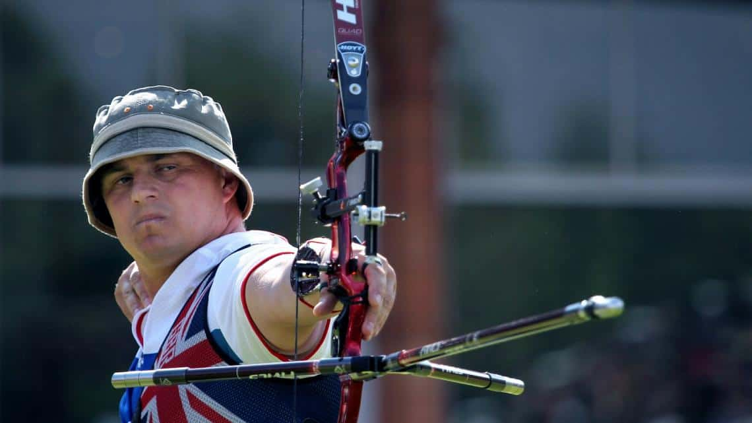
Photo credit: Archery GB
The new outdoor range pays tribute to Simon Terry, the first British archer to win two medals at an Olympic Games. Simon took bronze in both the men’s individual and men’s team events at the 1992 Barcelona Games. After his wins he took a break, spending his time driving a lorry and racing motorbikes. He returned to competitive archery in 2005, appearing at Beijing 2008 and London 2012. Simon died in 2021 at the age of 47 with tributes paid from across the archery community who remember him as an icon of the sport.
Simon Terry | Team GB

Margaret Maughan

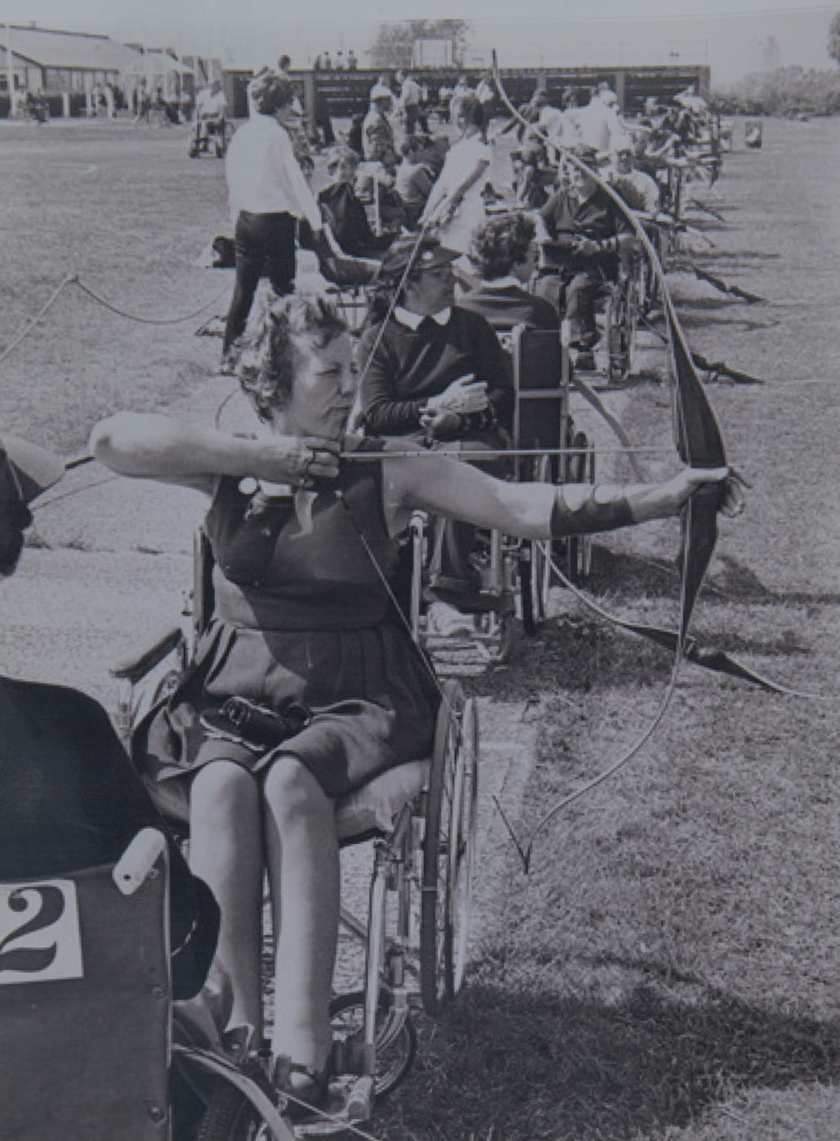
Photo credit: Wheelpower
The indoor range is named in honour of a trailblazer of the Paralympic movement, GB archer Margaret Maughan. Margaret won Great Britain’s first ever Paralympic gold medal at Rome 1960, the first Paralympic Games. She competed in a total of five Games in archery, swimming, dartchery and bowls. She remained a fervent advocate of the power of sport for disabled people and her pioneering status meant she was invited to light the cauldron at the opening ceremony of the London 2012 Paralympic Games at a packed stadium.
Margaret was paralysed from the waist down in a road accident in Malawi in 1959. She returned to Britain and was treated at the National Spinal Injuries Centre at Stoke Mandeville Hospital by Dr Ludwig Guttmann who pioneered the use of sport in therapy and is acknowledged as the founder of the Paralympic Games. During her rehabilitation, Margaret took up archery and joined an archery club. She went on to compete at the 1960, 1968, 1972, 1976 and 1980 Paralympic Games. Margaret passed away at the age of 91 in 2020.
ParalympicsGB | 1928 - 2020: margaret maughan

Performance Archery

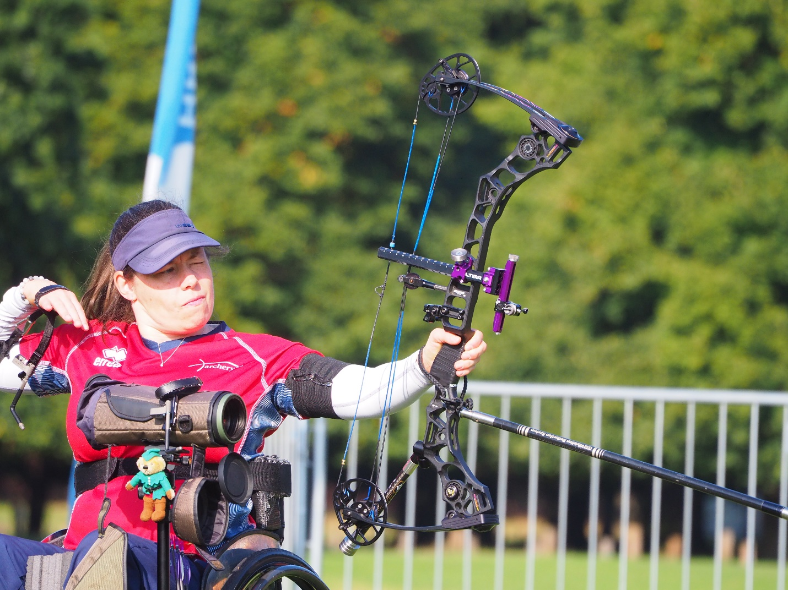
Photo credit: Archery GB
Archery GB champions archery on the world stage and supports all our archers to reach their full potential from grassroots level to the Olympic and Paralympic podiums. We administer and deliver a World Class Programme for athletes with medal potential who are selected to represent Great Britain on the world stage. The programme is funded by UK Sport and enables Olympic and Paralympic archers to train and develop at a world class facility at Lilleshall National Sports Centre, in Shropshire.
The main events for Archery GB are the Olympic and Paralympic Games but throughout each four-year Games cycle there are a number of milestone events such as the World and European Championships, as well as key events on the international programme including World Cups, World Ranking Events and Grand Prix events. Archery GB also supports teams at international events across other archery disciplines; Compound, Field and 3D Archery.

Performance Development Pathways

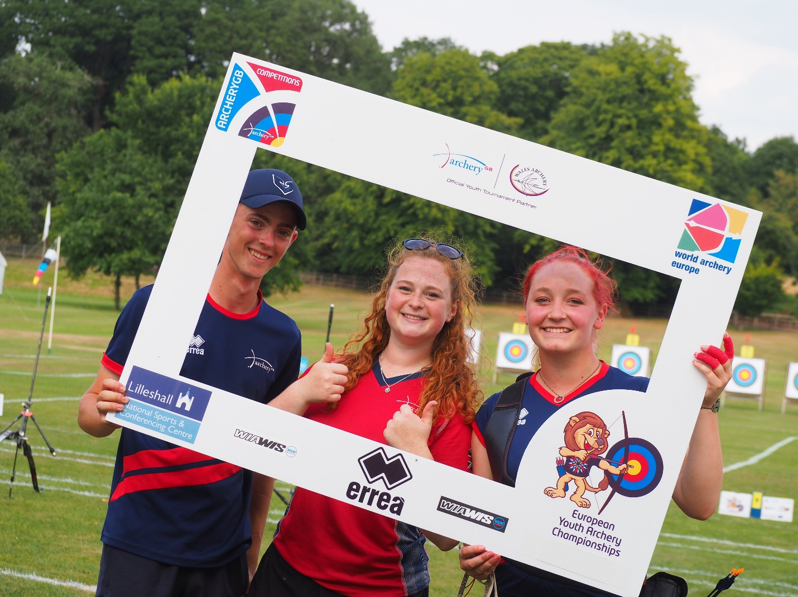
Photo credit: Archery GB

Archery GB’s pathways aim to develop world class archers for the international stage. The purpose of the Performance Pathways is to identify, nurture and prepare athletes to realise their potential as performance archers, competing against the world's best. There are three Performance Pathway programmes to support archers in their chosen discipline. You can find out about each programme via the links below:
Archery GB Olympic Performance Pathway | Archery GB
Paralympic Performance Pathway (archerygb.org)
Archery GB Compound Pathway | Archery GB

Project Rimaya

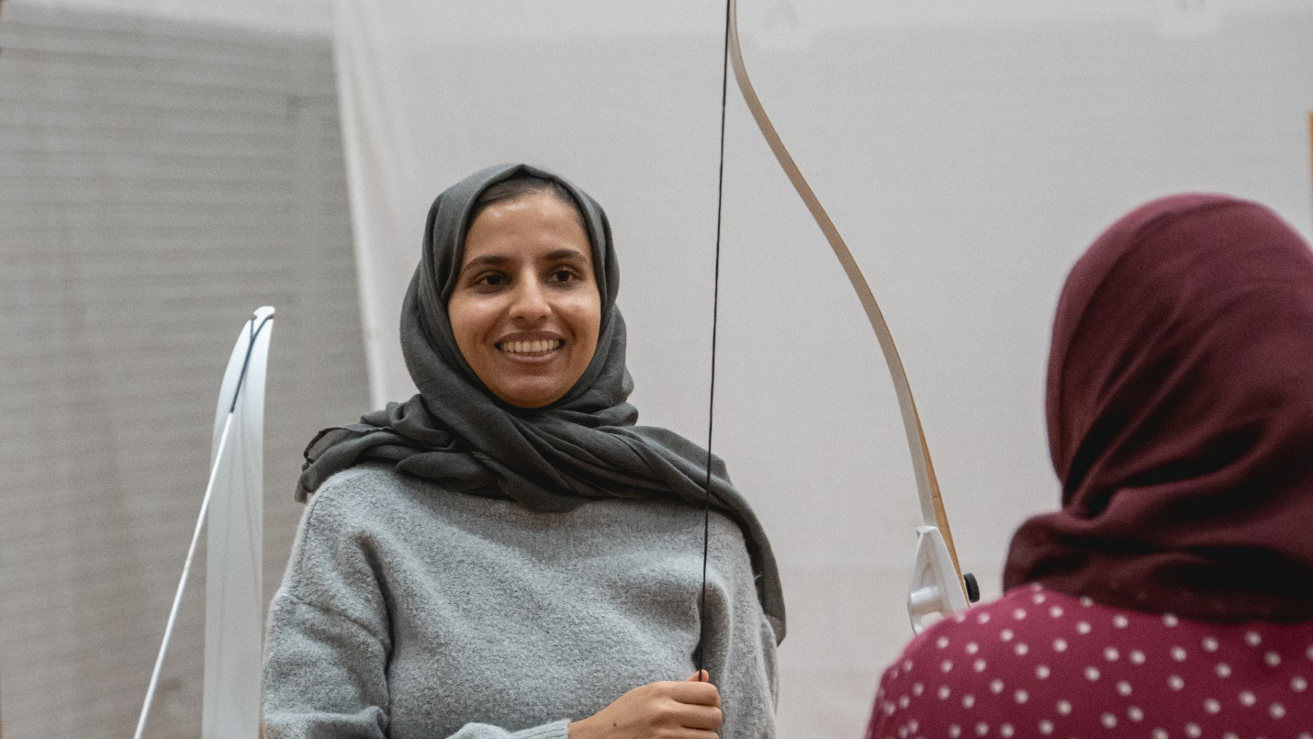
Photo credit: Archery GB
Opening doors to ethnically diverse communities, empowering Muslim communities to learn and grow through the sport of archery. Project Rimaya (the Arabic word for archery) was developed by Archery GB with funding from SportsAid to work with Muslim communities and increase accessibility to a sport which is significant to them. Archery has a long and rich history in Islam, and the sport is helping Muslim communities to feel inspired and united, supporting their physical, mental and spiritual wellbeing.
Project Rimaya is a SportsAid-funded initiative which launched in 2018 at Eden Girls’ School in Coventry, Ninestiles Academy and Small Heath Leadership Academy in Birmingham. The project has since grown significantly, and we now have Rimaya partnerships across the country.
Project Rimaya | Archery GB

Soft Archery – Arrows

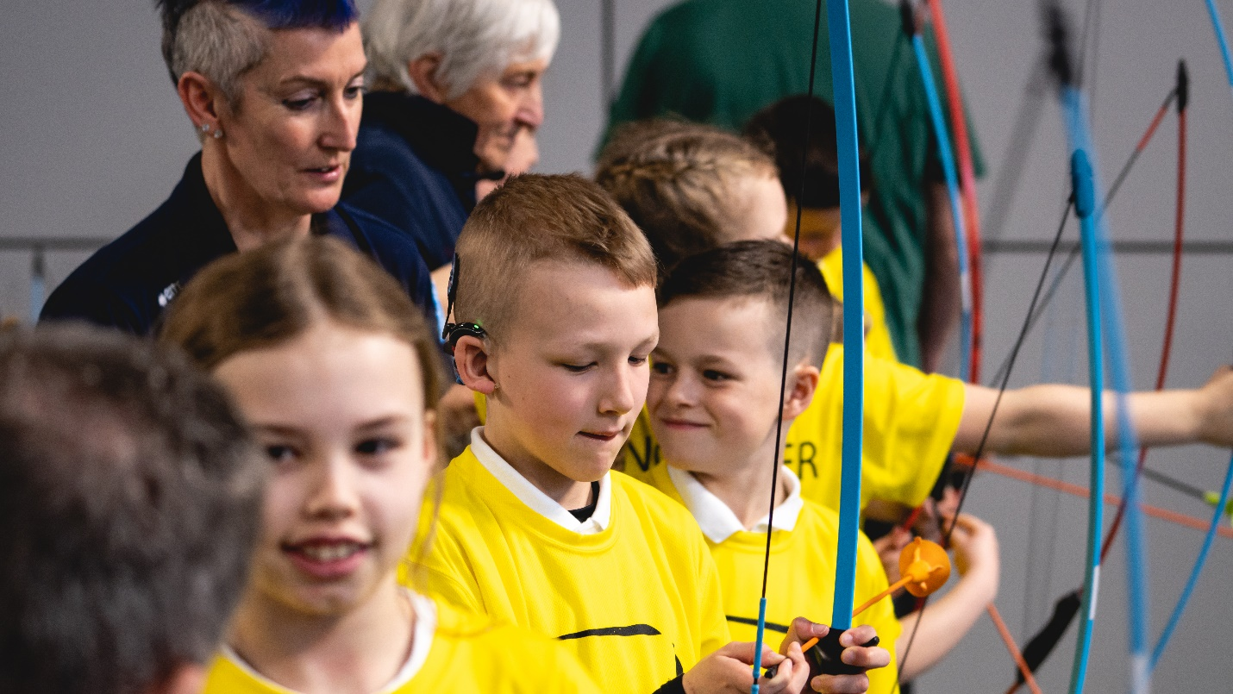
Photo credit: Archery GB
Soft archery is a safe and fun way to introduce the joy of archery in schools, care homes, kids’ clubs or to anyone who cannot make it to their local range. Using soft tipped arrows, Arrows Archery participants learn new skills in a safe environment, working on building strength and coordination while having fun doing something a little out of the ordinary.
We created Arrows Archery for primary schools to introduce young children to archery in a fun and safe way. The equipment and resources provided make it easy for teachers to deliver archery in almost any school environment and it is quick and easy to set up.
Soft archery uses arrows fitted with child-friendly suction cups to use in PE lessons, across the curriculum, in out-of-hours clubs and as part of School Games and sports days.
Soft Archery - Safe & Fun for Everyone | Archery GB

Start Archery Week

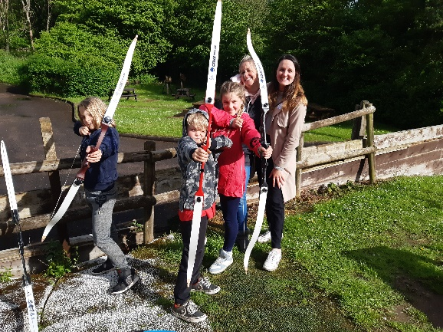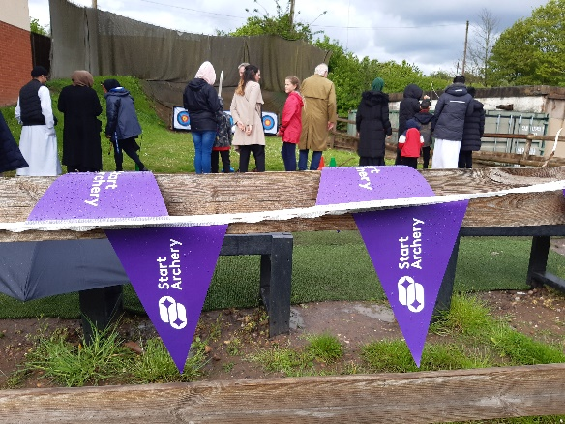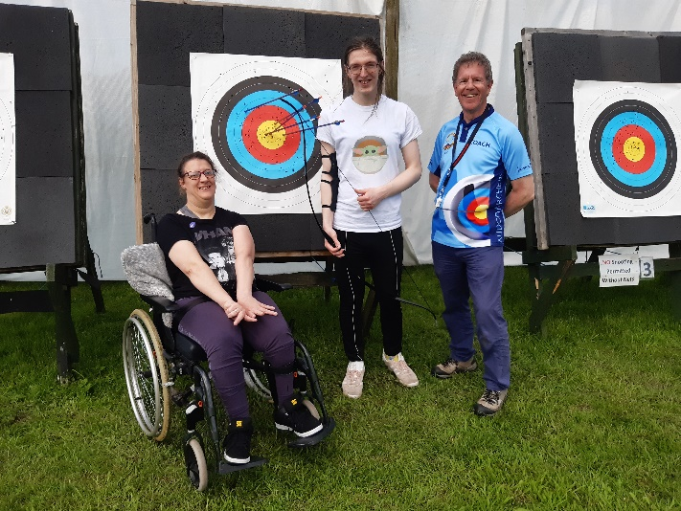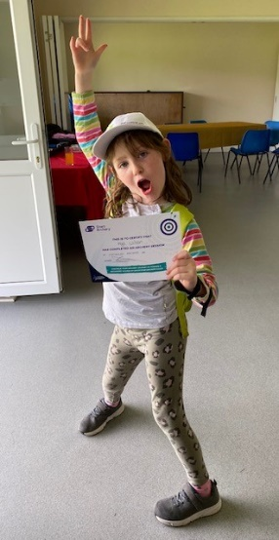

Photo credit: Archery GB
Start Archery Week gives people all over Great Britain and Northern Ireland the chance to try archery for the first time. This year, Start Archery Week will take place from 4-12 May. This year’s event is themed around mental health as we share some incredible personal stories of how our sport has benefited people’s minds as well as their bodies. We will also be looking ahead to Paris 2024 with Games themed celebrations and activities.

Over the course of the week, clubs and other providers will throw open their doors and welcome people of all ages to come and give the sport of archery a go. Visitors of all abilities and ages will be able to have a go at archery, delivered by our amazing team of qualified archery coaches and volunteers. There are no limits to who can do archery – it is for everybody regardless of physical ability. It also has numerous health and wellbeing benefits and is well documented as a confidence-boosting sport. Just give it a go!
