WELSH ARCHERY CLUB SETS UP FUNDRAISER
FOR UKRAINIAN ARCHER
- Perriswood Bowmen supports 20-year-old Ukrainian refugee with fundraising campaign
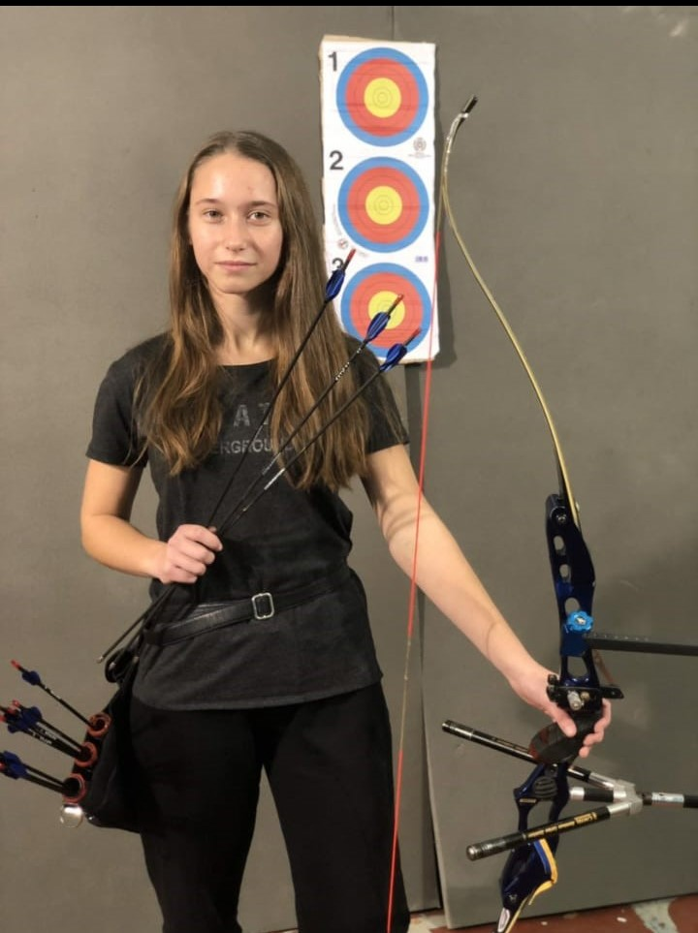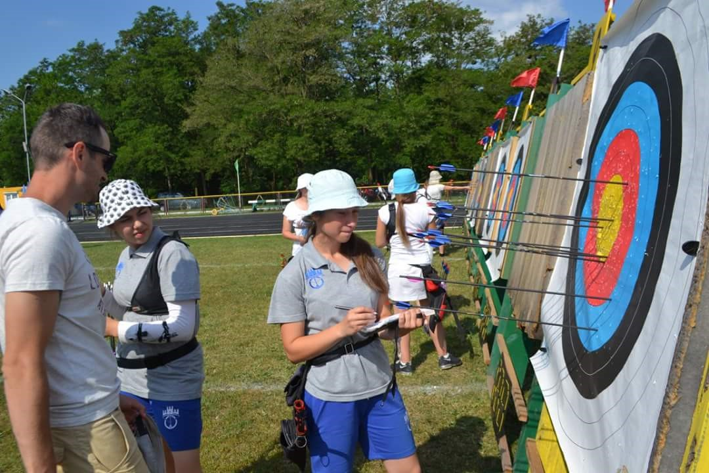
(Image credits: Kate Andrusenko)
XX August 2022: A Welsh archery club has launched a GoFundMe campaign to support a young Ukrainian archer who had to leave many of her belongings, including her archery kit, behind when she fled the war in Ukraine.
Perriswood Bowmen, located near Oxwich on the Gower, has launched the fundraising campaign with the aim of raising enough money to help 20-year-old Ukrainian Kate Andrusenko continue her archery training and return to competing at the same level she did in her home country.
The fundraiser has a target of £2,100, which will help Kate purchase the equipment she needs and restart her archery career, here in the UK.
20-year-old Kate Andrusenko is currently being hosted by a family near Swansea. Since arriving in the UK, Kate, who first started archery aged 11, has joined Perriswood Bowmen, who have supported her return to the sport.
Of the support Perriswood Bowmen has provided to date, Kate said: “Since arriving in Wales, the archery club at Perriswood, Gower have been extremely kind and helpful in enabling me to regain a level of practice but also more importantly, have given me a sense of normality, of the life I had back home.
“I am eager to re-start training at the level of which I enjoyed back in Ukraine, and to hopefully compete here in the UK. I wish to be able to continue regular practice and competitions here, so that when I return to Ukraine, I can continue my dream to join the Ukrainian National Team and take part (and win!) national and international competitions.”
Simon Browning of Perriswood Bowmen said: “Kate's displacement from her home meant she had to leave all but the essentials behind her. She is settling into Welsh life but misses the discipline of training and being involved in competition. As a club we wanted to help her get back to the sport she loves, which is why we’ve launched this fundraiser.
“Kate's great passion is archery, a sport she uses for mental and physical health. We hope to be able to provide equipment to replace the bow, arrows and other equipment that she was forced to leave behind when she fled her country. As a club and community we truly want to support her in re-engaging with the sport and help her regain a sense of normality and happiness.”
Those wishing to support this fundraising campaign can donate here: https://www.gofundme.com/f/kate-andrusenko-restart-her-archery-career

-ends-
Notes to Editors

Hi-res images are available here:

Media Contacts: White Tiger PR - Archery@whitetigerpr.com
Leanne Barton / Leanne.barton@whitetigerpr.com / 07568 925069
Kimberley Powles / kimberley.powles@whitetigerpr.com / 07966 867827

About Kate Andrusenko
Before fleeing the war in Ukraine, Kate lived with her mother in the town of Chernivtsi, where she was studying for her degree in hospitality management at the The Chernivtsi Trade and Economics Institute. She has been able to complete her third year online, and hopes to be able to complete her fourth and final year online also.
Kate first became interested in archery when her school hosted a demonstration by archery coach Dmytro Chebotarenko and within a month joined her local club. For the next nine years, she was coached by Chebotarenki and National Ukrainian Coach Oleg Osypenko, competing in a range of local and national competitions.

Kate has enjoyed a range of successes throughout her archery career, including coming second in cadets team category of the Archery Championship of Ukraine and 1st place in the younger cadets category at the Indoor Championship of Ukraine.

About Perriswood Bowmen

Perriswood Bowmen formed in 2003 and is based at, but independent of, the premises of Perriswood Archery and Falconry Centre, near Oxwich on the Gower. The club has both indoor and outdoor ranges, allowing club members to shoot 365 days of the year.

The club has 27 permanent members. All ages and abilities are welcome and its membership includes those with disabilities.

Club members compete at local, county and regional tournaments in Wales and England. Members have represented the Glamorgan Team at the Welsh Archery Association’s Inter-county tournament, at The Masters in Lilleshall, and at The Invictus games in Toronto, winning Gold.

About Archery GB
Archery GB is the British body for all forms of archery in the UK, an inclusive sport which lends itself to all spectrums of the population - regardless of age, disability or gender. With over 820 clubs and over 34,400 members, Archery GB is affiliated to World Archery, British Olympic Association & British Paralympic Association. More information www.archerygb.org. Beginners can visit www.startarchery.co.uk to find beginners’ courses and clubs near them and to learn more about the sport.

