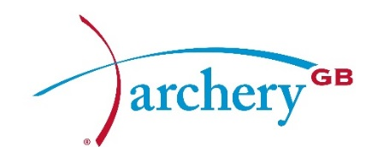

Summary of the Board of Directors’ Meeting

Saturday 18 & Sunday 19 July 2015
Conference Room, Lilleshall National Sports & Conferencing Centre, Newport.
Commencing 13.30 – 18 July

Present: | David Harrison | Chairman
 | David Sherratt | Chief Executive
 | Neil Armitage  Simon Cordingley  Mark Davies  Muriel Kirkwood  Bob McGonigle | Independent Director  Co-opted Director  Independent Director  Elected Director  Elected Director
 | Geoff Malyon | Elected Director
 | Chris Mortlock  Julie Ryan  Alan Willsher  Bryan Woodcock | Independent Director  Elected Director  Elected Director  Elected Director
In attendance: | Derrick Lovell | President
 | Susan Walford | Minute Taker
 | David Tillotson (in part)  Wendy Stead (in part)  Jane Purdon (in part)  Sacha Zarb (in part) | Performance Director  Finance Manager  Head of Governance – UK Sport  NGB Relationship Manager – Sport England

Apologies
No apologies were received.

Overview
This was a very busy meeting beginning with the Election of the Chairman of the Board. Two new Independent Directors also joined the Board, Neil Armitage and Mark Davies. The Board was joined in part by Jane Purdon - Head of Governance – UK Sport and Sacha Zarb – NGB Relationship Manager – Sport England, who talked about expectations of UK Sport and Sport England for the next funding cycle. David Tillotson, Performance Director gave an update on Performance and Wendy Stead, Finance Manager, answered questions around finance.

Election of the Chairman of the Board
Dave Harrison was voted in to continue as Chairman until the end of the 2016 AGM. Mark Davies was voted in as Chairman Elect to work alongside Dave Harrison and take over as Chairman of the Board following the 2016 AGM.

Departmental Updates
Reports were received from the Nominations Committee, Chief Executive and Finance Manager.

Subjects Discussed
Items from within the reports included the World Archery Europe 2016 Europeans Championships and the Operations Committee meeting.

Budgets
Wendy Stead presented the Budgets for 2016.

Board

Other items discussed were the appointments to Board Committees (Nominations, Audit and Remuneration), with the Audit Committee to be known as the Audit & Risk Committee. Suggestions from the Nominations Committee regarding Board Succession Planning and the process for the Election of the Elected Directors due at the 2016 AGM were considered. Directors’ review and guidance forms, Company Secretary, the Annual Self Assurance Return, the World Archery 2019 World Championships Bid and NI matters were also deliberated along with the Risk Register and Policy Register.

Terms of Reference
The Terms of Reference for the Nominations Committee were considered.

Strategic Plan and Business Plan
The Board was updated on the next stage of the Strategic Plan and Business Plan following meetings involving Heads of Departments, the Board and Operations Committee Chairman.

Next Meeting
The next scheduled Board meeting will take place on the Saturday 17 October 2015 at Lilleshall.

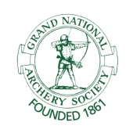 | Archery GB is the trading name of the Grand National Archery Society, a company limited by guarantee no. 1342150 Registered in England.

