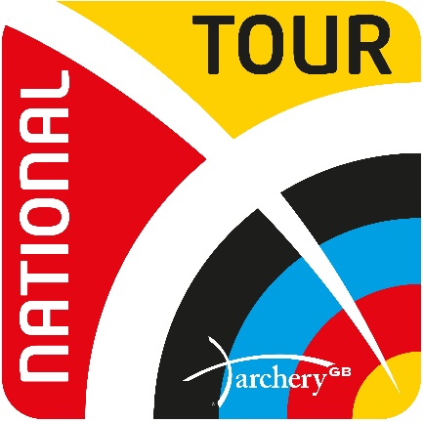
Archery GB National Tour Hall of Fame
Grand Final Champions of National Series 2009 – 2016 National Tour 2017 – 2023
 |  | 2009  Lilleshall | 2010  Leamington |  | 2011  Liverpool |  | 2012  Oxford |  | 2013  Nottingham |  | 2014  Nottingham |  |  | 2015  Nottingham | 2016  Nottingham | 2017  Birmingham | 2018 Lilleshall | 2019 Caldicot | 2020  Lilleshall | 2021 Lilleshall | 2022  Nottingham | 2023  Nottingham
RW |  | Charlotte Burgess | Naomi Folkard |  | Charlotte Burgess |  | Alison Williamson |  | Amy  Oliver |  | Amy  Oliver |  |  | Naomi Folkard | Nichola Turner | Naomi Folkard | Bryony Pitman | Jaspret Sagoo | Bryony Pitman | Penny Healey | Penny Healey | Penny  Healey
RM |  | Simon Terry | Simon  Terry |  | Simon  Terry |  | Larry Godfrey |  | Alan  Wills |  | Larry Godfrey |  |  | Patrick Huston | Patrick Huston | Patrick Huston | Alex  Wise | Tom  Hall | Tom  Hall | Patrick Huston | Patrick Huston | Tom  Hall
CW |  | Lucy O'Sullivan | Nichola Simpson |  | Lucy O'Sullivan |  | Christie Westman |  | Dani  Brown |  | Naomi Jones |  |  | Nichola Simpson | Lucy  Mason | Sarah Prieels | Jacquie Holmes | Ella  Gibson | Bayley Sargeant | Layla  Annison | Ella  Gibson | Lizzie  Foster
CM |  | Duncan Busby | Chris  White |  | Chris  White |  | Adam Ravenscroft |  | Michael Cauwe |  | Adam Ravenscroft |  |  | Neil Bridgewater | Neil Bridgewater | Adam Ravenscroft | James Mason | James Mason | Adam Carpenter | Adam Carpenter | Adam Carpenter | James Mason

