BRITAIN’S BEST TO BATTLE IT OUT IN ARCHERY GB’S NATIONAL INDOOR CHAMPIONSHIPS
- Around 55,000 arrows are expected to be shot during two days of competition for both juniors and seniors at Stoneleigh Park, Warwickshire
- A total of 888 archers will be taking part, with the oldest competitor aged 71 and youngest just 8
- Grassroots archers will be lining up against some of the best archers in the world
- Tournaments will round off Archery GB’s most successful season in recent history
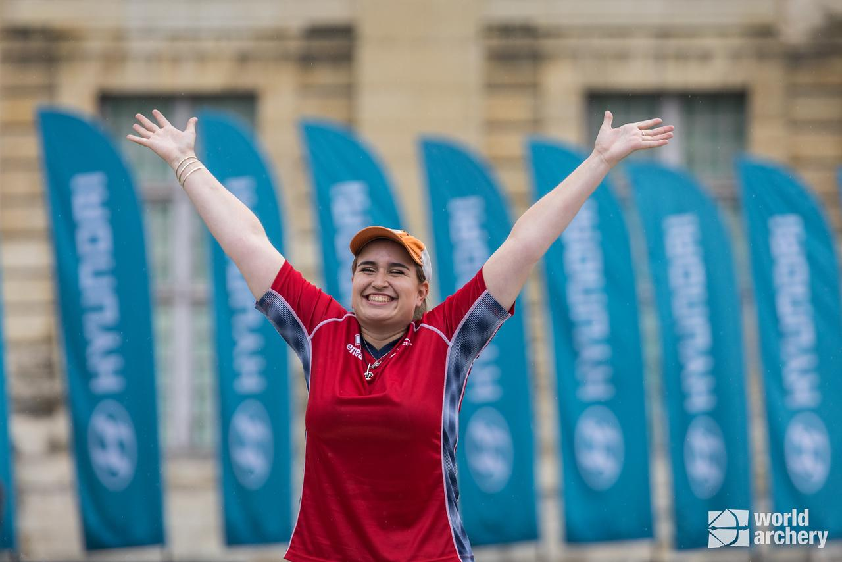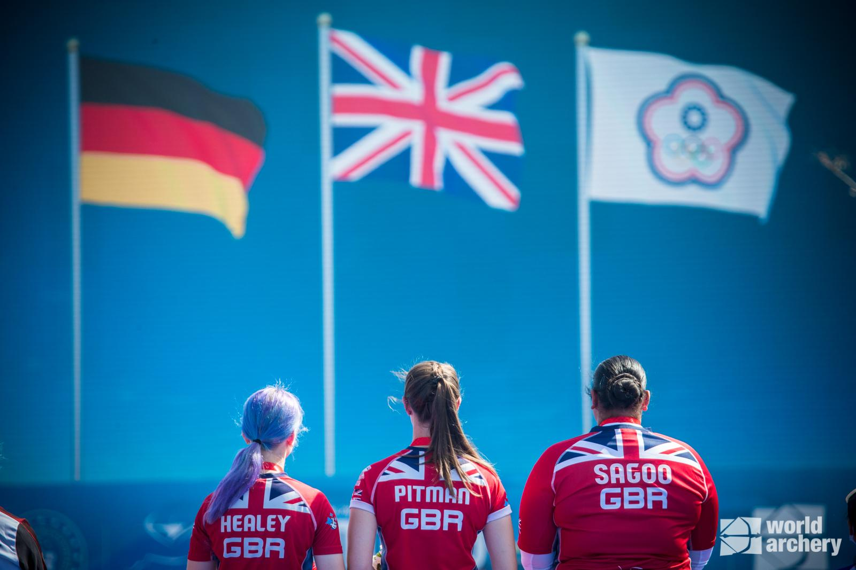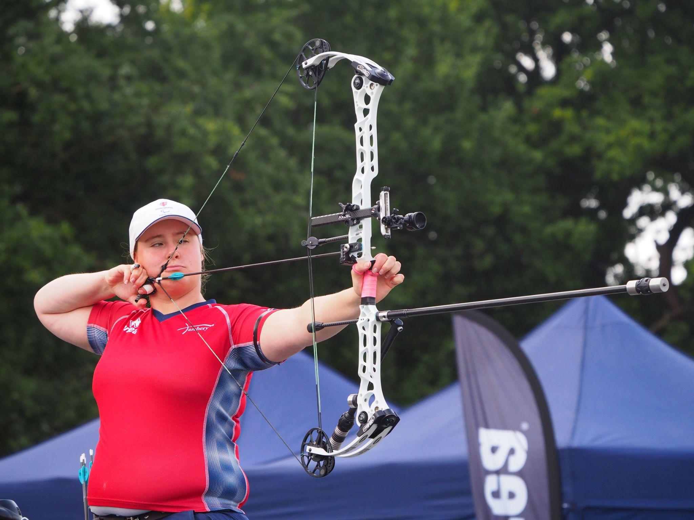
Left to right: Ella Gibson; Penny Healey, Bryony Pitman and Jaspreet Sagoo; Phoebe Paterson-Pine.
(Image credits: (l-r) World Archery, World Archery, Archery GB)
25 November 2022: Hundreds of archers will be battling it out next weekend in one of the largest indoor competitions of the year.
The National Indoor Championships will be taking place on Saturday, December 3 at Stoneleigh Park, Warwickshire, and the event is one of the few times in sport that grassroots competitors are able to line up and take part alongside archers who are ranked number one in the world.
The championships will feature competitions in the categories of Recurve, Barebow, Longbow and Compound. Among the competitors will be women’s compound world number one Ella Gibson, women’s compound European Champion Izzy Carpenter and recurve archers Penny Healey and Bryony Pitman, who came away with gold medals at this year’s World Cup stages. Also taking part will be Dutch archer Mike Schoesser, who is ranked number one in the world for men’s compound.
The Junior National Indoor Championships takes place the day after at the same venue on Sunday, December 4. Juniors compete in age groups for Under 21s, Under 18s, Under 16s, Under 15s, Under 14s, and Under 12s in Recurve, Barebow, Longbow and Compound.
With 888 archers registered to take part, it is expected that a staggering 55,000 arrows will be shot over the weekend.
Jon Nott, events manager for Archery GB, said: “It is not often in sport that grassroots competitors get the chance to line up against world number ones, but the Junior and National Indoor Championships provides that opportunity.
“It’s an exciting event that really showcases archery’s inclusivity, with people of all ages competing under one roof.”
An incredible 2022 season for GB Archers
The tournaments will cap off a brilliant year for GB archers.
It has been the most successful summer for GBR in recent history, not just on the international scene, but on the World and European record scene.
From smashing multiple world records to having the strongest season in the Hyundai Archery World Cup for a long-time, it all sets the scene for what is going to be an exciting road to Paris 2024 for archery.
-ends-
Notes to Editors

Media Contacts: White Tiger PR - Archery@whitetigerpr.com
Leanne Barton / Leanne.barton@whitetigerpr.com / 07568 925069
Kimberley Powles / kimberley.powles@whitetigerpr.com / 07966 867827

About Archery GB
Archery GB is the British body for all forms of archery in the UK, an inclusive sport which lends itself to all spectrums of the population - regardless of age, disability or gender. With over 820 clubs and over 34,400 members, Archery GB is affiliated to World Archery, British Olympic Association & British Paralympic Association. More information www.archerygb.org. Beginners can visit www.startarchery.co.uk to find beginners’ courses and clubs near them and to learn more about the sport.

