Deer Park Archers are proud to host the second series of 3 fully inclusive events - The Deer Park Archers Inclusion Series 2025-6. |  | 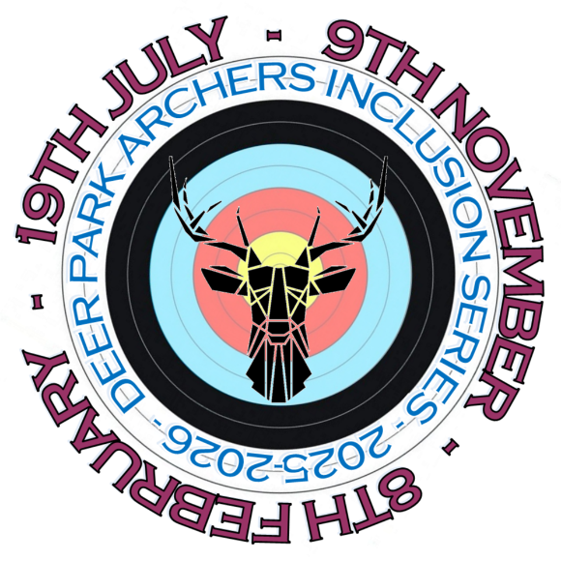
Event 1 - Indoor | Event 2 - Indoor |  | Event 3 - Outdoor
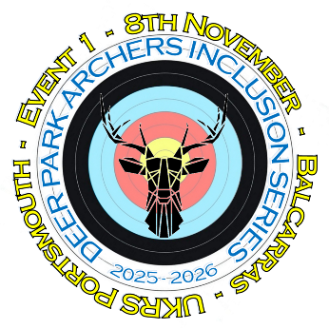 | 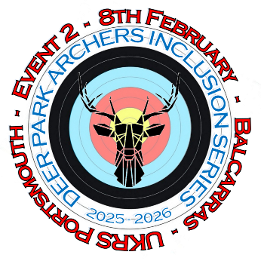 |  | 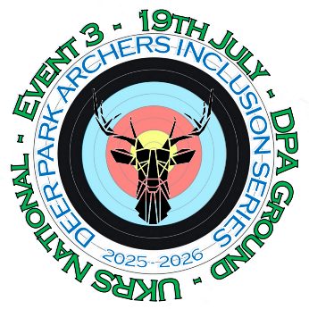
9th November 2025 | 8th February 2026 |  | 19th July 2026
UKRS  Portsmouth | UKRS  Portsmouth |  | UKRS  National
Balcarras School, Cheltenham | Balcarras School, Cheltenham |  | Deer Park Archers Ground, Shurdington

Each event will run as a separate competition with medals awarded in each category.
Events 1 & 2 will also serve as qualification, setting a handicap which the archers will be compared to for Event 3 with the best comparative performance being awarded the Inclusion Series Championship Title.
Only archers with a disability are eligible for The Inclusion Series Awards.
Each event will only open to archers with a disability initially with open sale of remaining places beginning around 6 weeks before each event.
Archers with a disability, contact the T.O. at petersissondpa@gmail.com for the password to enter now.  Book at https://bookwhen.com/dpaopenevents or scan the QR code | 

