EIGHT MEDALS FOR GB ARCHERS AT EUROPEAN PARA ARCHERY CUP FINALS IN NOTTINGHAM
- GB archers secure three gold, one silver and four bronze in international finals
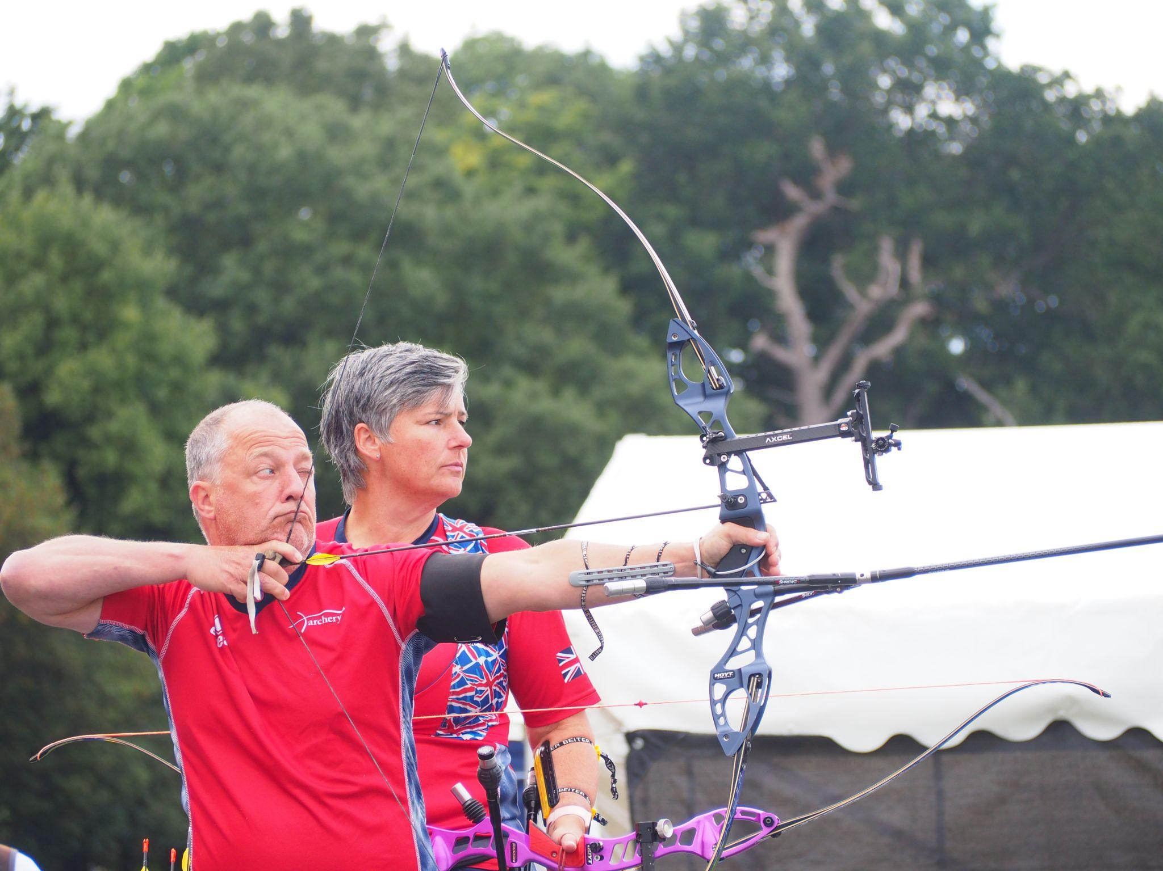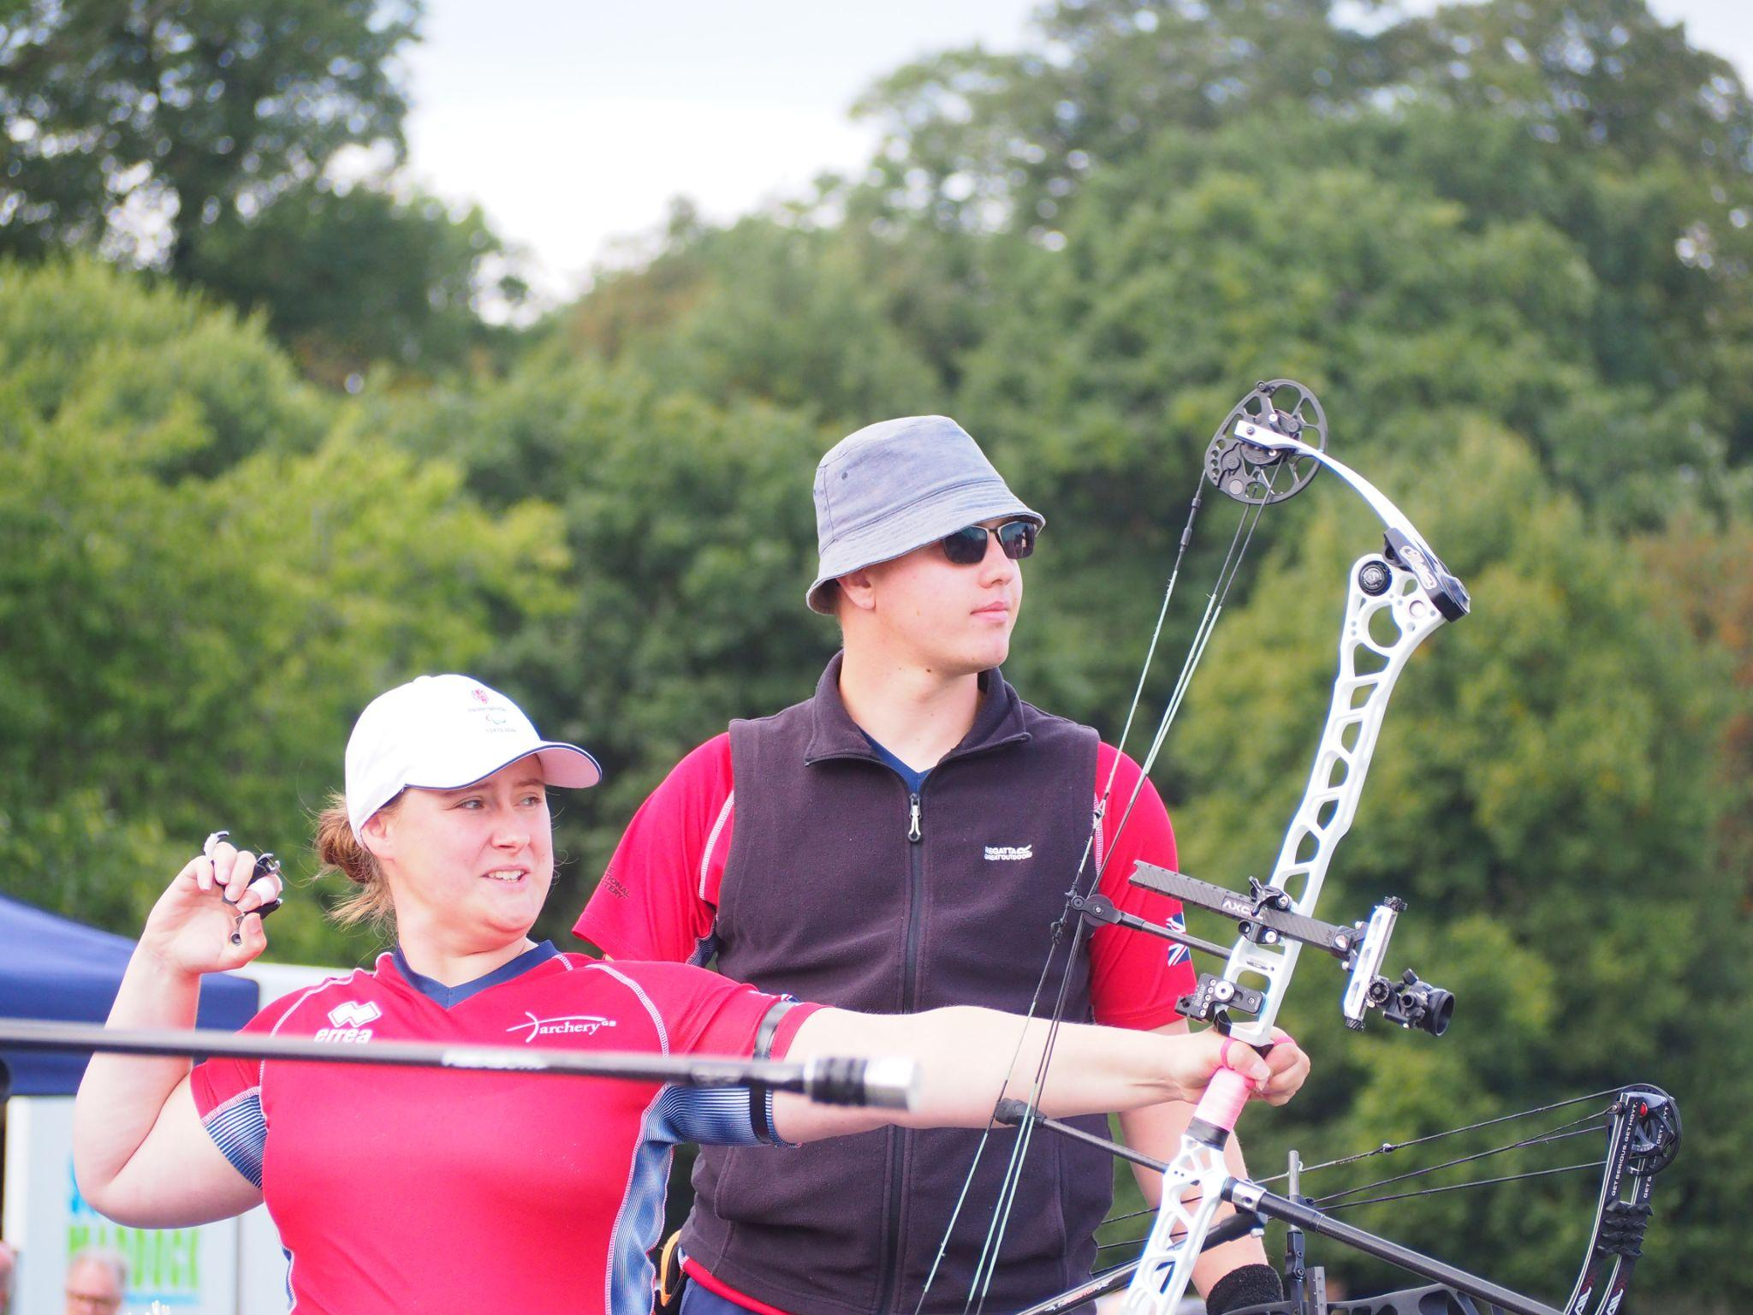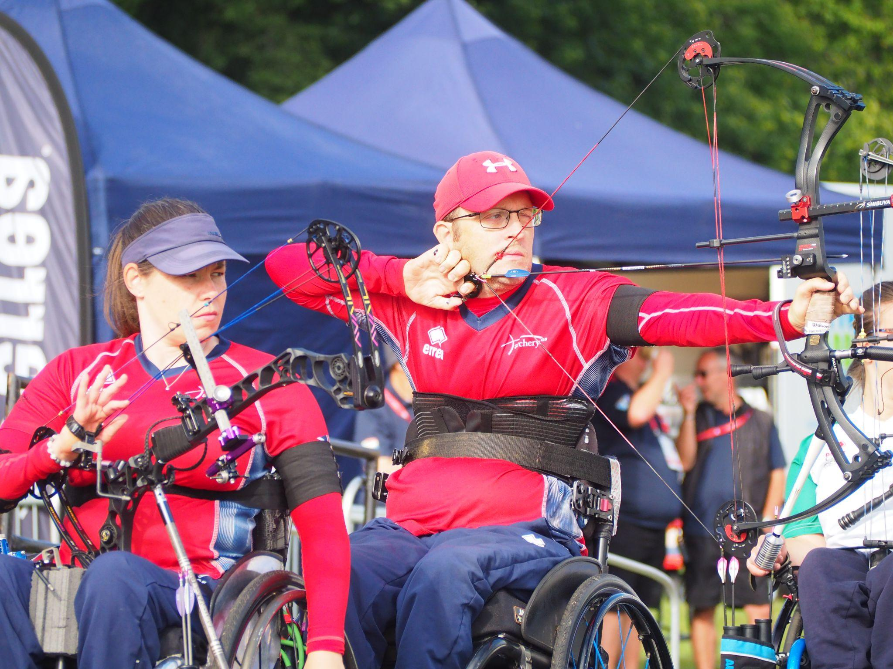
Left to right: David Phillips and Hazel Taylor, Phoebe Paterson Pine and Jamie Harris, Victoria Kingstone and Martin Saych
(Image credits: Archery GB)
16 September 2022: Great Britain’s archers excelled at the European Para Archery Cup Finals in Nottingham, securing a total of eight medals across the team and individual events.
The international competition, which was held on 15th September at Wollaton Hall, saw GB archers win three gold, one silver and four bronze medals, adding to an already successful year for the team.
Victoria Kingstone won bronze in the Women W1 Open competitions, and secured silver, alongside teammate Martin Saych in the W1 Mixed Team events.
Sharing her thoughts in light of her win and year’s achievement, Kingstone said “It's been a great experience to be shooting here at finals and to come away with a bronze individually and a silver for the team event is the culmination of a fantastic year.”
Saych then went on to win individual gold in the Men W1 Open category. Speaking on his wins, Saych said: “It's just an amazing day, just the feeling to shoot in the UK is just great, I'm just so happy.”
Jamie Harris went on to secure two further golds for GB, taking top spot in the individual Compound Men Open events and winning the Compound Open Mixed Team competition, alongside Phoebe Paterson Pine.
Paterson Pine also won individual bronze in the Compound Open Women category.
On her winning gold, alongside Harris, Paterson Pine said, “Today was amazing, Jamie and I shot so well together in the gold medal match. Getting to the last end and it being so close and leading into the shoot off that we had, we worked really well together, we communicated well and we both managed to pressure really well as well so I’m proud of the both of us for how well we’ve done.”
Completing a successful competition for GB, David Phillips secured individual bronze in the Recurve Men Open events, as well as bronze in the Mixed Recurve Open competition, alongside teammate Hazel Taylor.
Hazel Taylor came fourth in the Women Recurve Open competition. Jessica Stretton came fourth in the Compound Open Women events, after losing by just one point to teammate Phoebe Paterson Pine in the bronze medal match.
A Successful 2022 for GB’s Para Archers
The eight medal wins for GB archers in Nottingham is the latest medal haul in what has been an exceptionally successful competition year.
July saw GB archers win seven medals at the ​first leg of the Para Archery European Cup in Nove Mesto, Czech Republic, including two gold, two silver and three bronze medals across the individual and team events.
At the European Para-Archery Championships 2022 in Rome (30 July - 7 August), the athletes secured two gold, three silver and three bronze across the individual and team events.
National Tour Finals at Wollaton Hall (16 and 17 September)
Wollaton Park is also hosting the National Tour Finals at Wollaton Park on Friday 16 and Saturday 17 September, offering a chance to see some of the UK’s best archers compete on home soil.
Those attending the event will have the opportunity to have a go at archery. Tickets to the National Tour Finals are available here: Archery Competition in Nottingham Tickets - Wollaton Park, Nottingham - 15/09/2022 9:30 (gigantic.com)
-ends-
Notes to Editors

Image Credit: Archery GB

Hi-res images are available from Dropbox link with credit Archery GB:
https://www.dropbox.com/sh/nof0igguuxa25v2/AACExMTq1zRFLd9b8TS1wiRYa?dl=0

As a mark of respect to Her Majesty Queen Elizabeth II, both the European Para Archery Cup Finals and National Tour Finals have been altered to allow those attending to pay tribute to the Queen.

All flags are being flown at half-mast and GB athletes are wearing black armbands or ribbons as a mark of respect during this period of National Mourning. Both events also began with the National Anthem, followed by one minute’s silence.

David Phillips (Recurve Men Open): Dave finished eighth individually and in the mixed team at Tokyo 2020, representing GBR in two quarter finals. Dave is from Cwmbran, Wales. He has MS and is very active in the MS Society and is an ambassador for MS Cymru. Dave is also a Dual Ambassador for Ottobox and supporting athletes with disabilities. He returned to archery after a 30-year break when he was looking for a way to stay active with MS. He was selected for the GB squad in 2014 and made his international debut at the Para World Ranking Tournament in Nove Mesto, Czech Republic where he secured a gold medal as part of the men’s team and a mixed team bronze. In the same year, Dave was selected to represent Great Britain at the European Para Championship in Notwill, Switzerland where he won team gold and mixed team bronze, as well as finishing fifth in the individual competition. Dave finished in second with teammate Cameron Radigan in the double team event at the World Archery Para Championships. His Paralympic debut was in Rio where he finished fifth in the mixed team.

Jamie Harris (Compound Men Open): Jamie is from Stratford Upon Avon. From birth his lower right arm was missing multiple bone's resulting in its length being reduced and only having two fingers on his hand. He uses this arm to draw the bow after first getting into archery in 2012 at an event called Limb Power, at Stoke Mandeville. After discovering his love for the sport, he joined a local club. It quickly became apparent shooting off his fingers would not be viable due to his disability. To continue shooting, Jamie switched to compound shooting this allowed him to develop a custom trigger release that attaches around his arm. The development of his triggers is ever ongoing as it's integral to shooting. Jamie made great improvements to both his shooting abilities and equipment reliability. This has enabled him to medal at every National disability championship since it started in 2017 and he has won it twice (2018-2021). Jamie won bronze with teammate Jessica Stretton in the mixed team at the 2022 World Para Championships.
Martin Saych (W1M): Martin has been shooting for around four years. He is from Ipswich and works in Insurance as a Data Analyst. He was left paralysed as a teenager when he broke his neck in a trampolining accident. Prior to his injury he had competed in trampolining at an international level. In archery, he has won various medals internationally in Mixed team event and represented GB in the World Championships in Den Bosch in 2019. He has also played wheelchair rugby in the past.

Phoebe Paterson Pine (Compound Women Open): Phoebe is a junior indoor and outdoor national champion and gold medal Paralympian. She won gold at her Games debut in Tokyo winning the Compound Women Open. She has spina bifida. She first tried archery on a family holiday, enjoying it so much she joined her local club. Phoebe is a student at Worcester University, studying sports coaching science. She holds eight national records, four European records and three world records. Phoebe moved to Telford in 2019 from her family home in Cirencester, in the Cotswolds. Phoebe won bronze individually at the World Archery Para Championships in Dubai 2022. Phoebe is currently ranked World Number One within the Compound Women Open category.

Victoria Kingstone (W1W): Victoria grew up in Rainham, Kent but now lives in Camberley, Surrey. She has spina bifida. She is studying for a Masters degree in Sport and Exercise Psychology. Victoria was previously a Supporter Engagement Executive at Queen Elizabeth's Foundation for Disabled People. She is also a Global Athlete Mentor for The True Athlete Project. Victoria was part of the team that competed at the World Para Championships in 2019 in Den Bosch.

Jess Stretton (Compound Women Open): Stretton won gold at the Rio 2016 Paralympic Games in the Women’s Individual Compound W1 at just 16-years-old - the youngest archer at the Games. The following year she was made an MBE for her services to archery. Since Rio, Stretton has changed category – she now competes in the Compound Open and claimed individual silver in the 2019 World Para Championships in the Netherlands, setting a new world record in the process. She also won bronze at the World Youth Championships the same year. Jessica won bronze with teammate Jamie Harris in the mixed team at the 2022 World Para Championships. Stretton is from Hemel Hempstead and is an avid reader.

Hazel Taylor (nee Chaisty) (Recurve Women Open): Hazel finished sixth individually and eighth in the open mixed team at her debut at the Paralympic Games in 2021. Taylor secured her Paralympic Games quota spot at the 2019 World Archery Para Championships in the Netherlands. Hazel won gold in the Fazza Para Championships, a World Ranking tournament, in 2019. She followed that success with bronze back in the United Arab Emirates in February last year. She won mixed Bronze in the Euros in Pilsen in 2018. Hazel finished fourth at the 2022 World Archery Para Championships in Dubai. Away from sport, the 49-year-old is a keen beekeeper and enjoys crafts such as woodturning and sewing at her home in Glossop, Derbyshire.

Media Contacts: White Tiger PR - Archery@whitetigerpr.com
Leanne Barton / Leanne.barton@whitetigerpr.com / 07568 925069
Kimberley Powles / kimberley.powles@whitetigerpr.com / 07966 867827

About Archery GB
Archery GB is the British body for all forms of archery in the UK, an inclusive sport which lends itself to all spectrums of the population - regardless of age, disability or gender. With over 820 clubs and over 34,400 members, Archery GB is affiliated to World Archery, British Olympic Association & British Paralympic Association. More information www.archerygb.org. Beginners can visit www.startarchery.co.uk to find beginners’ courses and clubs near them and to learn more about the sport.

