Junior Archery Series Rules

Event Stages
For 2023 the following stages will be available:

Competition Name | Date | Venue
Stage 1 - Northern | Saturday 20th May | York Archers
Stage 2 - Southern | Saturday 17th June | Woking Archery Club
Stage 3 - Youth Festival | Monday 31st July- Friday 4th Aug* | Lilleshall
Stage 4 - Midlands | Saturday 19th Aug | Meriden Archery Club
Stage 5 - Finals | Rec / LB Sat 9th & Cpd / BB Sun 10th Sept | Deer Park Archers
* The qualification round is due to take place on Monday 31st July, followed by elimination matches up to and inc. the semi-finals. Medal matches take place on Friday 4th August on the Orangery.

Divisions, Classes and Rounds
- Rounds:
  - A single WA 50/70, AGB 122-50/30 or 80-50/30 will be shot as a qualification round
  - Elimination rounds at the applicable distance listed in 2.c.

- Compound, recurve, longbow and barebows will be able to gain points at the stages in both Junior Men and Junior Women categories.

- Age categories and distances will be as follows:

Distances
Age Category Compound Recurve Longbow Barebow
U21 50m - 80cm 70m - 122cm 70m - 122cm 50m - 122cm
U18 50m - 80cm 60m - 122cm 60m - 122cm 50m - 122cm
U15 50m - 80cm 50m - 122cm 50m - 122cm 50m - 122cm
U12 * 30m - 80cm 30m - 122cm 30m - 122cm 30m - 122cm
*The Under 12 category is not available at the youth festival

- In an event where there are low numbers of entry, the decision may be taken to amalgamate the categories to make it more competitive. Should this happen, points will be awarded based on the original qualification position and then for the H2H based on the finishing position within the un-combined category.

Example of d.

Bob | CM | 1st Qual (CM) | 2nd in combined Elim | 1st | 1st
Izzy | CW | 1st Qual (CW) | 1st in combined Elim | 1st | 1st
Jeff | CM | 2nd Qual(CM) | 3rd in combined Elim | 2nd | 2nd

Ranking Points from stages

a. Series points will be given based on finishing position in the qualification and elimination rounds at the stage.

Example If you finish first in the qualification round, then you will be awarded 1 point. If you then finish in 4th place in the head-to-head eliminations, then you would be awarded 4 points. Total number of points awarded at the stage would be 5 points. If you were to finish 2nd and then 7th = 9 points, and so on.

b. Following the qualification round, if an archer fails to compete in the elimination stages, then they will automatically be assigned 25 points for that part of the competition.

c. Results from the stages along with the current ranking for the series will be published following the event online.

Qualification to Junior Masters
a. Qualification to the junior masters will available by two methods 2023:
i. A junior archer achieving JMB/MB/GMB since the previous Junior
Masters ii. By completing 3 of the 4 junior Archery Series Stages

Grand Finals
- Qualification for the Grand Final will use your best 4 points totals added together from the possible 5 stages.
- Should an archer choose not to attend stage 5 after having qualified, they may still be placed 1st,2nd, or 3rd in the Series ranking.

Example of points totals (amending)

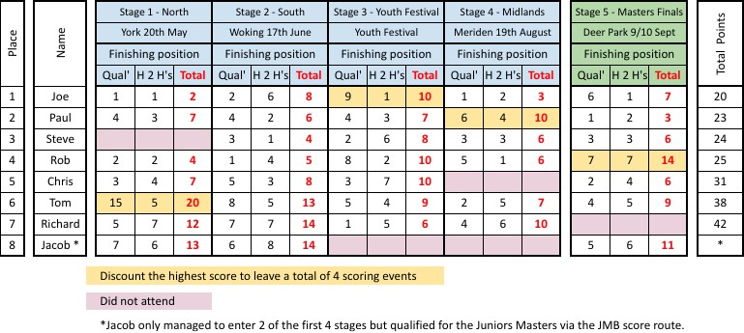

- Format:
  - If a class and division has less than 4 qualified athletes at the end of stage 5, then that category may not proceed to a Grand Final shoot off. The top 3 ranked archers will receive recognition of their placing.
  - The top 4 ranked archers present in each class and division will compete for one place in the Grand Final shoot off.
  - Following the class and division shoot off, the winners proceed to the Grand Final shoot off within their gender and bowstyle, which will be irrespective of age.
  - The class and division shoot off and Grand Finals will be a sudden death elimination format. Each archer will shoot 3 arrows in 2 minutes.
  - The archer with the lowest score drops out, until the winner is left.
  - Each archer shall shoot at their respective distance (i.e. an U21 Male recurve at 70m and an Under 12 Archer shooting at 30m). d. Awards:
i. Archery GB medals will be presented to the winners immediately following the finals at Deer Park. ii. Other awards may also be presented from sponsors of the series, as applicable at the time of the finals.

Entry
a. Entry to stages is as per the various events prospectuses, please refer to each of these for their various dates and terms.

Disputes
a. All disputes will be handled in the following ways:
- For issues at a stage: The Junior Series Organiser, the Event Organiser and the Chair of Judges will be able to act working together.
- For the Grand Finals: The Junior Series Organiser, the Event Organiser of Stage 5 and the Chair of Judges will be able to act working together.

