MOSQUE TO HOST FREE ‘HAVE-A-GO’ ARCHERY SESSIONS
- Stoke mosque and archery club team up as part of Archery GB’s Project Rimaya
- Initiative looks to broaden appeal of archery across Muslim communities
- Women’s sessions will be run by female coaches
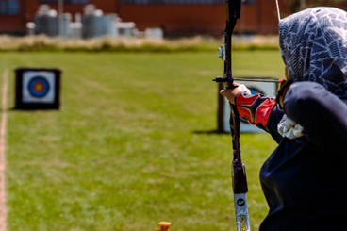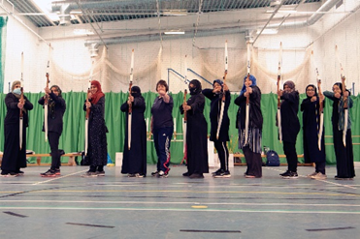
XX August 2022: A Stoke-on-Trent mosque will be hosting free “have-a-go” archery sessions to boost participation among the Muslim community.
The Hanley Central Mosque “have-a-go” day will be run by Trent Valley Archers and other local qualified Archery GB coaches on Sunday, August 7.
The initiative is supported by Archery GB’s Project Rimaya, a SportsAid funded initiative looking to increase participation in archery amongst Muslim communities.
Archery has particular cultural significance within the Islamic community, as part of Muslim heritage for over a thousand years and one of a limited number of recreational activities cited specifically in the Qur’an as a fundamental ‘Sunnah’ sport and therefore a respected activity for those of Muslim faith.
The “have-a-go” sessions will take place at the Equality House Community Centre in Raymond Street, behind the mosque.
From 11am to 1.30pm, there will be two free hour-long sessions, each for 20 women and girls, with female coaches on the shooting line.
From 2.30pm to 5pm, there will be another two free hour-long sessions, each for 20 men and boys.
Archery GB’s long-term strategy is to help put sport at the heart of the nation’s post pandemic recovery, bringing a new and inclusive sporting activity to ethnically diverse communities and providing practical support to establish new archery clubs in partnership with Islamic faith institutions and community groups.
Grant Piland, of Trent Valley Archers and Chair of Staffordshire County Archery Association is passionate about using the sport he loves to promote community integration. He is keen to bring people together following the pandemic, and to promote mutual respect and understanding within ethnically diverse local communities.
Grant saw the work being done through Project Rimaya and was inspired with his club to reach out to their local community. He has connected with representatives who have already successfully launched Project Rimaya initiatives, including Muslimah Sports Association and Barking Rugby Club, who run a joint project, as well as the Muslim Sports Foundation and Hanley Central Mosque.
He said: “What I want to see on the shooting line is everybody standing together and shooting arrows, talking and conversing with each other and respecting each other.
“That’s what we need to do, not just for the love of the sport, but for communities and for the country. It has become a passion of mine.”
Project Rimaya has become a particularly effective initiative to help develop the role of women in ethnic communities and showcase the way archery is a sport that can be used to develop community relations while encouraging wider participation in an activity that benefits both mind and body.
Further information on Project Rimaya can be found here.
-ends-
Notes to Editors
Media Contacts - White Tiger PR - Archery@whitetigerpr.com
Leanne Barton / Leanne.barton@whitetigerpr.com / 07867332590
Kate Bates / Kate.Bates@whitetigerpr.com / 07876803947
Kimberley Powles / kimberley.powles@whitetigerpr.com / 07966 867827

Hi-res images are available from Dropbox https://www.dropbox.com/sh/aheu78drhzpr7so/AAAdcLckk_uCTcwicuS_d42Oa?dl=0

About Archery GB
Archery GB is the British body for all forms of archery in the UK, an inclusive sport which lends itself to all spectrums of the population - regardless of age, disability or gender. With over 820 clubs and over 34,400 members, Archery GB is affiliated to World Archery, British Olympic Association & British Paralympic Association. More information www.archerygb.org. Beginners can visit www.startarchery.co.uk to find beginners’ courses and clubs near them and to learn more about the sport.

