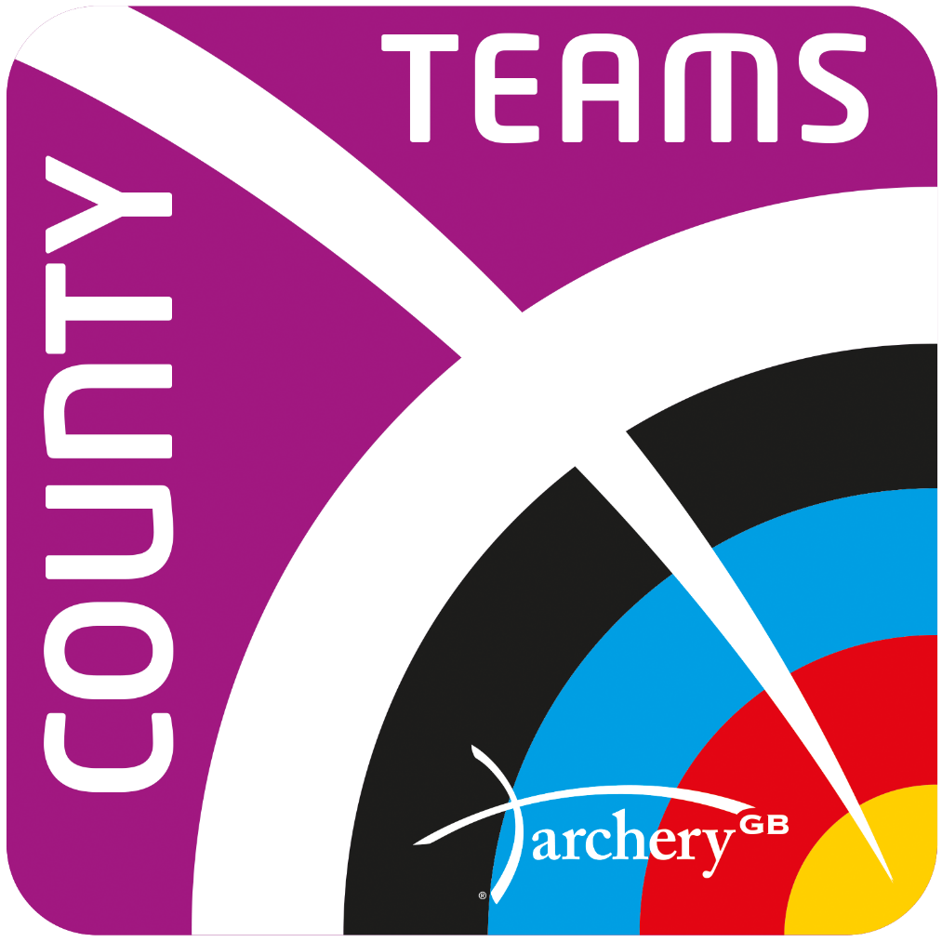

**Saturday 24 September – Team head to heads**

WRS WA 50/70m round will be shot in a double detail with six arrows shot in four minutes.

Teams of 3 archers per discipline, in Men’s & Women’s, Recurve, Compound, Longbow & Barebow head-to-head matches to follow. All matches will be shot to the current WA rules

**Sunday 25 September – Mixed team head to heads**

WRS WA 50/70m round will be shot in a double detail with six arrows shot in four minutes.

Barebow - WA50m on an 122cm face

Recurve and Longbow – WA70m on an 122cm face

Compound – WA50m on an 80cm face

**Saturday’s ranking round will determine the three-person team ranking position and the composition of the mixed team qualification.**

**Sunday’s ranking round will determine the mixed team positions. Matches will be shot to current WA rules.**

**All 4 elements will be taken into account for the final results.**

*All archers will shoot in the team and mixed team matches

-----------------------------------------------------------------------------------------

**Eligibility**

All entries must be ratified by a member of your County Committee before they will be accepted.

**Date**

23 and 24 September 2023

----------------------------------------------

**Entries open**

9 June

----------------------------------------------

**Entry via Members** [**Portal Link**](https://agb.sport80.com/)

-----------------------------------------------------**Price**

£148 per team of 3

£50 for single entry – single entry only available to create a mixed team

(No refunds 28 days prior to competition date)

-------------------------------------------------

**Location**

Lilleshall National Sports Centre, Newport, TF10 9AT

------------------------------------------------

**Contact** – [competitions@archerygb.org](mailto:competitions@archerygb.org)

------------------------------------------------

**Judges** - Gareth Beeby – COJ

Graham Potts, Cameron Ross , Ann Gillbanks, Chris Charlesworth, Neil Wright, Paul Clark, Phil Gillbanks

Steve Vallis

------------------------------------------------**Registration opens**

08:00 on both days during equipment inspection

------------------------------------------------

**Practice**

Assembly at 08.30 each day.

3 ends of practice from 08.45

The competition will start immediately afterwards.

------------------------------------------------

Target Lists, Results and competition information will be published on [www.ianseo.net](http://www.ianseo.net).

-------------------------------------------------

All entries will be treated in accordance with the Archery GB privacy notice

-------------------------------------------------

Competition terms and conditions available on the website

**National County Team Championships 202**