TOP UK ARCHERS SET FOR SENSATIONAL SHOWDOWN AT NATIONAL TOUR FINALS
- GB’s sharpest shooters prepare to showcase their skills on home soil
- Athletes competing include world-leading women Ella Gibson, Penny Healey and Bryony Pitman
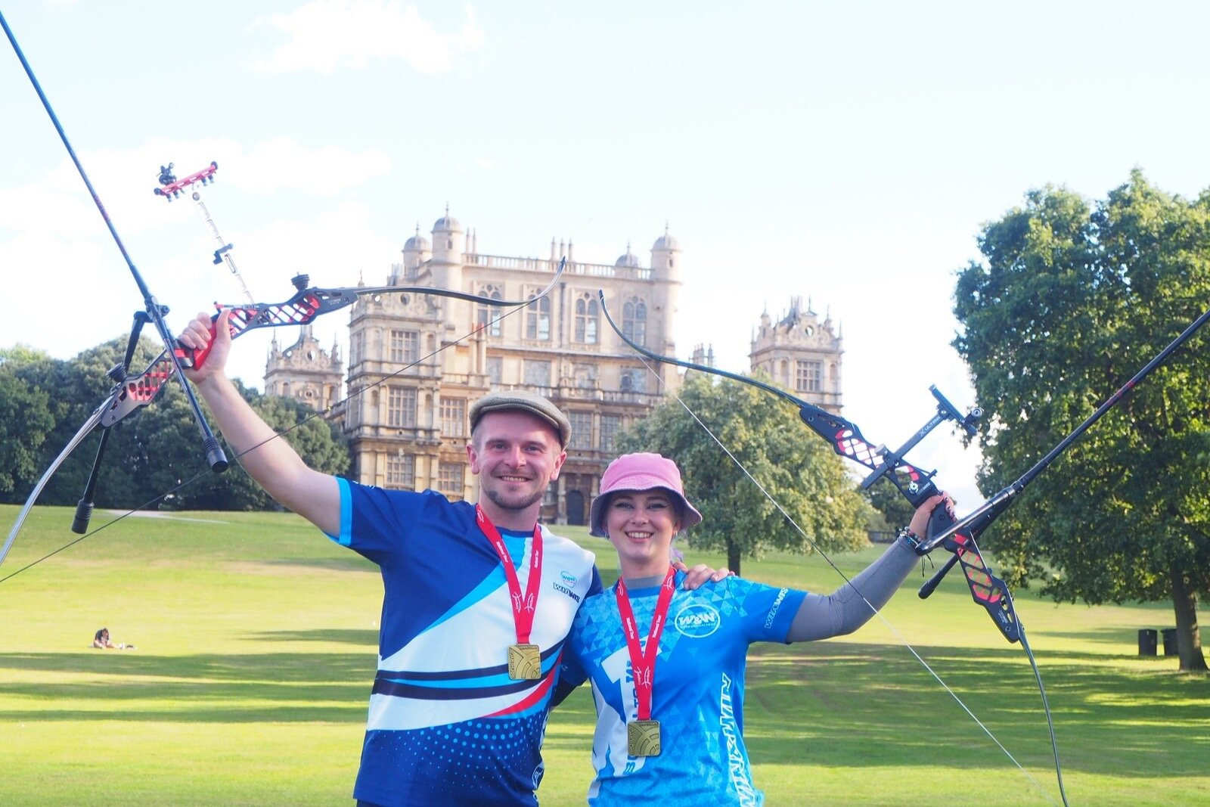
(Photo caption: Left - Right: Patrick Huston and Penny Healey celebrate at last year’s National Tour Finals. Credit Archery GB)
XX August 2023: On the 2nd and 3rd September, a selection of the UK’s finest archers will assemble at Wollaton Hall in Nottingham for the National Tour Finals, where six champions will be crowned in the disciplines of recurve, compound and barebow archery.
The event will give spectators unique access to an incredible weekend of archery action that includes a number of home-grown, world-leading athletes and Olympic hopefuls aiming to be named in the GB squad for next year’s Olympic Games in Paris.
On Saturday September 2, the compound and barebow archers will be competing with top names including Ella Gibson who recently broke the 50-metre qualifying world record and is current world number 1, the 2022 European champion Izzy Carpenter, as well as her equally talented brother and reigning National Tour champion, Adam Carpenter who will be competing to retain his crown for the fourth consecutive year.
In the recurve competitions on Sunday September 3, there is the chance to watch 18-year-old Olympic hopeful Penny Healey, the current world number 1, who has already qualified for the world cup finals in Mexico later this year. Alongside her will be Tokyo 2020 archer and world number 3 Bryony Pitman, whilst representing the male side will be 2022 National Tour Final winner Patrick Huston looking to retain his title.
As well as all this top-class sports action there will be plenty for spectators and families to enjoy, including food available to purchase and meet and greets with some of the top names in the sport. There will even be a have-a-go range for visitors to try their hand at the sport*.
This will be the seventh time the National Tour competition has been held at Wollaton Hall and tickets can be purchased in advance by visiting here or on the day. Full details can be found on the event website.
-ends-
Notes to Editors:

- For those aged over 10, the cost of the have-a-go will be 6 arrows for £5 or £3 to ticket holders. A soft version using suction cup arrows will be available for under 11s at a cost of £2 for 6 arrows. Timings: 10am – 4.30pm Saturday, and 10am – 3.30pm Sunday.

Schedule of events:
- Saturday 2 September barebow/compound categories
10am – 16:30pm
- Sunday 3 September recurve categories
10:30am – 15:30pm

Athlete Profiles:
Ella Gibson: Current world number 1 Ella first tried archery in October 2014 when some coaches from Xperience Archery came to her secondary school. They put on a six-week taster session after school, which led to a beginners’ course with Deer Park Archers and she joined the club in June 2015. Ella has competed internationally since 2018.
As part of the women’s team, she won gold at the 2022 European Championships and silver at World Cup stages 3 and 4. She won bronze as part of the mixed team at the third stage of the World Cup.
Bryony Pitman: Bryony made her Olympic debut at the Tokyo 2020 Games, finishing ninth both individually and in the women’s team. Bryony was also part of the bronze-winning team at the 2019 World Archery Championships.
Bryony won individual gold at the World Cup in Antalya, along with Mixed Team Silver with Alex Wise and gold in the women’s team with Penny Healey and Jaspreet Sagoo. She also won individual silver at the Birmingham 2022 World Games and the World Archery Field Championships 2022 and silver as part of the women's recurve team at stage 4 of the World Cup. She is currently ranked world number 3.
Penny Healey: Penny is the youngest on the national squad, at just 18 years old, and is known not only for her astounding talent, but her penchant for pink and purple hair.
She started archery when she was 9, after watching the Disney movie “Brave”. The teenager shot to the top of the world rankings for women’s recurve following an awe-inspiring gold medal win at the Antalya 2023 Hyundai Archery World Cup Stage 1 in April.

Just days earlier Penny also won the gold medal in women’s recurve at the European Grand Prix, held on home soil at Lilleshall, Shropshire.
She is still currently ranked world number 1.

Izzy Carpenter: Izzy first started archery when she was ten years old, having tried the sport on a family holiday. Izzy, from Huddersfield, placed 5th at the 2023 Berlin Senior World Championships with the compound women’s team.
Having completed a Master’s Degree in creative writing in 2021, she not only competes internationally for Great Britain but is also the Events Marketing Officer for Archery GB.
Her biggest achievements are becoming the 2022 European champion for compound women and the team champion.

Adam Carpenter: Adam is from Barnsley Archery Club and started archery when he went on a family holiday to Center Parcs. Adam, who was seven at the time, and his older sister Izzy loved it and took a beginners’ course. His biggest achievements so far are back-to-back National Tour Champion for 2022, 2021 and 2020, along with setting the UK junior compound indoor 18m national record of 595. Adam’s goals for this year are to make the team for the senior European championships and to get the fourth in a row National Tour win.

Patrick Huston: Patrick, a 3x World Champion at junior level, competed in the Tokyo 2020 Games, his second Olympic Games. The highlight was fifth in the men’s team and eighth in the mixed team. He is originally from Belfast, Northern Ireland. Patrick won silver with mixed team partner Naomi Folkard at the European Games in 2019 and Bronze at the World Championships in 2017. Patrick has a collection of European Field Medals, Junior and senior with individual and team podiums. He was part of the bronze winning team at the Archery World Cup in Antalya, 2018. During the 2021 season, Patrick won silver individually at the European Field Championships in Croatia and set 4 separate national records along with a record-setting 4th win of the AGB National Tour.

Media Contact: Spider PR: archery@wearespider.com
Rebekah Smith / rebekah.smith@wearespider.com / 07840 104801
Sara Dagen / sara.dagen@wearespider.com / 07309 781429

About Archery GB
Archery GB is the British body for all forms of archery in the UK, an inclusive sport which lends itself to all spectrums of the population - regardless of age, disability or gender. With over 820 clubs and over 38,309 members, Archery GB is affiliated to World Archery, British Olympic Association & British Paralympic Association. More information www.archerygb.org. Beginners can visit www.startarchery.co.uk to find beginners’ courses and clubs near them and to learn more about the sport.

