

**WORLD AND NATIONAL RECORDS BROKEN AT NATIONAL INDOOR CHAMPIONSHIPS**

* **17-year-old Penny Healey breaks world record, becomes National Champion and wins the TRU Ball Axel Back2Back competition**
* **Phoebe Paterson Pine sets new National Record**
* **15-year-old Ollie Hicks becomes new Barebow Men’s National Champion and Junior National Champion**

**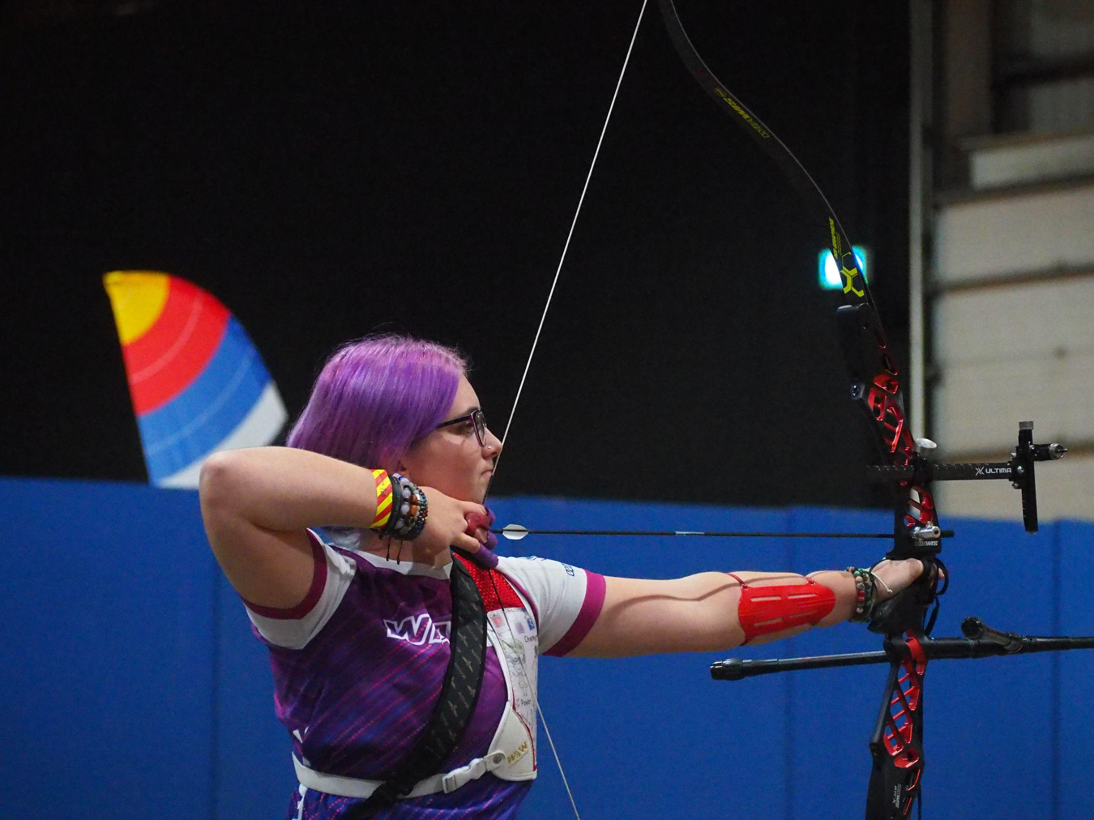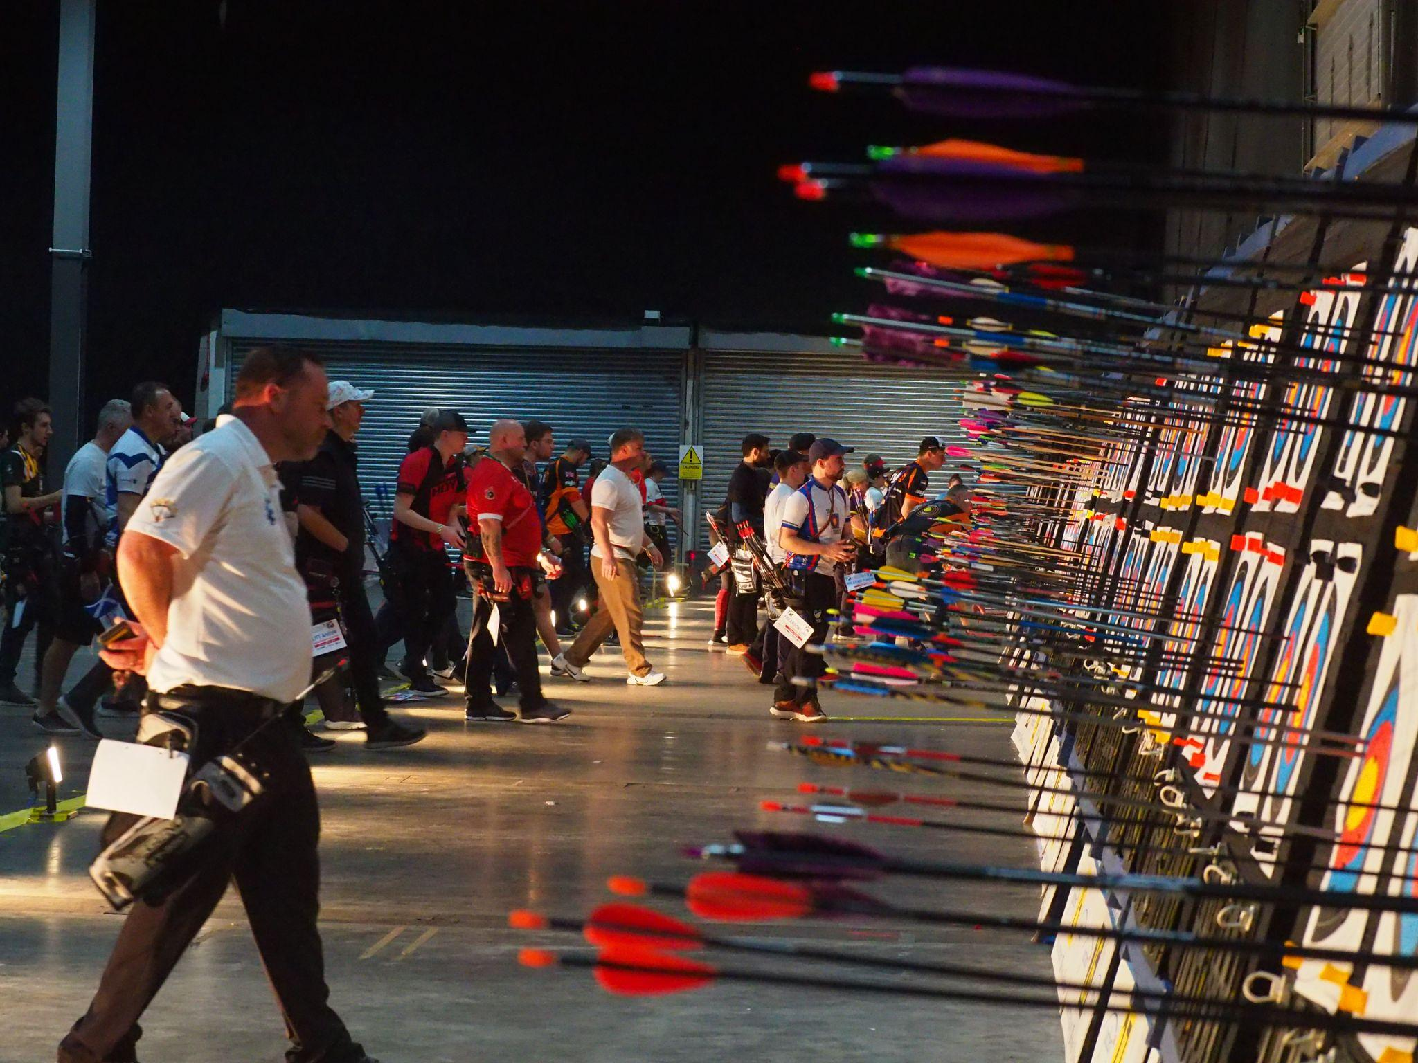  
Left: Penny Healey takes aim.**

***(Image credits: Archery GB)***

**XX December 2022:** A swathe of world and national records were broken as hundreds of archers took part in one of the UK’s largest indoor competitions.

The National Indoor Championships and the Junior National Indoor Championships were held at Stoneleigh Park in Warwickshire on Saturday, December 3 and Sunday, December 4.

**World record broken**

On Saturday, at the National Indoor Championships, Penny Healey broke the Under 18 Recurve Women 18m World Record, and matched the Under 21 Recurve Women 18m World Record. She shot a 594 in a WA 18m round out of a possible 600 points. The previous world record was 593 set in 2020. She was one point off the Recurve Women 18m World Record.

Penny, who is ranked 24th in the world, went on to become the Recurve Women National Champion after beating world number two Bryony Pitman 6-4 in a tense gold medal match between the two friends.

**Back2Back win**

Penny continued her form into Sunday where she claimed the top spot in the TRU Ball AXCEL Back2Back competition. The final six archers included Bryony Pitman and world number 8 Gaby Schloesser, from the Netherlands. The final match of the event was between Penny and Gaby who shot a matching score, which went to a tie break. In this unique competition, the best of the last arrow shot (closest to the centre) decides the tie break, which was Penny.

The TRU Ball Axcel Back2Back is a unique eliminator competition in which every arrow is a ‘match’ arrow. There is no qualification, just large rounds of matches and the final consists of six archers where the lowest score of each round is eliminated.

**Other highlights include:**

* Phoebe Paterson Pine set a new national record in the Women Open Compound WA 18m category, shooting 578 out of a possible 600.
* Ollie Hicks, 15, of Bowmen of Warfield in Berkshire, became both Barebow Men National Champion and Junior National Champion after competing and winning both competitions over the weekend. Ollie set a new Senior, Under-21 and Under-18 [World Record in September](https://worldarchery.sport/news/200941/hicks-sets-new-barebow-bar-673-point-world-record-aged-15) for the Barebow Men 72-arrow 50m category.
* James Woodgate, of Woking Archery Club, who was recently announced as the number one in the national rankings for recurve men, also becomes National Champion.
* Ella Gibson continued her fine form for 2022 by becoming both Compound Women National Champion and TRU Ball Axel Back2Back Champion.

The exciting competition is one of the few times in sport that grassroots competitors are able to line up and take part alongside archers who are ranked number one in the world.

With 888 archers registered to take part, a staggering 55,000 arrows were shot over the weekend.

**An incredible 2022 season for GB Archers**

Tom Duggan, Archery GB’s Performance Director, said: “The tournaments have capped off a brilliant year for GB archers.

“It has been the most successful summer for GBR in recent history, not just on the national scene, but on the World and European stage too.

“From breaking multiple world records to having the strongest season in the Hyundai Archery World Cup for a long time, it all sets the scene for what is going to be an exciting road to Paris 2024 for archery.”

-ends-

**Notes to Editors**

The full lists of medallists by event, hi-res images and video footage are available at:

<https://www.dropbox.com/sh/s1xw8cg4j26a8ag/AAClw4pInz4Vg-lJTl8faaG7a?dl=0>

More hi-res images of the National Indoor Championships and winners, which should be credited to Archery GB, can be downloaded at

<https://archerygb.smugmug.com/National-Indoor-Championships/2022/National-Indoor-Champs-2022/>

More hi-res images of the Junior National Indoor Championships and winners, which should be credited to Archery GB, can be downloaded at

<https://archerygb.smugmug.com/Junior-National-Indoor-Championships-2022/>

**Archer biographies:**

**Penny Healey:**

Penny is the youngest on the national squad, at just 17 years old. She started archery when she was 9, after watching the Disney movie “Brave”. It inspired her to have a go at archery, as it looked enjoyable and she used to do horse riding. Penny did her beginners course at Audco Archers. Penny’s proudest achievement to date is winning the Indoor World Series Finals in 2022 in Las Vegas. Along with shooting the European junior, national senior and junior WA720 record. Her advice to archers is to work hard and enjoy what you do! “You shoot your best when you're having fun, and the hard work is what helps you reach your full potential as an archer.” Penny’s goal for this year was to make the senior international team which she has now achieved, put in some new personal bests and to medal internationally. She medalled twice as part of the women's recurve team winning gold and silver at different stages of the Hyundai World Cup. She also came first in the National Tour Final 2022. Outside of archery, she likes to listen to music, and achieved her grade 5 for violin.

**Phoebe Paterson Pine:**

Phoebe is a junior indoor and outdoor national champion, gold medal Paralympian and current world number 1. She won gold at her Games debut in Tokyo winning the Compound Women Open. She has spina bifida and first tried archery on a family holiday enjoying it so much she joined her local club. Phoebe is a student at Worcester University, studying sports coaching science. She holds multiple National, European and World records breaking five UK, European and World records over five days in 2022! Phoebe moved to Telford in 2019 from her family home in Cirencester, in the Cotswolds. She won bronze individually at the World Archery Para Championships in Dubai 2022 and gold at the Disability Championships. She won gold at the 2022 European Para Archery Championships and the Para Archery European Cup in the individual Compound Women Open event as well as bronze as part of the mixed team with Jamie Harris also at the Para Archery European Cup. Competing in the women's team with Jessica Stretton she won gold at the Para Archery European Cup and silver at the European Para Archery Championships. She won gold with teammate Jamie Harris at the 2022 European Para Cup Final as part of the mixed team and bronze in the Compound Women individual event.

**James Woodgate:**

James made his Olympic debut at the Tokyo 2020 Games. Finishing 33rd individually and fifth in the team. James is from Woking Archery Club, in Surrey. He is studying physics at Warwick University whilst training. James ranked first at the World Youth Championships in the recurve junior men division, in 2021.

**Ella Gibson:**

Ella first tried archery in October 2014 when some coaches from Xperience archery came to her secondary school. They put on a six-week taster session after school and that led to a beginners’ course with Deer Park Archers and she joined the club in June 2015. Ella has competed internationally since 2018, winning a silver at the European Outdoor Championships, bronze at the Lancaster Classic and team medals on the World stage.

In February, 2022, her first big win individually on the international stage came when she took gold and the Compound Women European Indoor Champion title in Slovenia. In the same year she won the National Tour Final, individual gold at stages 1, 3 and 4 of the World Cup and silver in the World Cup Final. Ella won silver at the Birmingham 2022 World Games. As part of the women’s team, she won gold at the European Championships and silver at World Cup stages 3 and 4. She won bronze as part of the mixed team at the third stage of the World Cup. Ella has broken several records and is currently World Number 1.

Ella’s family own and run Dolcetti Ice Cream, in Cirencester. They have moved to bigger premises, which includes a 25-metre indoor range so that Ella can continue to shoot, whatever the weather.

**Media Contacts: White Tiger PR -** [Archery@whitetigerpr.com](mailto:Archery@Whitetigerpr.com) Leanne Barton / [Leanne.barton@whitetigerpr.com](mailto:Leanne.barton@whitetigerpr.com) / 07568 925069

Kimberley Powles / [kimberley.powles@whitetigerpr.com](mailto:kimberley.powles@whitetigerpr.com) / 07966 867827

Amaka Umunna / [amaka.umunna@whitetigerpr.com](mailto:amaka.umunna@whitetigerpr.com) /07399 060261

**About Archery GB**

Archery GB is the British body for all forms of archery in the UK, an inclusive sport which lends itself to all spectrums of the population - regardless of age, disability or gender. With over 820 clubs and over 34,400 members, Archery GB is affiliated to World Archery, British Olympic Association & British Paralympic Association. More information [www.archerygb.org](http://74n5c4m7.r.eu-west-1.awstrack.me/L0/http:%2F%2Fwww.archerygb.org/1/01020180a98cbda9-8e57777e-d0bb-407b-a1f6-bec693ced52b-000000/U7Sj-5aARbXnfwerq3W-89GEnIQ=269). Beginners can visit [www.startarchery.co.uk](http://74n5c4m7.r.eu-west-1.awstrack.me/L0/http:%2F%2Fwww.startarchery.co.uk/1/01020180a98cbda9-8e57777e-d0bb-407b-a1f6-bec693ced52b-000000/ayOC_KwdMGgFiFQeNx2rNl-3JBM=269) to find beginners’ courses and clubs near them and to learn more about the sport.