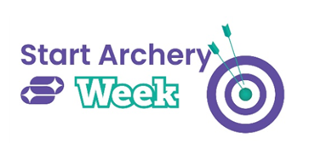


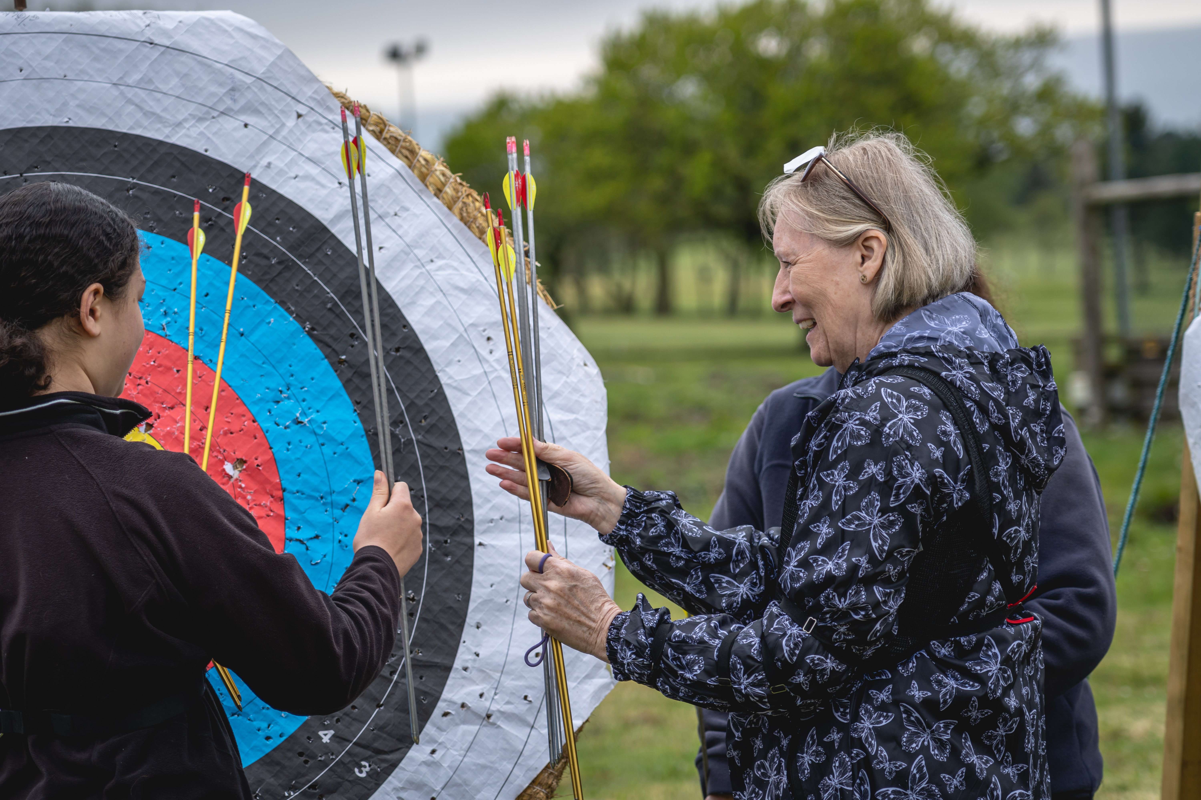

Photo credit: Archery GB

START ARCHERY WEEK EVENTS HIT THE MARK
xx June 2024 - This year’s Start Archery Week (4-12 May) saw archery clubs and activity providers across the country open their doors to more than 10,000 potential archers, giving people of all ages and abilities the chance to draw back their bows and have a shot at archery.
Between them, archery clubs and activity providers across the UK hosted 98 events, with participants able to have a go at the sport, and coaches on hand to guide people through the basics.
Since it began in 2012, Archery GB’s Start Archery Week has introduced more than 70,000 people to archery thanks to archery clubs and activity providers taking part in this nationwide week dedicated to welcoming more people to the sport. This year saw Kinetic and Avalon Archery come on board as premium partners, kindly providing giveaway prizes worth more than £1,000 to say thank you to all the incredible volunteers who make Start Archery Week possible.
“As one of the most accessible sports around, it was great to see so many people picking up a bow and having a go at archery,” says Ruth Hall, Chief Executive of Archery GB. “We’ve had some great feedback from the coaches who were impressed with the passion and excitement of those who attended events, many who came along with friends and family. As we gear up for a busy summer of sport, we’re thrilled to know that so many thousands of people have given archery a go.”
This year’s focus was on the mental health and wellbeing benefits of archery with those who attended Start Archery Week events able to experience this for themselves. As a sport that requires focus and concentration, archery can support increased mindfulness, enhance the ability to stay present and decrease stress.
During Start Archery Week, participants were also invited to sign up to the Start Archery newsletter and go into a draw to win two pairs of tickets to watch archery at the Olympic or Paralympic Games in Paris this summer. The lucky winners, picked at random, will be heading to the French capital to watch the best archers in the world battle it out against the stunning backdrop of Les Invalides.
If you’re interested in giving archery a go, you can find a beginner’s course by heading to: https://startarchery.co.uk/start-my-journey/find-an-experience
-Ends-
Notes to Editors:
Hi-res images are available to download here. Please credit Archery GB: https://archerygb.smugmug.com/Start-Archery-Week/SAW-2024-
Media Contacts
Bethan Simkins or Laura Wilson at archerygb@targetgroup.co.uk or call 01242 633100.
About Archery GB
Archery GB is the British body for all forms of archery in the UK, an inclusive sport which lends itself to all spectrums of the population - regardless of age, disability or gender. With over 800 clubs and more than 38,300 members, Archery GB is affiliated to World Archery, the British Olympic Association and the British Paralympic Association. More information: www.archerygb.org

