GB ARCHERS TAKE THREE MEDAL WINS AT YANKTON 2022 WORLD ARCHERY FIELD CHAMPIONSHIPS
- Bryony Pitman wins Recurve Women individual silver

- Patrick Huston beats world number one to take Recurve Men individual bronze

- Louisa Piper secures bronze in Recurve Under 21 Women
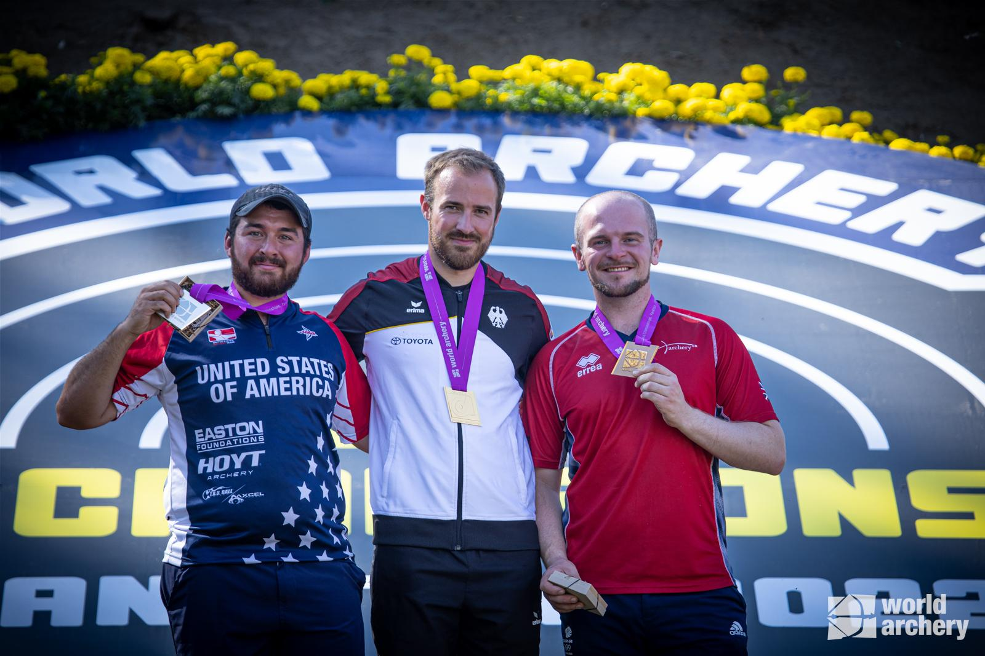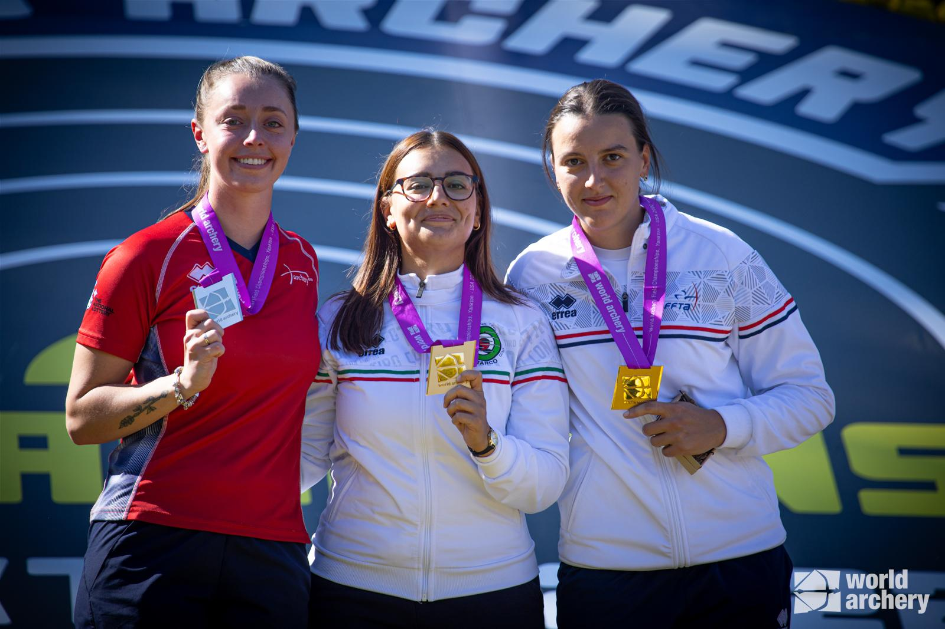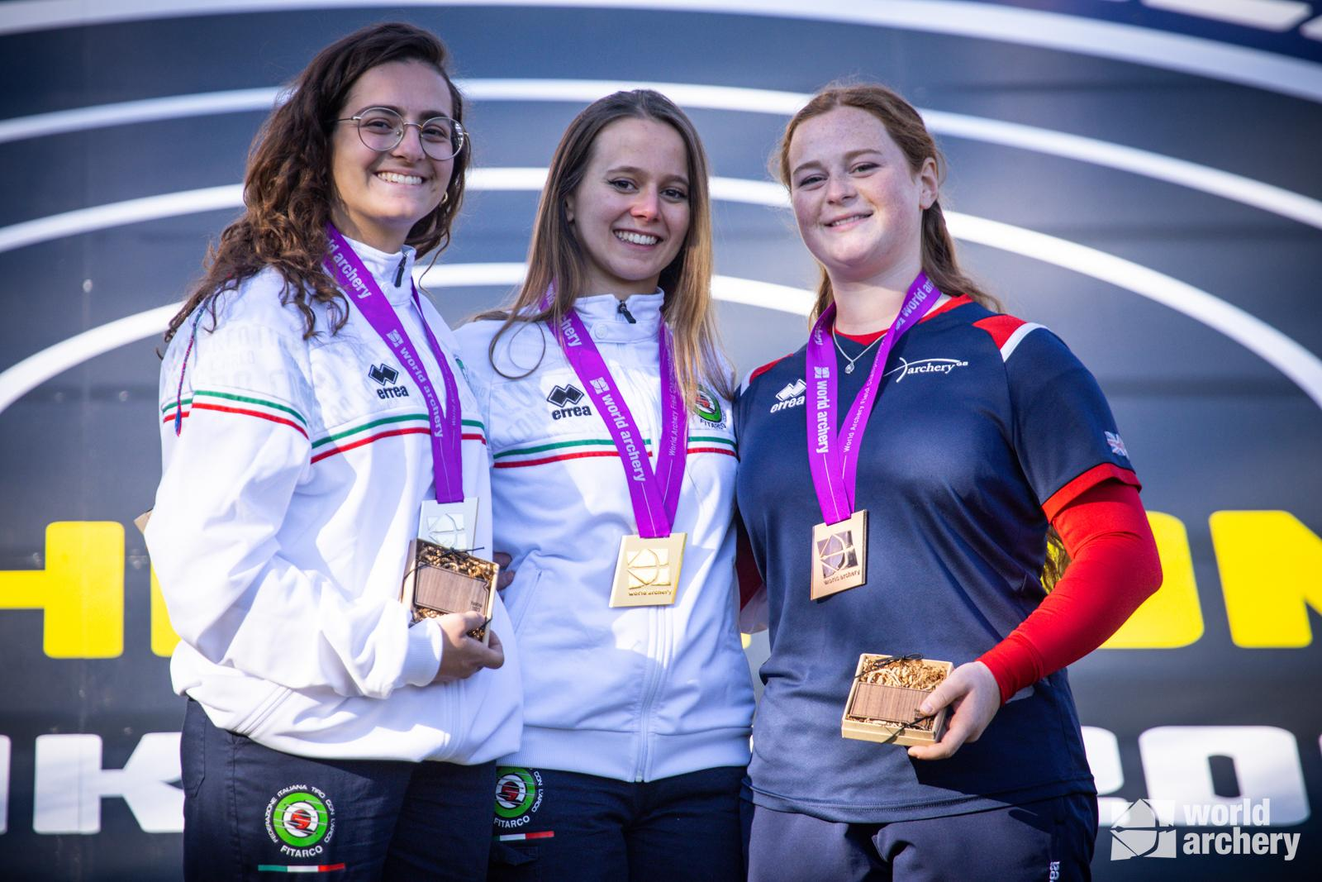
(Photo Credit: World Archery)
XX October 2022: Great Britain’s archers have once again enjoyed international success on the world stage, taking one silver and two bronze medals at the World Archery Field Championships in Yankton, United States, which took place from 3 October to 9 October.
Olympic archer and gold medallist at the Antalya Hyundai World Cup 2022 Stage 1, Bryony Pitman, won silver in the Recurve Women. Pitman missed out on the gold medal by just one point placing her in an optimum position ahead of this weekend’s Tlaxcala 2022 Hyundai Archery World Cup Final.
Following on from his gold medal win at the National Tour Finals in Nottingham last month, Olympic archer Patrick Huston secured bronze in the Recurve Men individual competition in Yankton.
Speaking on his recent win, Patrick Huston said, “It was a great experience getting to shoot on the finals field three times. The NFAA set out a tremendous four targets to decide the medals and it was a pleasure to get to shoot it! I'm so happy to have taken the bronze against the world number one, I feel it was a very important victory for me. The match was very close throughout, but then Brady shot a four on the 25m target and I think that gave me a significant advantage and probably turned the result in my favour".
Woking’s Louisa Piper secured the bronze medal in Recurve Under 21 Women; Piper previously won gold in the Recurve Under 21 Women team event at the European Youth Championships in August.
World number one (Women Compound) Ella Gibson narrowly missed out on the bronze medal taking fourth place in the Compound Women. Throughout 2022, Gibson has won multiple medals on the international competition stage, including individual gold at the World Games in Birmingham, USA and the Paris 2022 Hyundai Archery World Cup Stage 3, setting Gibson in good stead for the upcoming Tlaxcala 2022 Hyundai Archery World Cup Final.
-ends-
Notes to Editors -
Video footage is available for download from World Archery here, please credit World Archery if using: 2. Recordings - Google Drive
Hi-res images are available from dropbox: https://www.dropbox.com/sh/8ivzz66ksue1yk5/AABSEGdYNAIxEXWPWSr-_Jh7a?dl=0

About Archery GB
Archery GB is the British body for all forms of archery in the UK, an inclusive sport which lends itself to all spectrums of the population - regardless of age, disability or gender. With over 820 clubs and over 34,400 members, Archery GB is affiliated to World Archery, British Olympic Association & British Paralympic Association. More information www.archerygb.org. Beginners can visit www.startarchery.co.uk to find beginners’ courses and clubs near them and to learn more about the sport.
Patrick Huston: Patrick, a 3x World Champion at junior level, competed in the Tokyo 2020 Games, his second Olympic Games. The highlight was fifth in the men’s team and eighth in the mixed team. He is originally from Belfast, Northern Ireland. Patrick won silver with mixed team partner Naomi Folkard at the European Games in 2019 and Bronze at the World Championships in 2017. Patrick has a collection of European Field Medals, Junior and senior with individual and team podiums. He was part of the bronze winning team at the Archery World Cup in Antalya, 2018. During the 2021 season, Patrick won silver individually at the European Field Championships in Croatia and set 4 separate national records along with a record-setting 4th win of the AGB National Tour.
World Archery Bio - https://worldarchery.sport/profile/12648/patrick-huston/biography

Bryony Pitman: Bryony made her Olympic debut at the Tokyo 2020 Games, finishing ninth both individually and in the women’s team. Bryony was also part of the bronze winning team at the 2019 World Archery Championships. In 2019 she also won gold as part of the women’s recurve team at the European Games, Minsk. She has previously competed at the Summer Youth Olympics. Bryony lives in Shoreham, West Sussex. She’s a graduate in History from Northumbria University and studied for a Masters degree in Intelligence and Security from Brunel University. Bryony is a keen gym goer and is often at the Underground Gym in Brighton.
World Archery Bio - https://worldarchery.sport/profile/12453/bryony-pitman/biography
Ella Gibson: Ella first tried archery in October, 2014, when some coaches from Xperience archery came to her secondary school. They put on a six-week taster session after school and that led to a beginners’ course with Deer Park Archers and she joined the club in June, 2015. Ella has competed internationally since 2018, winning a silver at the European Outdoor Championships last summer, bronze at the Lancaster Classic and team medals on the World stage. In February, 2022, her first big win individually on the international stage came when she took gold and the compound women European Indoor Champion title in Slovenia. Currently ranked 13th in the world, Ella’s goal this year is push into the top 10. Ella’s family own and run Dolcetti Ice Cream, in Cirencester. They are moving to bigger premises, which will have a 25-metre indoor range so that Ella can continue to shoot, whatever the weather.
World Archery Bio - https://worldarchery.sport/profile/22413/ella-gibson/biography
Louisa Piper: Louisa debuted for the GBR senior team at 14 having debuted for the GBR U21 and U17 teams earlier in the same calendar year. Louisa has seven World and European U17/U21 medals in both Target and Field archery, was the 2019 European Field U21 Champion and has shot two ratified World Records (one jointly with her sister Eleanor), she has also claimed 40 UK National Records. She is currently studying Aerospace Engineering at Nottingham University. She is a member of Woking Archery Club.
World Archery Bio - https://worldarchery.sport/profile/20470/louisa-piper/biography
Media Contacts
White Tiger PR - archery@whitetigerpr.com
Leanne Barton / leanne.barton@whitetigerpr.com / 07867 332590
Kimberley Powles / kimberley.powles@whitetigerpr.com / 07966 867827
Amaka Umunna /amaka.umunna@whitetigerpr.com / 07399 060261

